Report on the Online Job Orientation Programme dated 26/07/2021

Pazhassiraja Career Guidance Cell in association with Avodha Edutech has organized an online job orientation programme for the students on July 26th at 3 PM on Google meet. Orientation programme was organized to create an idea about different job oriented courses offered by Avodha Edutch that will be really useful fir the students.
. Pazhassiraja Career Guidance Cell focused not only the students of our college but also the students from other educational institutions in our locality Pulpally. For this purpose messages were sent to the institutional heads for sharing it with their students.
Through this programme Pazhassiraja Career Guidance Cell tried to introduce different job oriented courses with 3 month duration and 3 month internship which is offered by Avodha.
Mr.Swarun Sebastian Career Guidance Cell Coordintor,Pazhassiraja College delivered the welcome speech. Litha Leo was the resource person and with her excellent session she really motivated the students. She mainly focused on discussing the different job oriented courses offered by Avodha Edutch. There was a question answer session which helped the students to interact with the speaker. Programme has got great acceptance from the students by the active participation of 60 plus participants.

Principal IQAC Coordinator Career Guidance Cell Coordinator

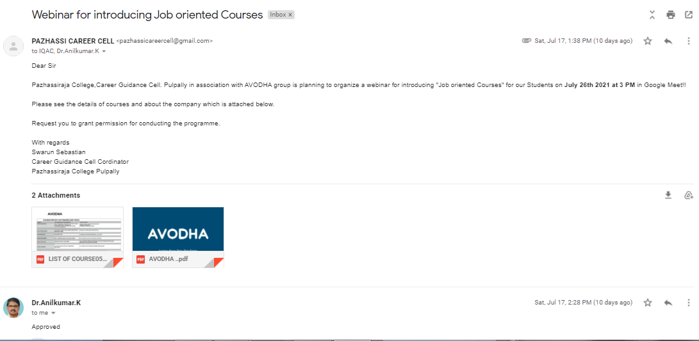
Contents of the proposal sent to the principal and the approval message from principal
