Seminar on "Professional Careers in Commerce" dated 31/10/2022

Career Guidance Cell Pazhassiraja College Organaised one day seminar on "Professional Career s in Commerce" with association of Navanirman Consultancy on31/10/2022. The seminar was well planned and executed. Programme was anchored by Final year BBA student Megaha KK and programme was inaugurated by Vimya K P HOD Commerce Pazhassiraja College. Renju Thomas the coordinator of Career Guidance Cell was the programme oraganaizer and coordinator.
Speaker of the program Sri Tintu Thomas really impressed the students by his thoughtful messages and students got real insight about the careers in front of them. Speaker covered almost all areas in commerce.

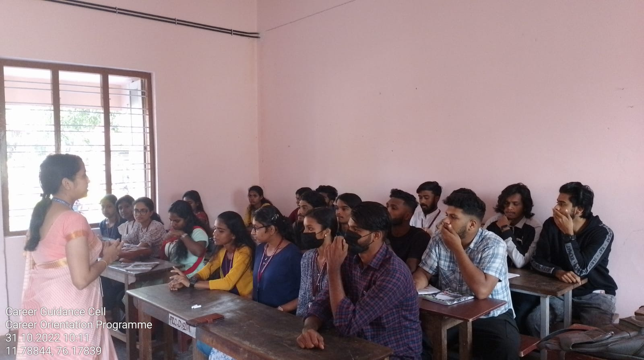

Convener IQAC Coordinator Principal
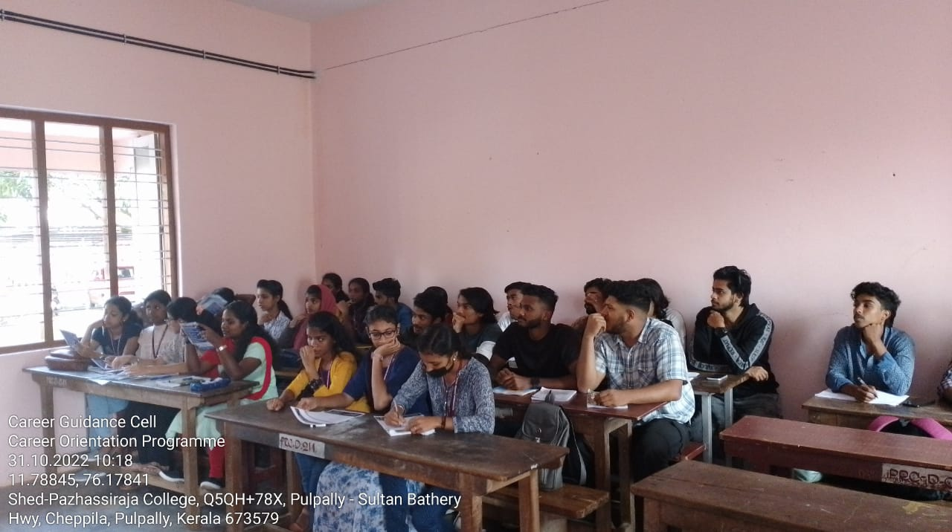
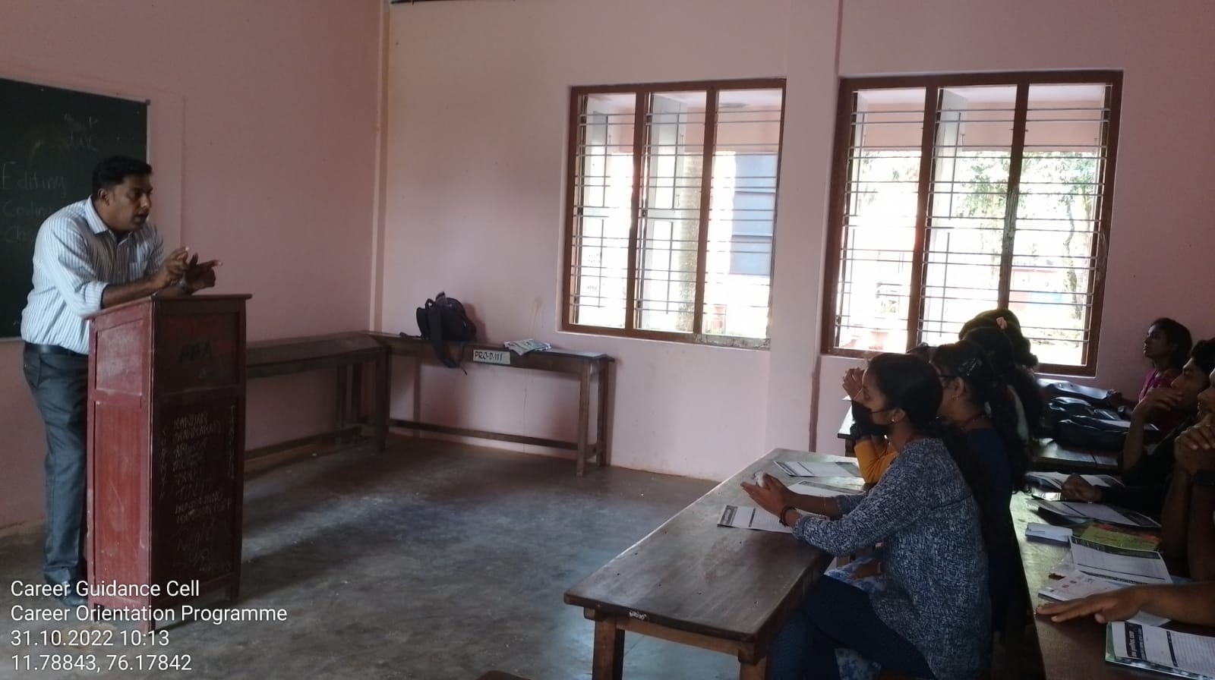

Convener IQAC Coordinator Principal
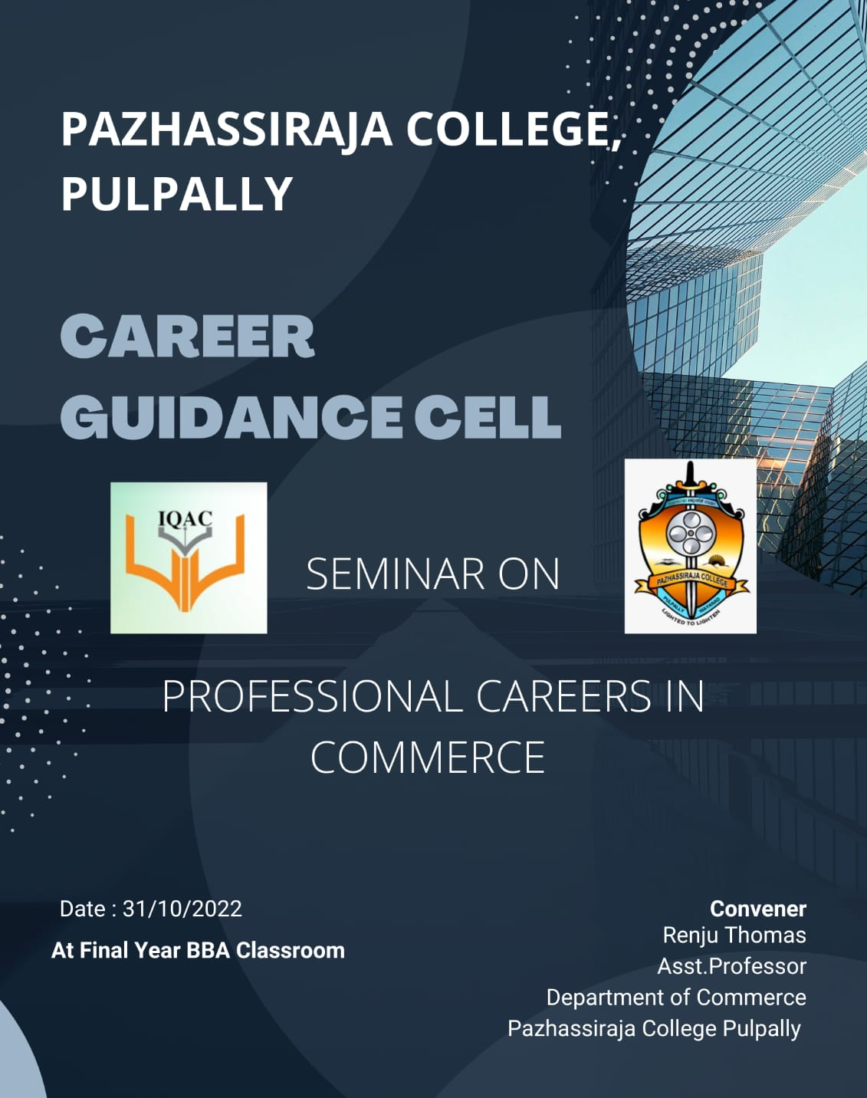

Convener IQAC Coordinator Principal

