Report on the Online Orientation Programme for Civil Services dated 16/06/2021

Pazhassiraja Career Guidance Cell in association with Ductus Academy has organized an online orientation programme for civil services on July 16th at 8 PM on Google meet. Orientation programme was organized to o have an idea about the civil service aspirants in our locality and to give them an orientation about civil service exams. Pazhassiraja Career Guidance Cell focused not only the students of our college but also the students from other educational institutions in our locality Pulpally. For this purpose messages were sent to the institutional heads for sharing it with their students.
Through this programme Pazhassiraja Career Guidance Cell tried to offer a hand to those students in our society who have civil service dreams. Programme exactly started at 8PM. Mr.Swarun Sebastian Career Guidance Cell Coordintor,Pazhassiraja College delivered the welcome speech and the inaugural address was given by Dr. AnilKumar K, Principal Pazhassiraja College. PK Nimshid,Faculty at Kerala Civil Service Academy was the resource person and with his excellent session he really motivated the students. He mainly focused on discussing the syllabus of Civil service exams with the students. There was a question answer session which helped the students to interact with the speaker. Programme has got great acceptance from the students by the active participation of 160 plus participants. Programme ended up with the vote of thanks of Mr.Renjith , Manager Ductus academy by 9.30 PM.
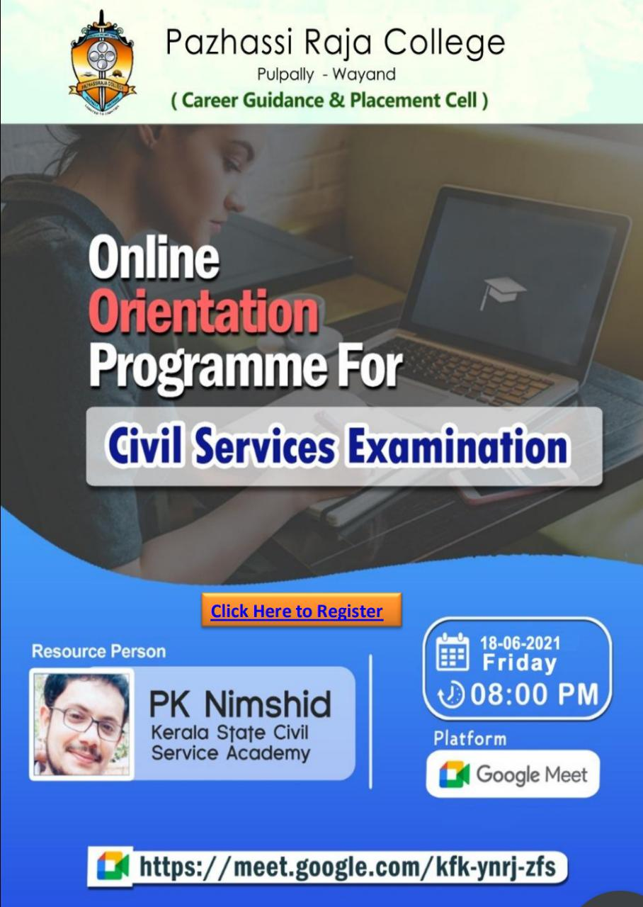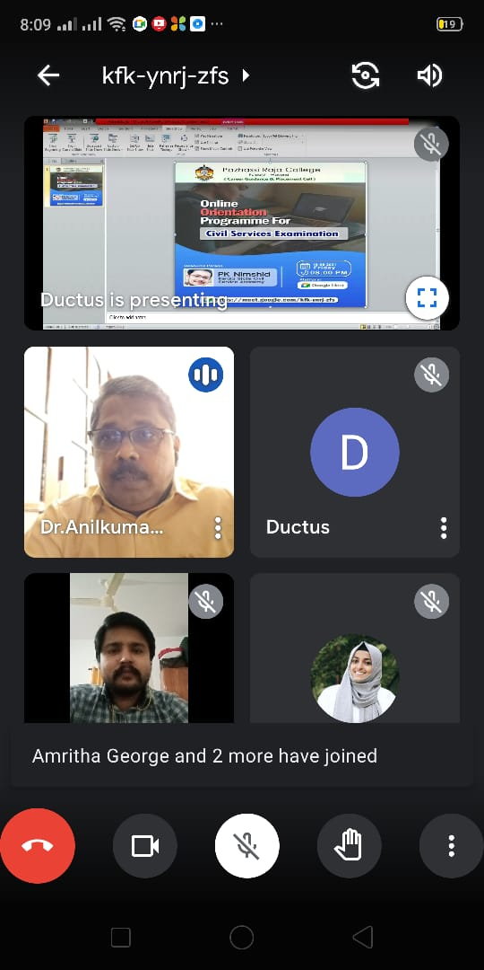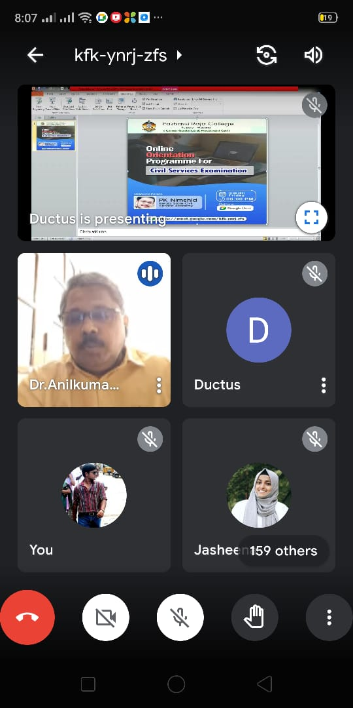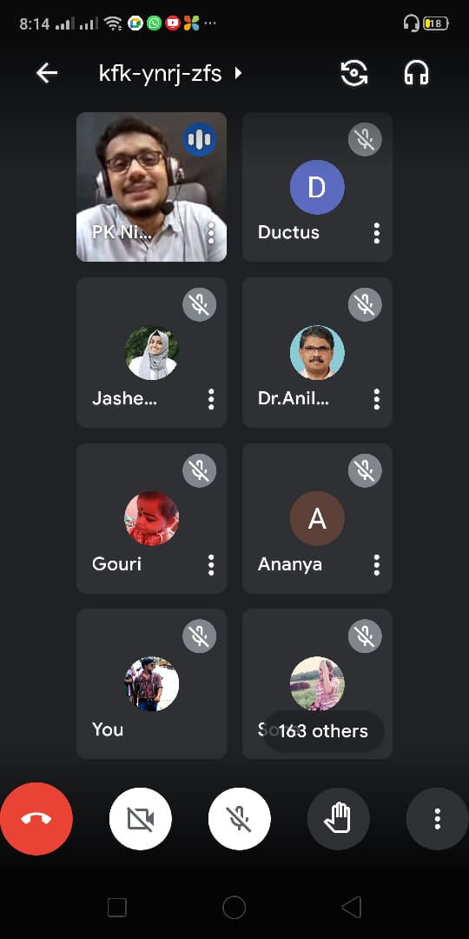

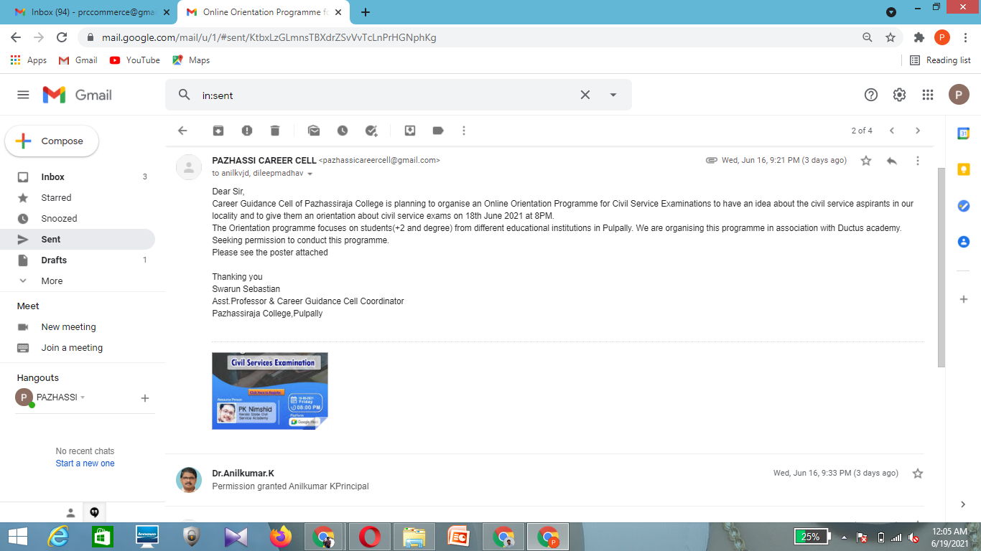Contents of the proposal sent to the principal and the approval message from principal

