Report on the Job Orientation Programme dated 20/07/2022

Pazhassiraja Career Guidance Cell in association with Avodha Edutech has organized a job orientation programme for the students on July 20th 2022 at Multimedia room at 11 AM. Orientation programme was organized to create an idea about different job oriented courses offered by Avodha Edutch that will be really useful fir the students.
. Through this programme Pazhassiraja Career Guidance Cell tried to introduce different job oriented courses with 3 month duration and 3 month internship which is offered by Avodha.
Mrs. Renju Thomas Career Guidance Cell Coordintor,Pazhassiraja College delivered the welcome speech. Mr.Abdul Bari Principal in charge inaugurated the seminar. Mr.Kamarudheen and Mrs. Frankly team leads of Avodha Edutech were the resource persons and with their excellent session they really motivated the students. They mainly focused on discussing the different job oriented courses offered by Avodha Edutch. There was a question answer session which helped the students to interact with the speaker. Programme has got great acceptance from the students by the active participation of 130 plus participants as two batches.

Principal IQAC Coordinator Career Guidance Cell Coordinator

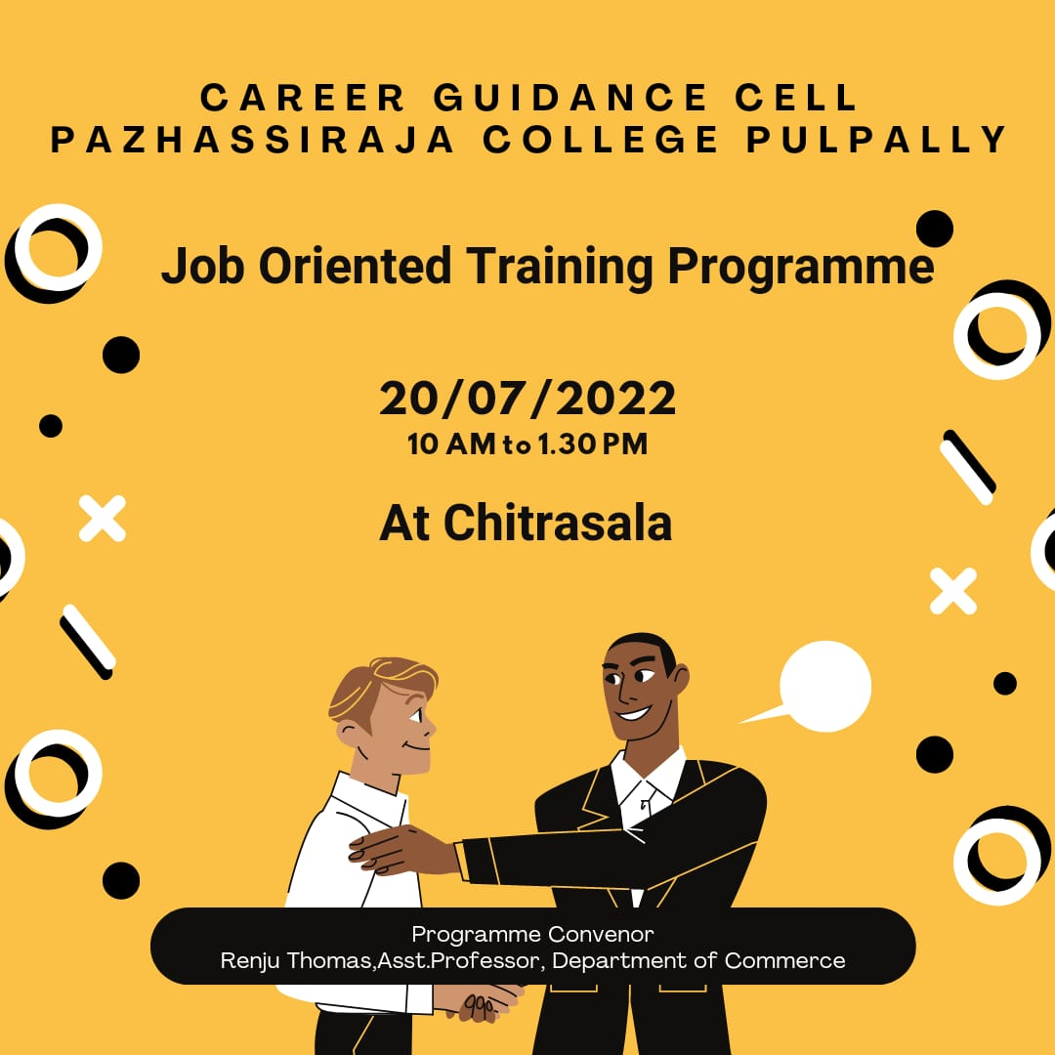
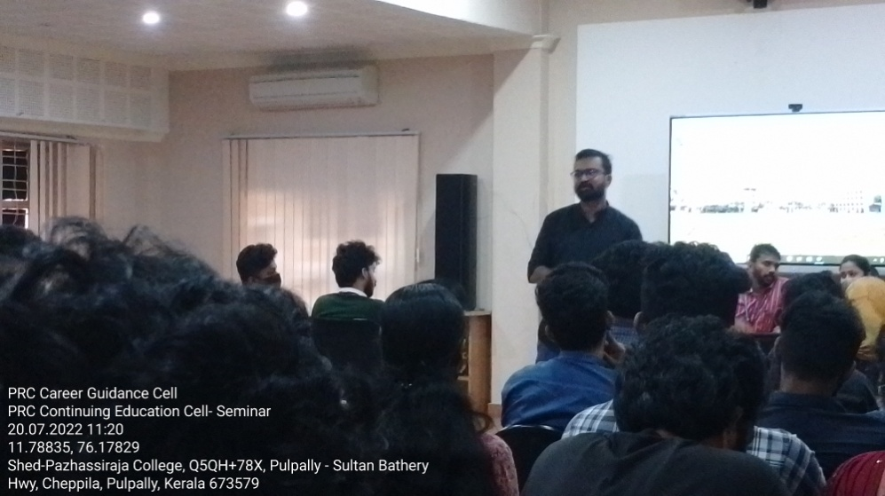

Principal IQAC Coordinator Career Guidance Cell Coordinator
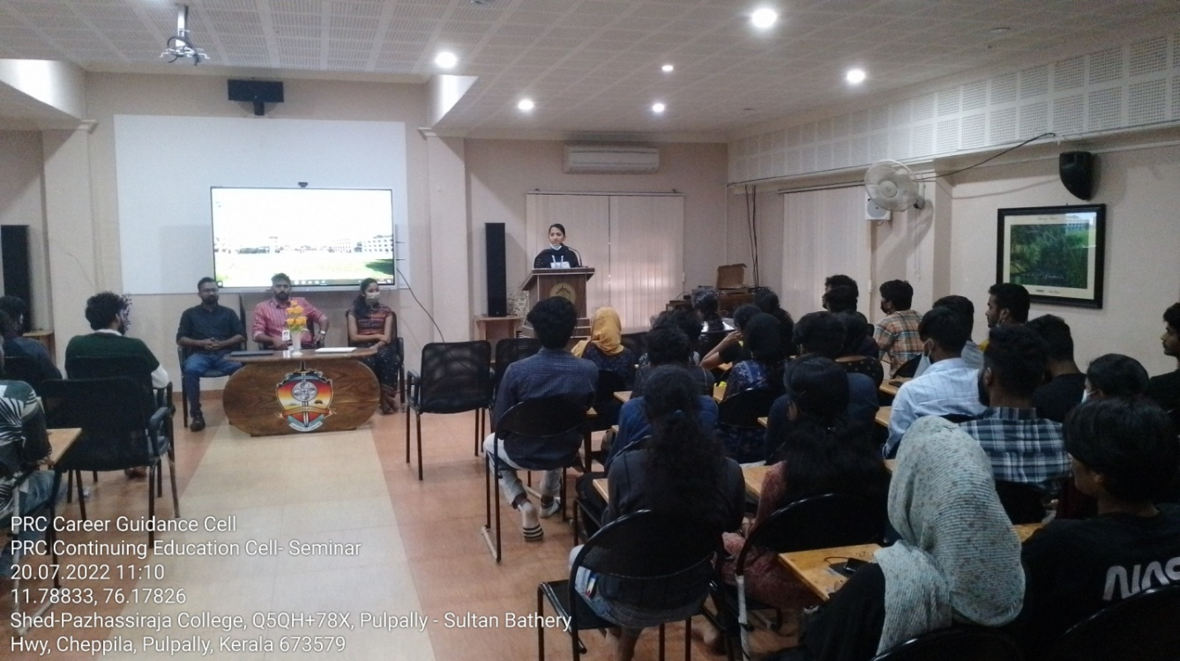
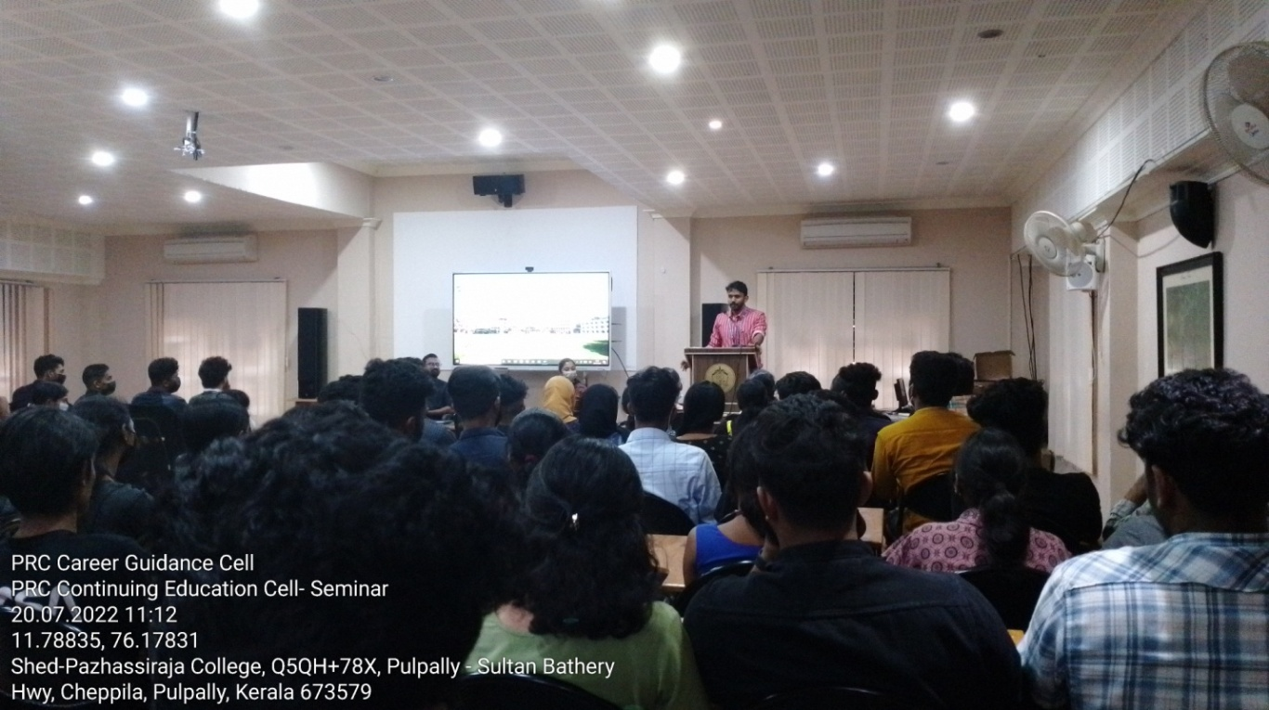

Principal IQAC Coordinator Career Guidance Cell Coordinator

