PAZHASSIRAJA COLLEGE PULPALLY, WAYANAD, 673579
CAREER GUIDANCE CELL PAZHASSIRAJA COLLEGE PULPALLY

PRESENTS
EDUCATIONAL EXHIBITION 2021-2022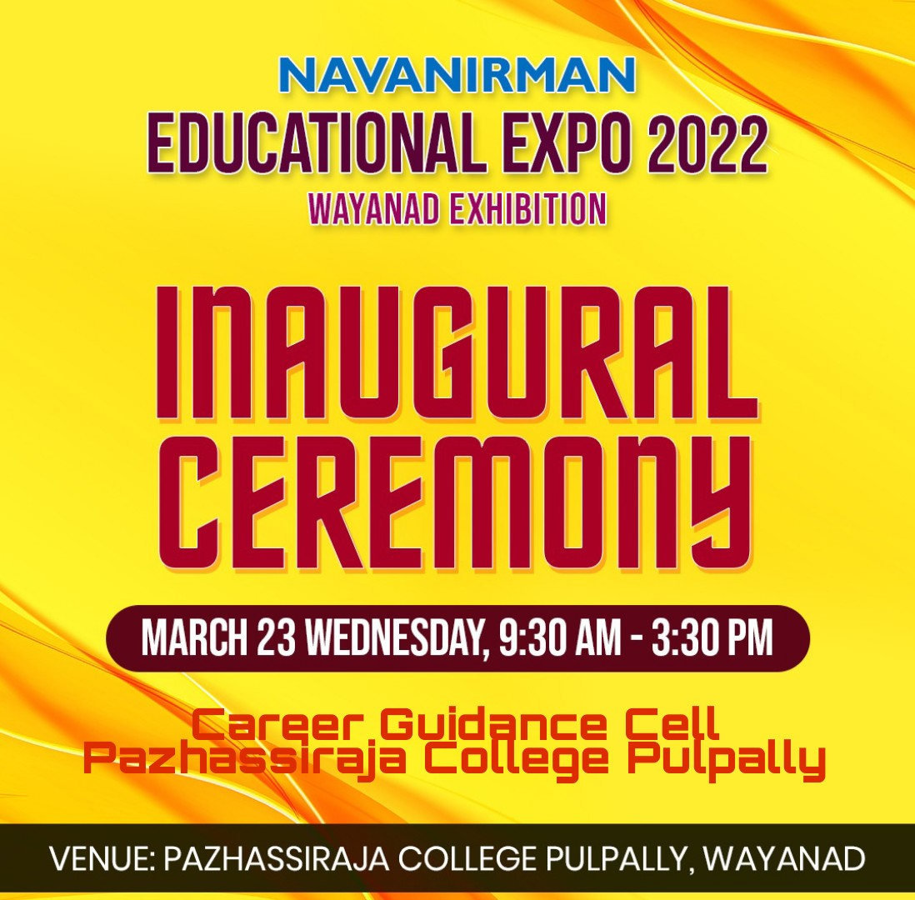

Career Guidance Cell Coordinator Principal
Mr.Swarun Sebastian Dr.AnilKumar K
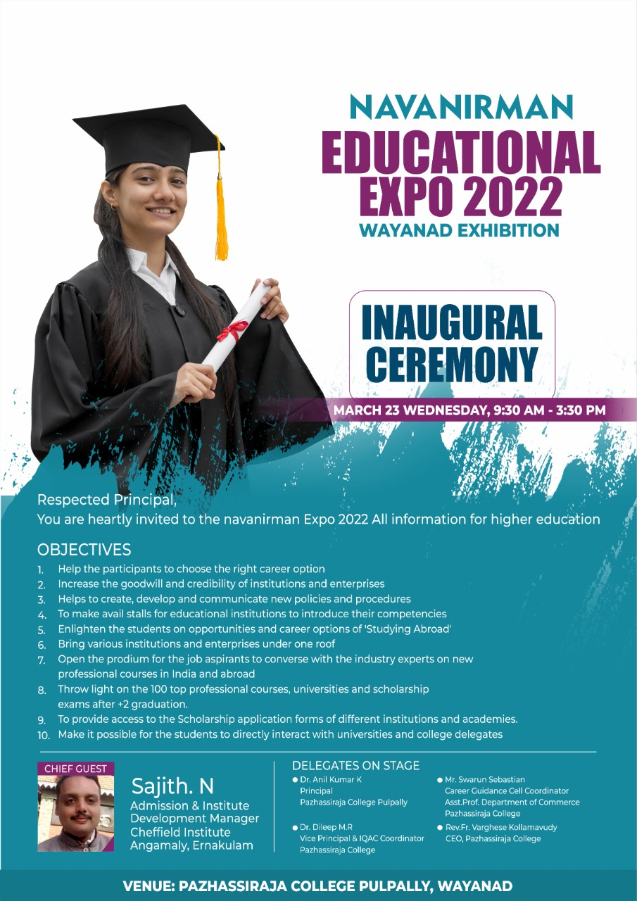

Career Guidance Cell Coordinator Principal
Mr.Swarun Sebastian Dr.AnilKumar K
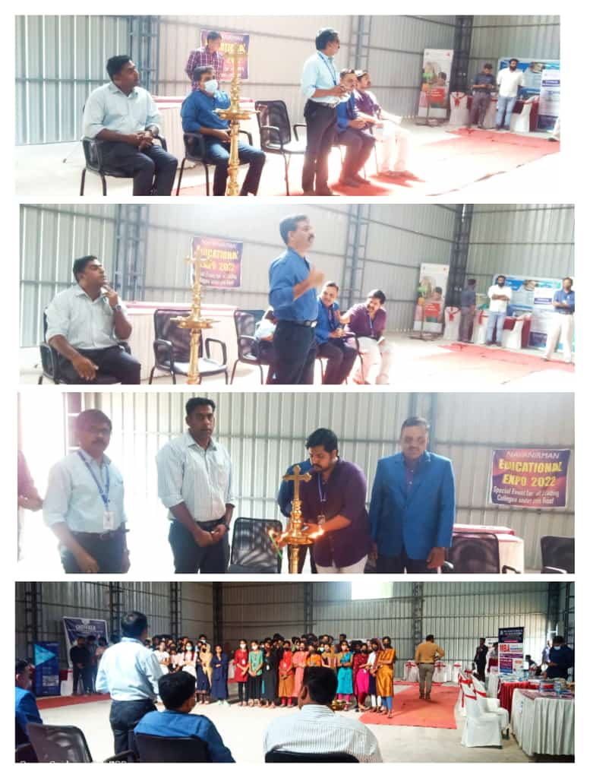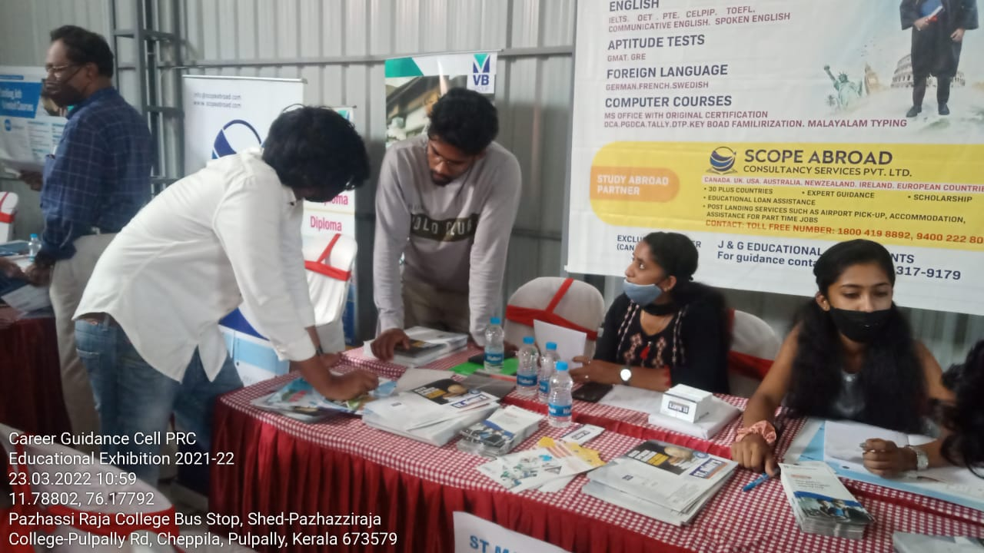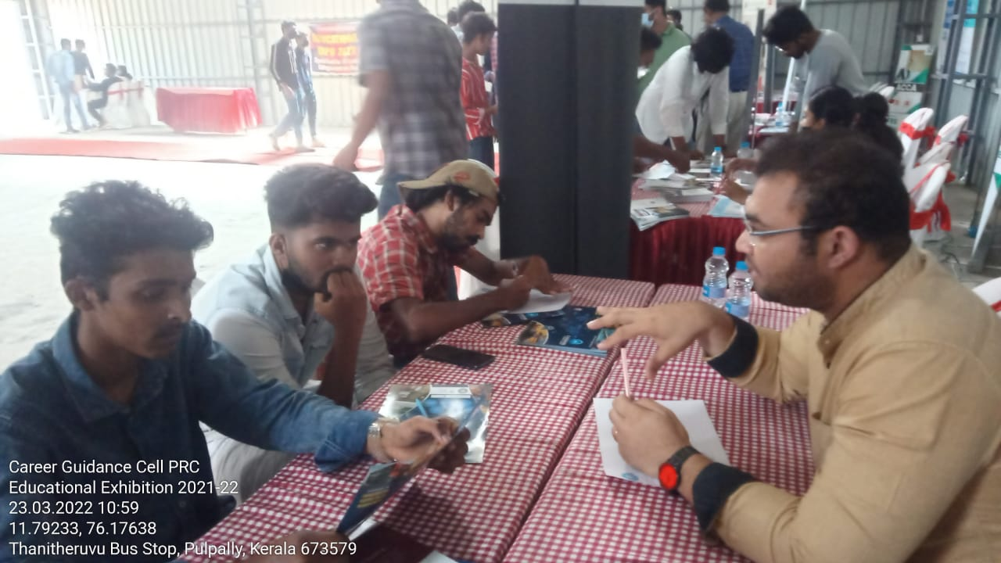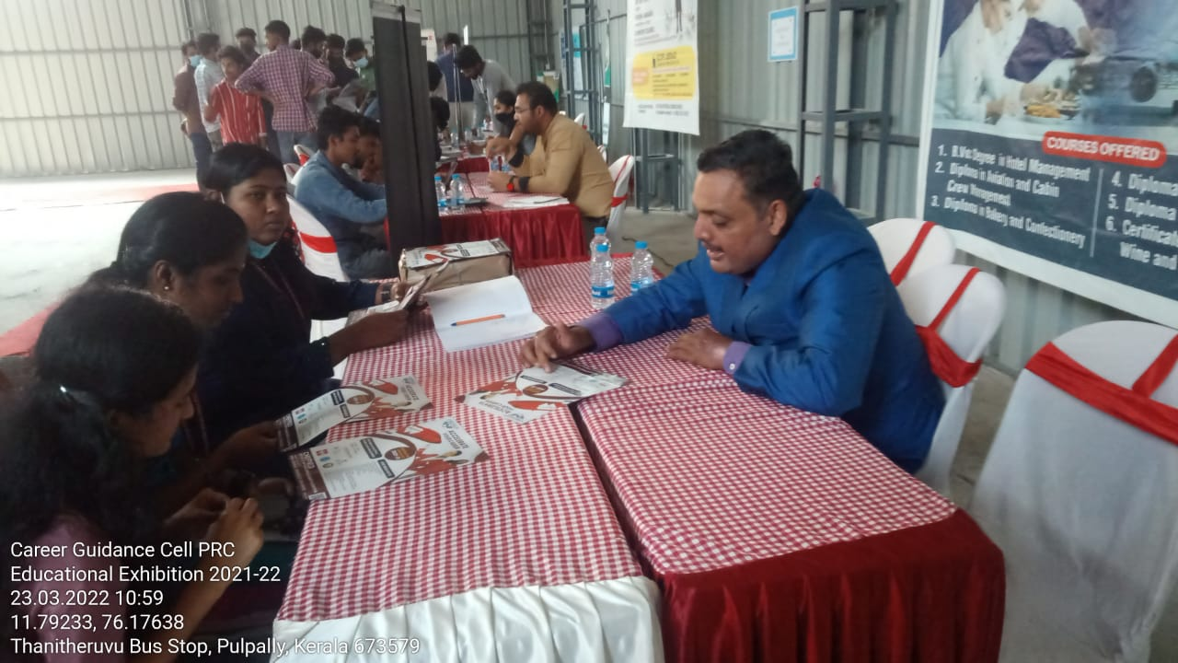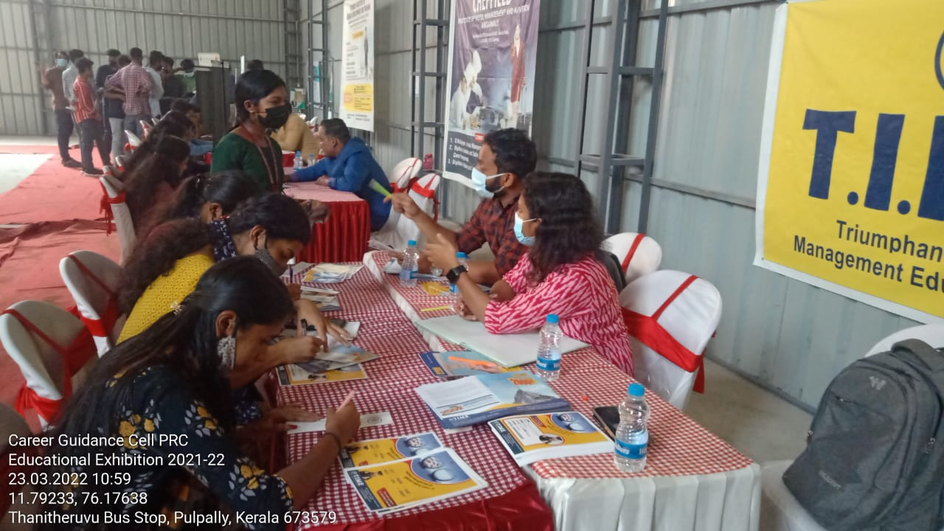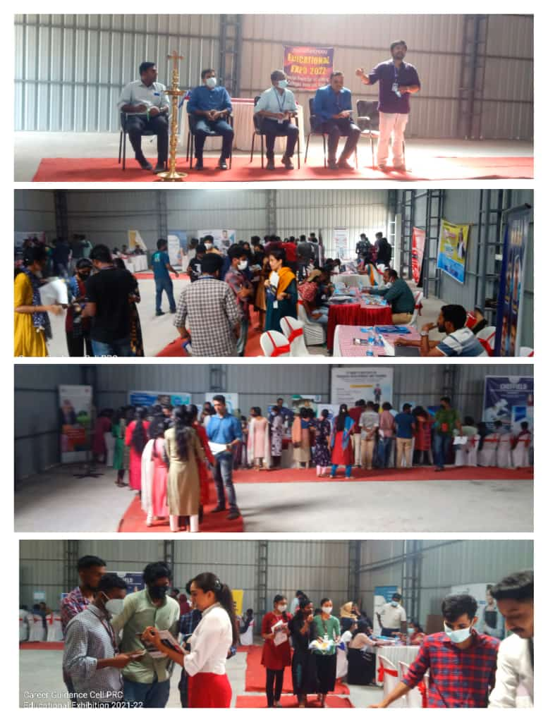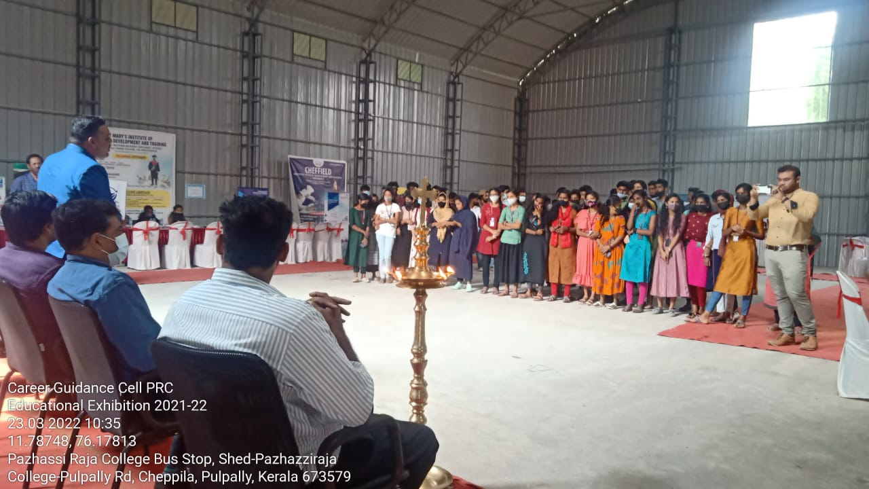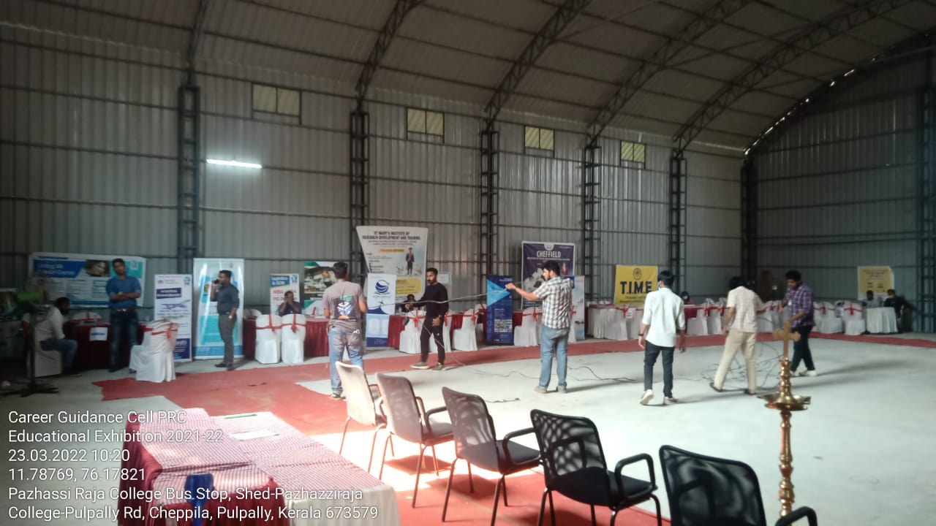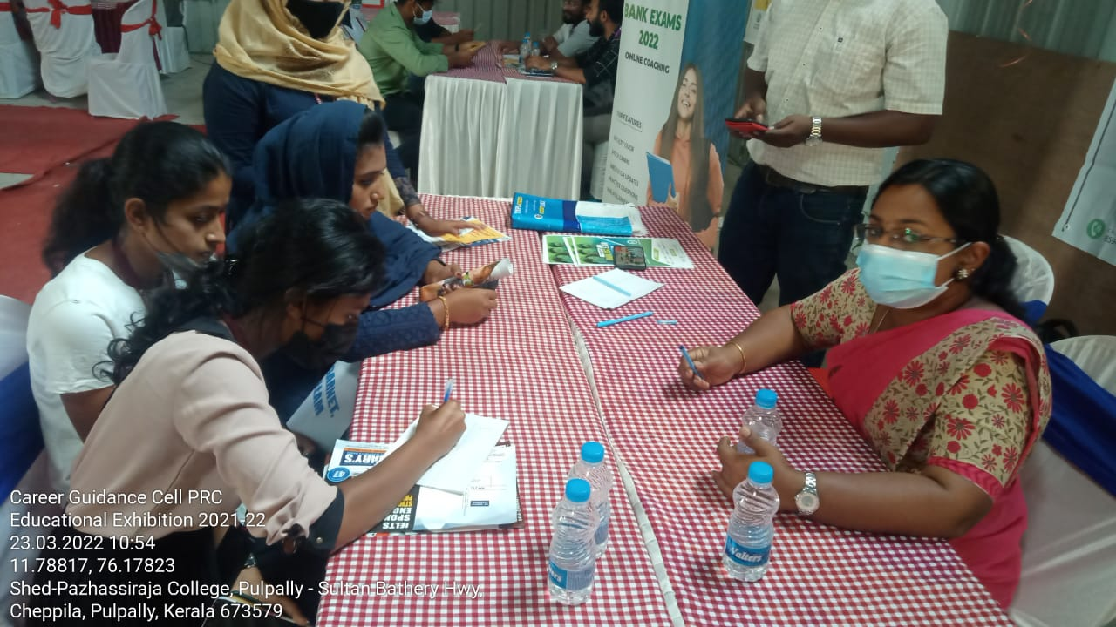

Career Guidance Cell Coordinator Principal
Mr.Swarun Sebastian Dr.AnilKumar K

CAREER GUIDANCE CELL PAZHASSIRAJA COLLEGE PULPALLY
EDUCATIONAL EXHIBITION 2021-2022
LIST OF INSTITUTIONS PARTICIPATED IN THE EXHIBITION
SL NO | INSTITUTE | Signature of Representatives | STALL NO
1 | VIDHYABHARATHI GROUP |  | 1
2 | SIMAT |  | 2
3 | LEESHORE ACADEMY |  | 3
4 | DESIGN GROUP |  | 4
5 | EASA COLLEGE OF ENGINEERING, COIMBATORE |  | 5
6 | SNGIST COLLEGE, NOTH PARAVOOR |  | 6
7 | CAREER GUIDANCE THRISSUR |  | 7
8 | ACCOUNTANTS SERRVICE SOCIETY, COCHIN |  | 8
9 | CHEFFIELD INSTITUTE OF HOTEL MANAGEMENT |  | 9
10 | G TECH |  | 10
11 | SKY FORD |  | 11
12 | CATALYST EDUCATION |  | 12
13 | CARDEA HEALTHCARE EDUCATION |  | 13
14 | ALTIS INTERNATIONAL ACADEMY |  | 14
15 | MARY MATHA ARTS AND SCIENCE COLLEGE,ALAKODE |  | 15
16 | SUMMIT IAS ACADEMY |  | 16
17 | REG IMMIGRATION & EDUCATION |  | 17

Career Guidance Cell Coordinator Principal
Mr.Swarun Sebastian Dr.AnilKumar K

CAREER GUIDANCE CELL PAZHASSIRAJA COLLEGE PULPALLY
EDUCATIONAL EXHIBITION 2021-2022
LIST OF STUDENTS FROM SN COLLEGE PULPALLY WHO PARTICIPATED IN THE EXHUBITION

Sl.no | Name | Signature | Department | Year
1 | Amriutha KV |  | B.Com | 2019-22
2 | Anusree Balachandran |  | B.Com | 2019-22
3 | Amritha VR |  | B.Com | 2019-22
4 | Kavya PV |  | B.Com | 2019-22
5 | AnjanaSajanan |  | B.Com | 2019-22
6 | AparnaJayan |  | B.Com | 2019-22
7 | AnaghaDinesh |  | B.Com | 2019-22
8 | Akshay Mable Jose |  | B.Com | 2019-22
9 | Sidharth PS |  | B.Com | 2019-22
10 | Manujith |  | B.Com | 2019-22
11 | Jithin |  | B.Com | 2019-22
12 | Ajay P Reji |  | B.Com | 2019-22
13 | Sreejith VS |  | B.Com | 2019-22
14 | Jishnu Suresh |  | B.Com | 2019-22
15 | Aparna C |  | B A English | 2019-22
16 | Ayana Prabhakar |  | B.Com | 2019-22
17 | Twinkle Saji |  | B.Com | 2019-22
18 | Shana Nasrin |  | B.Com | 2019-22
19 | Basily |  | B.Com | 2019-22
20 | Dayana Joy |  | B.Com | 2019-22

Career Guidance Cell Coordinator Principal
Mr.Swarun Sebastian Dr.AnilKumar K

