Report on the Career and Course Abroad-Orientation Webinar dated 19/07/2021

Pazhassiraja Career Guidance Cell in association with EazyLink Academy has organized a webinar on “Global Career Opportunities & Campus Placements - India and Abroad” for the students on July 19th at 3 PM on Zoom. Orientation programme was organized to with a view to help all the students to prepare for their future career plans in India & Abroad.
Key Areas Covered:
1. Global career Options - Higher education with 100% placement assistance
2. FREE Master programs in GERMANY
3. Upto 30% scholarship in UK
4. Upto 4 years stayback options in Australia
5. IRELAND offering 1 year master programs with scholarships upto 4 lakhs and exemption of IELTS
6. One year master programs from world's top Universities in English speaking Countries
Mr.Swarun Sebastian Career Guidance Cell Coordintor,Pazhassiraja College delivered the welcome speech. Sony Akkara Career consultant was the resource person and with his excellent session he really motivated the students. He mainly focused on discussing the different opportunities for students in abroad. There was a question answer session which helped the students to interact with the speaker. Programme has got great acceptance from the students by the active participation of 80 plus participants.

Principal IQAC Coordinator Career Guidance Cell Coordinator
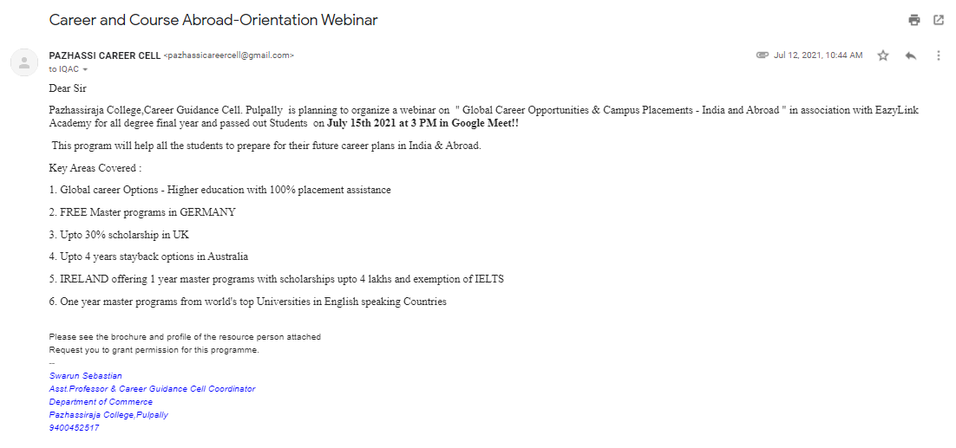
Contents of the proposal sent to the principal and the approval message from principal
