A Report on Activities of Walk With Scholar Program in Pazhassiraja College During the Academic Year 2018-19.

About WWS Program

“Walk with Scholar” is a mentoring program functioning under the “New Initiatives in Higher Education” of the Department of Collegiate Education, Government of Kerala. This scheme introduces the idea of mentoring to under graduate students and builds on the concept of mentor as a ‘Guide’ and ‘Friend’.
Mentoring is a process where a mentor with greater experience and wisdom guides the mentee to develop both personally and professionally.

Activities on 2018-19

College council appointed Smitha Chacko, Assistant Professor, Department Of Microbiology as the coordinator of WWS Program with effect for the year 2018-19 and she has attended orientation programme for coordinators of WWS on 11-09-2018 at Loyola College of Social Sciences, Trivandrum.
Detailed List of Internal mentors 2018-19 for WWS
Serial No. | Name of the Mentor | Designation With Subject | Year of mentees
1 | Abdul Bari | Asst. Professor in Microbiology | I Year
2 | Dr. Joshy Mathew | Asst. Professor in History | I Year
3 | Philomina K.J | Asst. Professor in Malayalam | I Year
4 | Shelji Mathew | Asst. Professor in Tourism | I Year
5 | Amal Marcus | Asst. Professor in Economics | I Year
6 | Anoop Kumar | Asst. Professor in Tourism | II Year
7 | Dr. Teena | Asst. Professor in Hindi | II Year
8 | Dr. Silvi TS | Asst. Professor in Economics | II Year
9 | Neetha Francis | Asst. Professor in Computer Application | II Year
10 | Koshy C.J | Asst. Professor in BBA | II Year

EXTERNAL MENTORING

A list of eminent resource persons disciplines like Civil Service, Medicine, Psychology, IT, Drama and film, Teaching was prepared and submitted to the New Initiatives as per their instruction. They provided the approved list of state level and District level resource persons for the smooth conduction of the programme. According to the instructions from the Office of the New Initiatives, Government of Kerala, as per the programme 50 sessions were conducted by different external mentors.

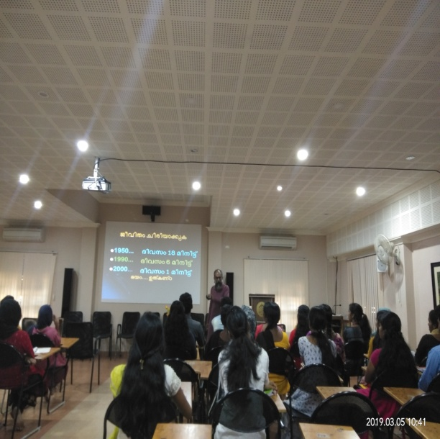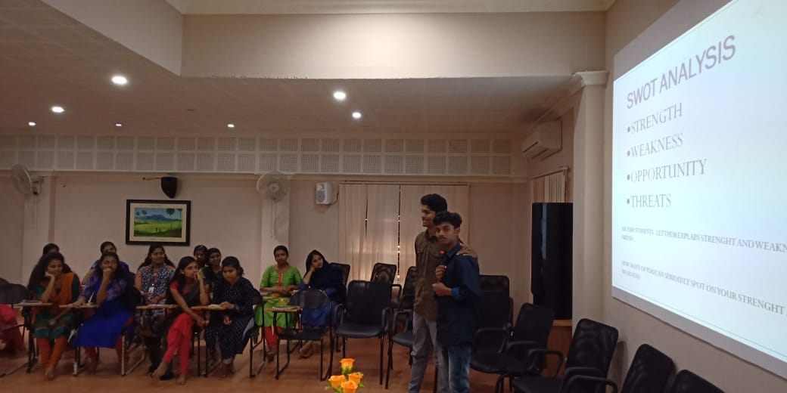
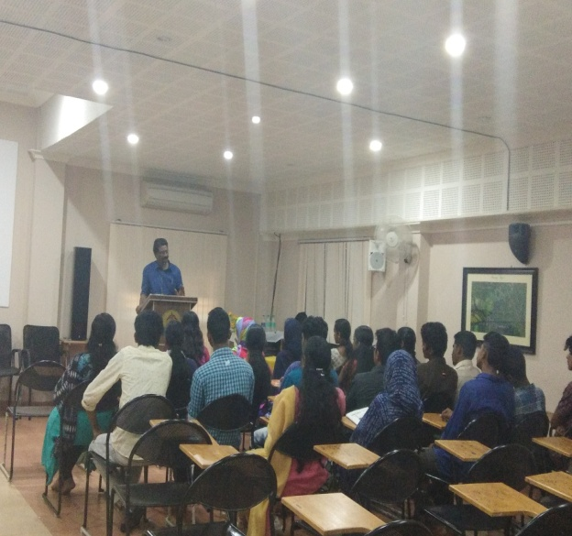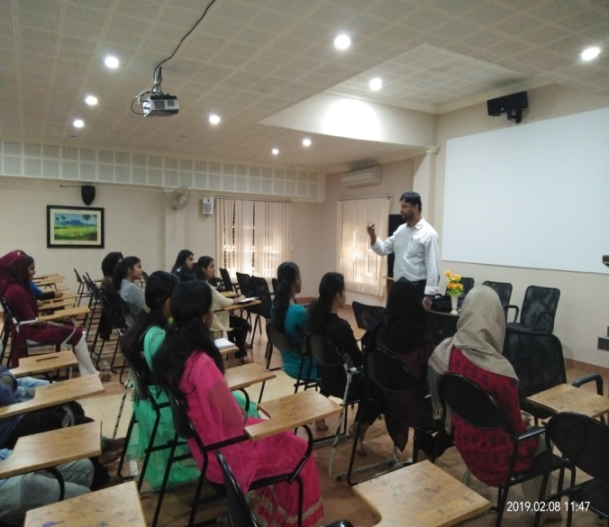

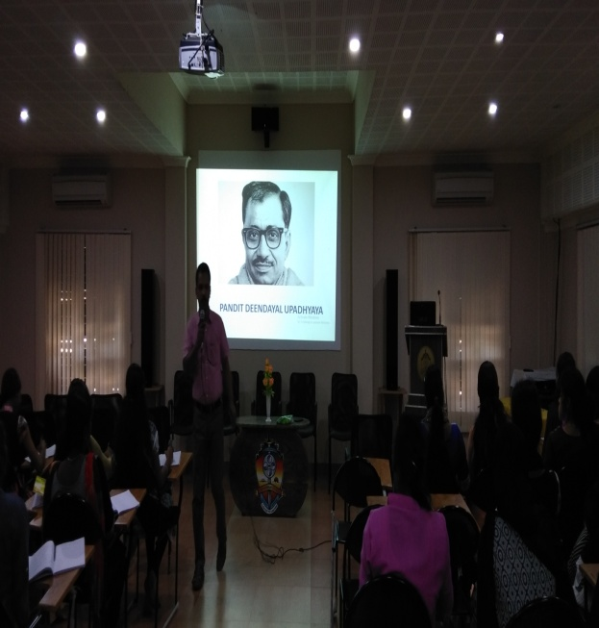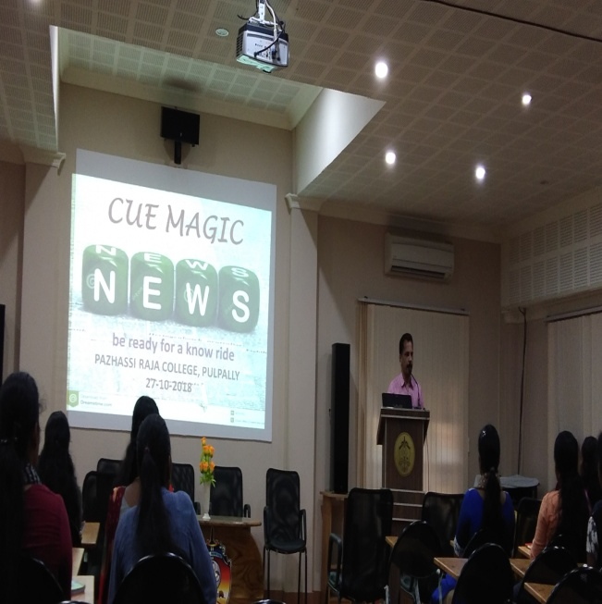

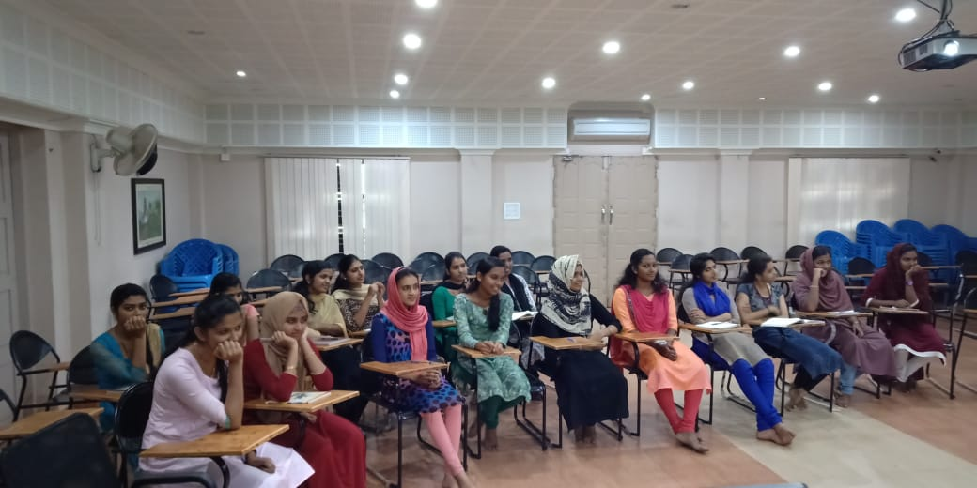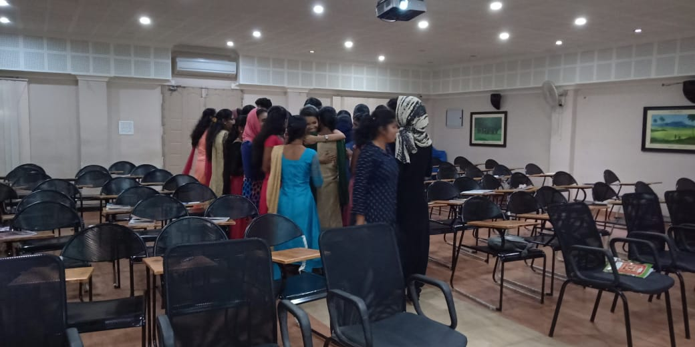

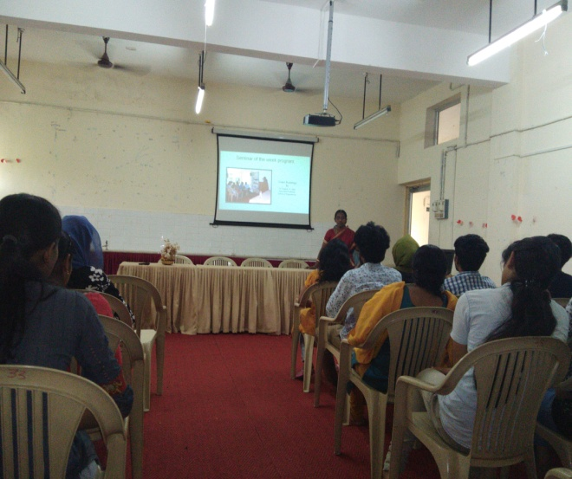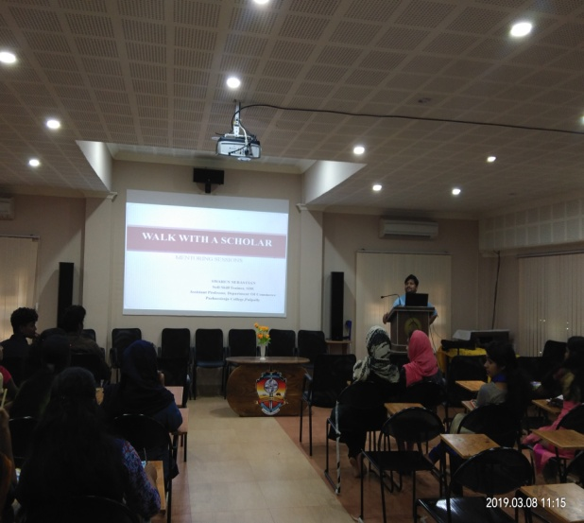

MOTIVATIONAL VISIT
On the basis of a proposal submitted to New initiatives, Higher Education, Govt of Kerala, Pazhassiraja College received the sanction letter for the motivational visit with the second year WWS mentees to various Educational and research institutions at Cochin. The motivational visit started on 23rd January 2019. First day started with Cochin University of Science and Technology. The permission has been granted by the Vice-Chancellor of CUSAT and Dr. P. K. Baby, Director, Department of Youth Welfare of the University co-ordinated the visit.
Department of polymer science and rubber technology, The School of Environmental Studies. The noteworthy moment was the interactive session with Dr. Sivanandhan Achari, Director of the department. He is a well known speaker and his talk enlightened the students. Dr. Rajathy Sivalingam gave a class on Pollution and biodegradation methods.Then we went to the University library. They have arranged an interactive class for the students. Dr. Surendran Cherukodan, Assistant Librarian interacted with the students and dispersed many valuable information regarding bioinformatics tools for research.

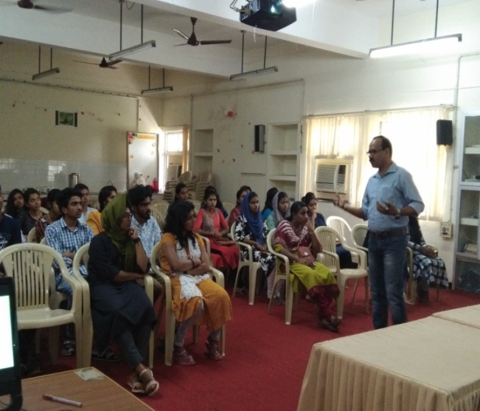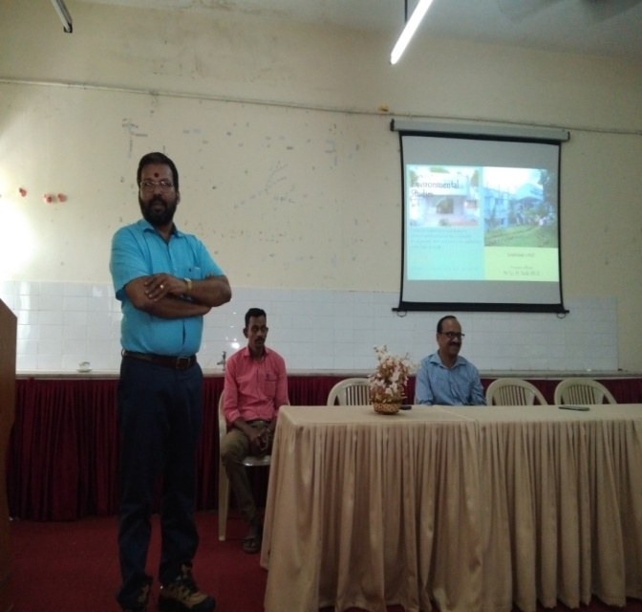

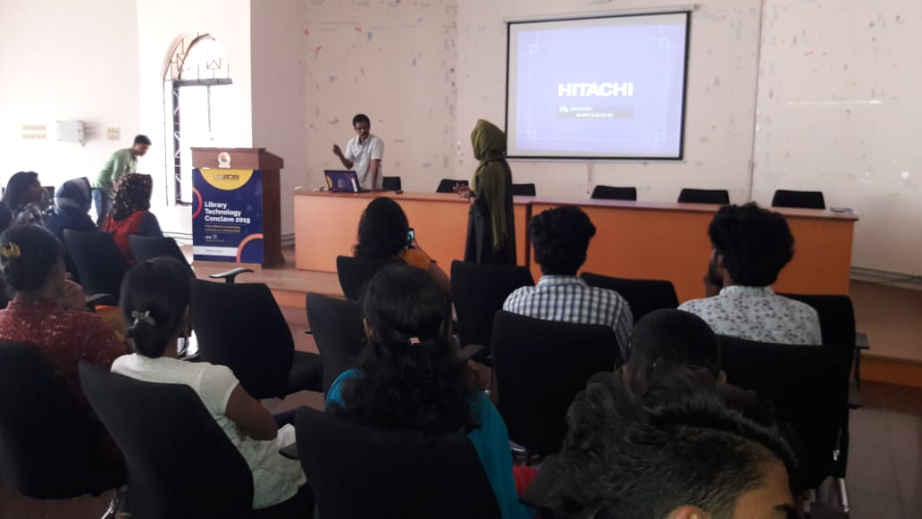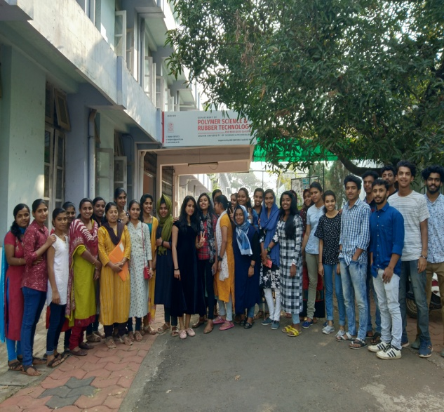

On the second day, we visited the The Central Marine Fisheries Research Institute (CMFRI), It is an institute for the Indian Council of Agricultural Research (ICAR).There was a museum of the marine lives. The main attraction was the original pearl. This is the first time we the teachers also observing the pearl in the original body of the shell with the flesh. Everything is preserved in the museum. Even there were many marine plants, algae and a penguin too.
Next we visited the Mangalavanam Bird Sanctuary, near to CMFRI. It is small mangrove forest area inside the city with many bird and plant species.
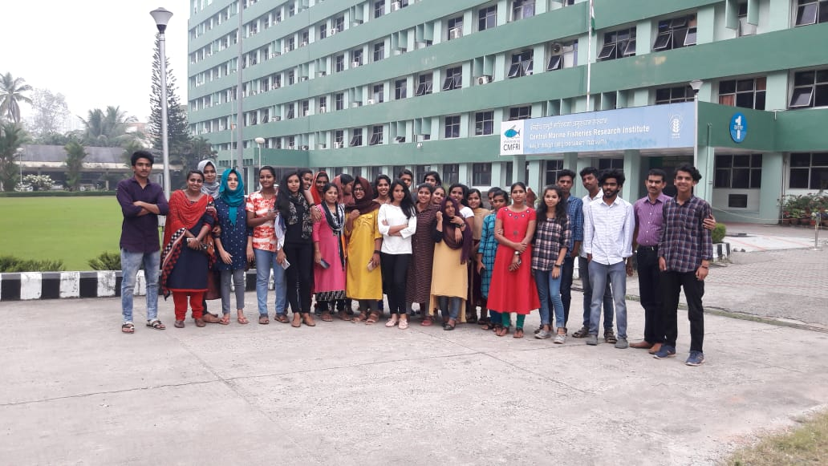

MOCK TESTS / INTERVIEWS
Mock Interviews were conducted for second year students of the programme by Mr. Swarun Sebastian, Asst Professor; Dept. Of BBA, A well known Trainer motivational speaker conducted the mock interview session. A session was provided to prepare for interview and students was given personal feedback of their mock interview.

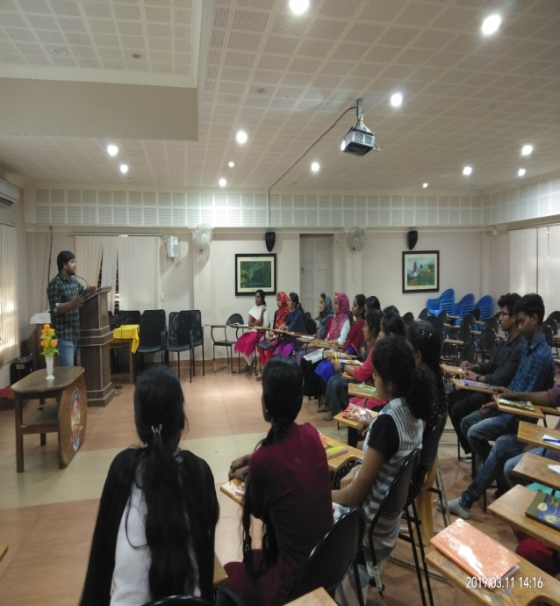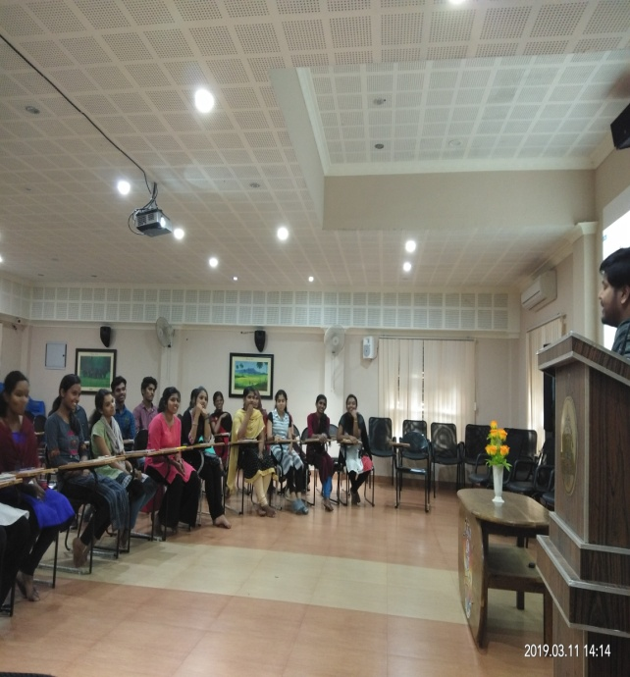

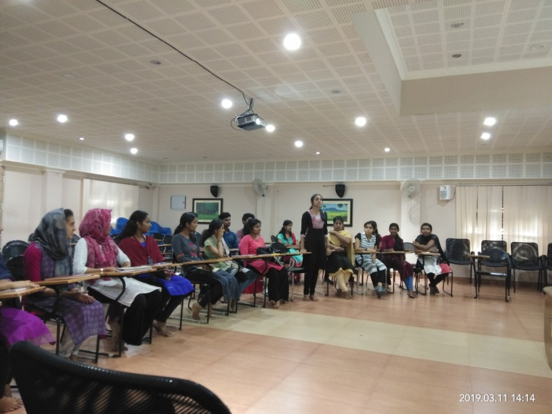

STATIONERY KIT
The 60 students of Walk with a Scholar were given note books and pens as part of the stationary kit allotted for the mentees for the academic year 2018-2019.

STUDY MATERIALS
All the 60 students of Walk with a Scholar were distributed Manorama Year Book, 2018 and two motivational goal setting books as study material for the academic year 2018-2019.
Walk with a Scholar Programme was completed successfully in Pazhassiraja College during the academic year 2108-19.

