PAZHASSIRAJA COLLEGE PULPALLY,WAYANAD
WALK WITH A SCHOLAR PROGRAMME
REPORT 2016-17
Walk With a Scholar (WWS) scheme proposes to arrange specialized mentoring programs for students in Under Graduate Programs in Arts, Science and Commerce and to provide guidance for their future. The scheme introduces the idea of mentoring and builds on the concept of mentor as a 'Guide' and 'Friend'. It helps the students in Arts, Science and Commerce Colleges to get necessary orientation to prepare them for employment or guidance necessary to select areas for higher study. The mentoring scheme for students will be purely voluntary in nature. It will be open for all students entering the first year of the Under Graduate Programme of Study. Students selected for the Programme should have secured at least 60% marks at the Higher Secondary/Plus Two level. This stipulation of minimum marks is not applicable for SC/ST students
Maximum number of students identified under WWS Scheme, is 30. If the number of applicants exceeds 30, the College council will evolve a method of selecting the required number of students so that the neediest students and those genuinely interested in the scheme alone are selected. Admission to the scheme is voluntary in nature. Any student of a first year degree programme with a minimum of 60% marks is eligible to apply for admission. The maximum number of students to the program is 90(including first&second third year) The students are selected department-wise on the basis of merit in consultation with the respective heads of department and class tutors.
The Scheme aims at giving necessary orientation to needy students, to prepare them for employment and give them necessary guidance, motivation and necessary mental support to identify appropriate areas for higher study as well as employment. The mentoring scheme is planned to identify the opportunities available for the scholars, the areas suitable for them, and the manner in which the scholar should proceed before them and evolve ways by which they can be acquired.
Coordinator of the Programme
PHILOMINA K J, Assistant Professor of Malayalam is nominated by College Council as Coordinator of the Programme for the year 2016-17. The Coordinator has given adequate training to teaching faculties for the better organization of the programme.
Internal mentors (2016-17)
Fifteen Internal mentors who are able to mentor and support the scholars and who can act as a Guide to the scholars in building their careerwere selected. The Internal Mentors assigned for the WWS Programme 2016-17 include

FIRST YEAR MENTORS
Serial No. | NAME OF THE MENTOR | Designation With Subject
1 | SUSMIN JAMES | Assistant professor in Commerce
2 | NIDHEESH | Guest lecturer in Commerce
3 | SHAIJUMON P V | Guest lecturer in Tourism
4 | DR.TEENA | Assistant professor in Hindi
5 | ABDULBARI | Assistant professor in Microbiology
SECOND YEAR MENTORS
1 | NEETHU GEORGE | Asst. Professor in Biochemistry
2 | SANOOP KUMAR P V | Asst Professor in  Travel and Tourism Management
3 | NEETHA FRANCIS | Asst. Professor in  Computer Applications
4 | VIMYA K P | Assistant Professor in commerce
5 | LINTU JOSE | Asst.ProfessorinMathematics
THIRD YEAR MENTORS
1 | NIRANJANA C | Asst.Professor commerce
2 | DR. JOSHY MATHEW | Asst. Professor in History
3 | SALEEL .M. M | Associate Professor inEnglish
4 | SMITHA CHACKO | Asst. Professor in Microbiology
5 | SILVI T S | Asst.professor in Economics

FIRST YEAR INTERNAL MENTEES

NO | NAMES | DEPARTMENT
1 | ROSE MARIYA AUGUSTINE | BA ECONOMICS
2 | HARISREE CS | BA ECONOMICS
3 | CHANJAL P SHAJI | BA ECONOMICS
4 | JITHYA SCARIA | BA HISTORY
5 | SHONE AUGUSTIN | BA ECONOMICS
6 | SNEHA SIMON | BA ECONOMICS
7 | MAJIYA CA | ENGLISH
8 | HIBA THASNIM | ENGLISH
9 | TINU JOSE | ENGLISH
10 | AMAL GEORGE | ENGLISH
11 | MIBIN EMMANUVEL | ENGLISH
12 | ANJU BENNY | HISTORY
13 | SHABEEBAETTUVEETTIL | BSC MICROBIOLOGY
14 | ARYA AV | BSC MICROBIOLOGY
15 | REYONA N J | BSC MICROBIOLOGY
16 | NANDHU MANOJ | BA HISTORY
17 | AMRUTHA MOHANDAS | BSC MICROBIOLOGY
18 | ASWATHY PP | BSC MICROBIOLOGY
19 | ANAGA RAJ | BBA
20 | AYANA SURESH KP | BBA
21 | SINOMOL MATHEW | BBA
22 | AMAYA NAIR | BBA
23 | RINU THOMAS | BBA
24 | ADHITHYA UNNI | BA HISTORY
25 | KRISHNAJITH PR | BTTM
26 | SHIBIN VS | BTTM
27 | ASWATHY R | BA HISTORY
28 | VARGHESE PAUL EP | BTTM
29 | ABIN KURIAKOSE | BTTM
30 | SHIFNA P | BTTM

Students selected for the WWS Programme (2016-17) are genuinely interested in this programme and they are the neediest students who were eventually chosen from various disciplines. Each Internal Mentor was given charge of 6 students.The Internal Mentors regularly meet their mentees in groups to know them personally and to improve inter-personal relations and also general discussions were conducted by each group on various topics of common interest.
The internal mentors started their sessions in the first week of September. After making rapport with mentees,proper guidance was given to them according to their needs. The internal mentoring session was really helpful to the mentees because it helped them to identify their genuine interest. The session for internal mentoring was scheduled by the mentors themselves according to their convenience and each of them has engaged 10hours session. The sessions were arranged after the regular class and it was on Saturdays. Attendance register for the scholars and mentors were maintained separately. The detailed evaluation report of internal mentoring session was prepared by internal mentors and it has been submitted to the coordinator. Activity report and photographs are attached along with this report.

External Mentoring

The mentees were also provided with sessions by External Mentors who can strongly influence them from within and help them to evolve and transform into a person they want to be. This was scheduled according to the convenience of the resource persons and all the mentees have to attend the sessions. Mentees were also allowed to interact with the resource person and more importance were given to solve the problem of stage fear, communication etc. this helped to improve the confidence level of mentees .Special Emphasis was given to motivate and create more confidence among mentees to avail better future opportunities. Legal awareness, Personality development, Career counselling, Orientation for preparing competitive examinations were the main activities of the external mentoring. Each of the external mentors has engaged four to five Hour session as allotted to them. The external mentoring sessions was completed on20th June .External sessions organized in the academic year 2016-17 were handled by distinguished faculty persons included.

- Dr.Lijo john., (Asst. Professor, dept.of Biochemistry, KVASU)handled a session on topic- exploring to research world. He told that research is very important for the students because it helps them to have a detailed analysis of everything. When we have a proper in depth analysis on a topic, the result comes out to be fruitful and also the knowledge is enhanced. In Research we should carefully analyze the problems or to do the detailed study of the specific problems, by making use of the special scientific methods. He has mentioned the importance of proper review of literature before going for an indepth study. He has conducted various practice sessions on how to write a review of literature, the tools that can be used for analysis, how to interpret the results etc. after the session students were allowed to visit the lab facilities and he explained the working mechanism of various laboratory equipments.

- Mr.K H JAREESH.,( Career Consultant and H R D trainer), has conducted an Interest Inventory Test and One to One Counselling under the aegis of Walk With a Scholar in collaboration with CIGI-Calicut. He administered the test followed by the Counselling. He has discussed the importance of various social skills such as interpersonal relationship, effective communication, cooperation and team work and empathy. Thirty Students were benefitted from the program

- Mr. Z A SHAMEEM., (HSST, STATISTICS) handled a session on topic “How to learn and improving memory?” As we know each individual’s learning capacity varies considerably and it will depend not only on ability but also on motivation, personality, learning style and an awareness of our own learning processes. He explained various tips to improve our memory. He has engaged a detailed session on types of memory which includes long term memory and short term memory. He also explained how we can improve our concentration while we study. He provided various tips on Time management. Students were very interested in the session and they have asked many questions to the resource person on the above said topic.

- V R Rajesh.,( Psychologist), handled a session on topics such as counselling and its importance and positive attitude. He explained that many students today are apprehensive about sharing their deep feelings with someone and do not find someone to confide their secrets. He told that here the role of a counselor fulfils such demands. A counsellor hears all the problems, thoughts, feelings of his/her subject, finds out his/her solution and do not judge them on any account. This is what makes one feel more comfortable and establishes a relation with the counselor. He also explained the importance of positive attitude. Without positive attitude one cannot be success in his/her life. He told that we all should possess a positive attitude in our personal life and also in our career. He freshens up the students mind with positive thoughts and it really motivated our students.

- Vishnu Lona Jacob., (BE,MBA-NLP& Motivational trainer of various institutions in south India & abroad) has handled a session on various topics such as life skills & job orientation, group discussion, interview etc. He explained that the interview is the final hurdle most people have to cross in getting a job. And to become success in interview we should not only focus on our knowledge level but also we should improve our life skills and language. First of all we should have a great application or resume. This will help us to highlight what we are. He told that in an interview, the interviewer wants to see if your talents meet their needs for the job or for admission to the college. he also discussed about the questions that can be asked in an interview. He conducted a mock interview which helped the students to know how a real interview session would be. He was able to motivate the students very much .He also explained the qualities to achieve the students by communication skills, leadership,organizing power, team work,confidence etc.

- SUBAIR ELAKULAM.,( Govt, approved guide in tourism) handled a session on the topic –golden rules of guiding. this session was only for TTM students. He told that a tour guide or a tourist guide should be able to provide assistance to people on organized tours and individual clients at educational establishments, religious and historical sites, museums, and at venues of other significant interest. He should be able to share information on cultural, historical and contemporary heritage interpretation. He explained that a tour guide's duties depend on their location and employer. If they are self-employed, they will usually give tours of publicly accessible travel destinations like national parks or nature attractions. Those who are employed by a visitor's bureau or corporation offer tours of cities, industrial locations, or other points of interest. The three main areas of specialization within the guiding industry are historical tour guiding, corporate tour guiding, and nature or eco-tour guiding. He also explained about the qualities and various skills that a tourist guide should possess. Under his training students got more information about a guides roll in tourism sector.

- Prof. VARGHESE VAIDYAN., (Retired principal international trainer, lions club trainer, UGC NAAC peer team member) conducted a session on topic-sparkle as a speaker, speech outlines effective communication. He told that to become a better speaker, each of us should use the following strategies such we should study the topic very well andPlan appropriately. Positive thoughts should be shared among the audience. He mentioned that after planning we should Practice it. While speaking we should engage with our audience and also we should Pay attention to our body language. We should watch recordings of our speeches and this will help us to identify our mistakes and to understand our body language. It was the most valuable session as per the feedback from our students.

- Pof. Georgie KE.,(Rtd. professor, director of Mar Gregoriose Knowledge centre, Sulthanbathery )has handled a session on topic -life skills. He explained that theLife skill is a term used to describe a set of basic skills acquired through learning and/or direct life experience. It enables each individual and groups to effectively handle issues and problems commonly encountered in daily life. They include creativity, critical thinking, problem-solving, decision-making, the ability to communicate and collaborate, along with personal and social responsibility. He explained that these are very essential skills to face our challenges and to lead a success life. He also told that as students, they need new life skills such as the ability to deal with stress and . He has interacted with our students and shared his experience.

- Mohammed Iqbal.,( CIGI,Senior communicative English trainer) conducted a session on Topic-Effective Public Speaking. He mentioned various skills that a person should possess for public speaking. he told that People always wants to listen to someone who is interesting, relaxed, and comfortable. Practice is the key to master or to acquire public speaking skills. He told that speakers should personalize their communication because People like to hear about other people’s experiences—the triumphs, tragedies, and everyday humorous anecdotes that make up their lives. As a public speaker one should be able to teach and motivate public. So in all of our preparation and presentation, we should think about our purpose and it will help our audience members to achieve their goals. He has given certain topics to our students and they were asked to speak about five minutes. He then corrected their mistakes and guided them on certain areas that each student should focus.

KOSHY C J-(Asst. professor, Dept.of commerce, PRC Pulpally)conducted a session of mock test .He explained the importance of mock test when we face to an opportunity to a job. He prepared the question paper in various streams especially current affairs and general knowledge as part of the question paper.

- Dr.RajanIyyappan., a young investigator working in IISC Bangalore covered a session on Topic-research oriental motivation. This session was exclusively for life science students. He told that we should only carry out research when we are fascinated by the topic and would like to find answers to some unsolved problems, or gain insights into a particular issue. He shared his experience as a researcher. He explained that as a researcher one should have Clarification on the topic that we wish to study. We should make sure that there exists a researchable topic/question. After that we should start literature search and for that one should have an appropriate training on library, research, key skills etc. he then explained a sample research work and made the students to understand the various contents of research work.

Gilli George ,(counselor and trainer of Sreyes social service society ,trainer of bank employees, kudumbasree etc..)spoke on the topic capacity building through meditation .He spoke extensively on the importance of meditation for increased concentration, ability to absorb and understand new information and having an overall anxiety free student experience. building capacity is all about taking risk and pushing oneself to go the extra mile and not taking the easy way out.

Sanju T Kurian-(Counselor and trainer of Kerala police, director of minority department of Kerala govt., Norka, women development corporation). A session on character formation was covered by Sanju T Kurian .He demonstrated with various examples the role of character formation in the development of personality of an individual. Personality as dynamic concept is helpful in growth and development of a person’s whole psychological system. He introduced students to different-individual experience and different situations which helped them in processing the importance of character formation.

Mr.Aji George(-mentor- health and career ,counselor –Govt. of Kerala). Dealt with the topic career counseling and motivation. He covered the various career prospects available to students of different streams .He also advised students about the various measures that can be taken to ensure that they are employable after their graduation .He motivated students by showing many motivational videos which revealed to them that life is a challenge which can be succeeded with hard work and determination.

Oneday motivational visit to Ootty

On 25-03-2017., thirty selected students which includes First, second &third year students of WWS went to Ootty for a motivational visit. Visit to Pasteur institute was a valuable experience of students. Pasteur institute is one of the leading institute in the production of antirabies vaccine and DPT group of vaccines for the expanded programme of immunizations of govt. of India.
The Institute, Pasteur was founded in the year 1887 by Louis Pasteur, the famous French chemist and microbiologist. He was committed both to basic research and its practical applications. As soon as his institute was created, Pasteur brought together scientists with various specialties. The first five departments were directed by two normaliens (graduates of the ÉcoleNormaleSupérieure): ÉmileDuclaux (general microbiology research) and Charles Chamberland (microbes research applied to hygiene), as well as a biologist, IlyaIlyichMechnikov (morphological microbe research) and two physicians, Jacques-Joseph Grancher (rabies) and Emile Roux (technical microbe research). One year after the inauguration of the Institut Pasteur, Roux set up the first course of microbiology ever taught in the world, then entitled Cours de Microbie Technique (Course of microbe research techniques). thefacultied from the institute has conducted various sessions to our students. The students also have visited the museum and funeral chapel near by the institute.
After the visit of pastuer institute we visited Providence College.It is a women’s college, established in the year 1966, is founded and run by the sisters of St Joseph of Trabes, a Catholic minority institution registered under the Nilgiris St Joseph's Sisters Society. The institution was started for the benefit of the women without distinction of caste or creed. The college is affiliated to Bharathiar University, Coimbatore as a first grade college.The college gives importance to excel in learning and teaching through study and research, to inculcate in students ,social Responsibility and human dignity, to face challenge etc. the college has many aided course and unaided courses and also research programmes. A fully automated library facility including barcode, inflibnet, OPAC and other aids of quick accession in the institute was a great surprise to our students. Many of our girls are very much interested about this college and are planning to apply this college for their future studies.
After that we visited a few tea plantations. Their production, distribution and other things explained to them by the employees of these factories. At 6pm started back our journey to our college.

PHOTOS OF EXTERNAL MENTORS

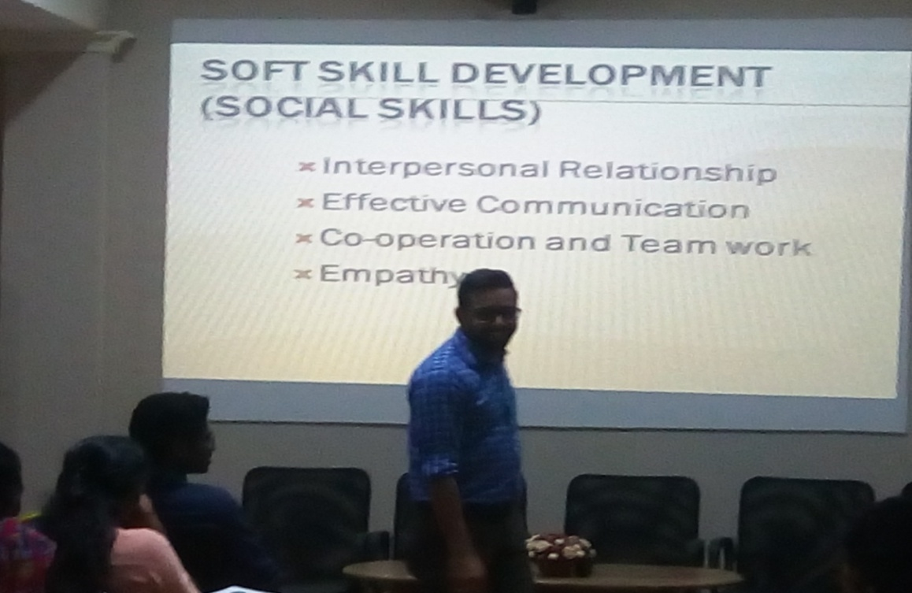
K H JAREESH

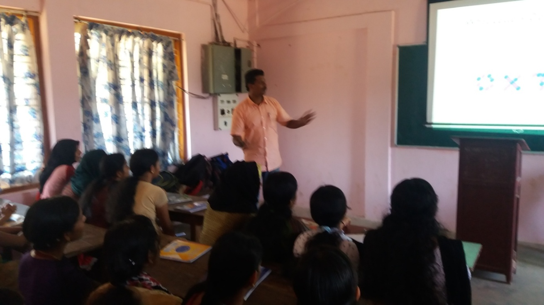

Mr. Z A SHAMEEM

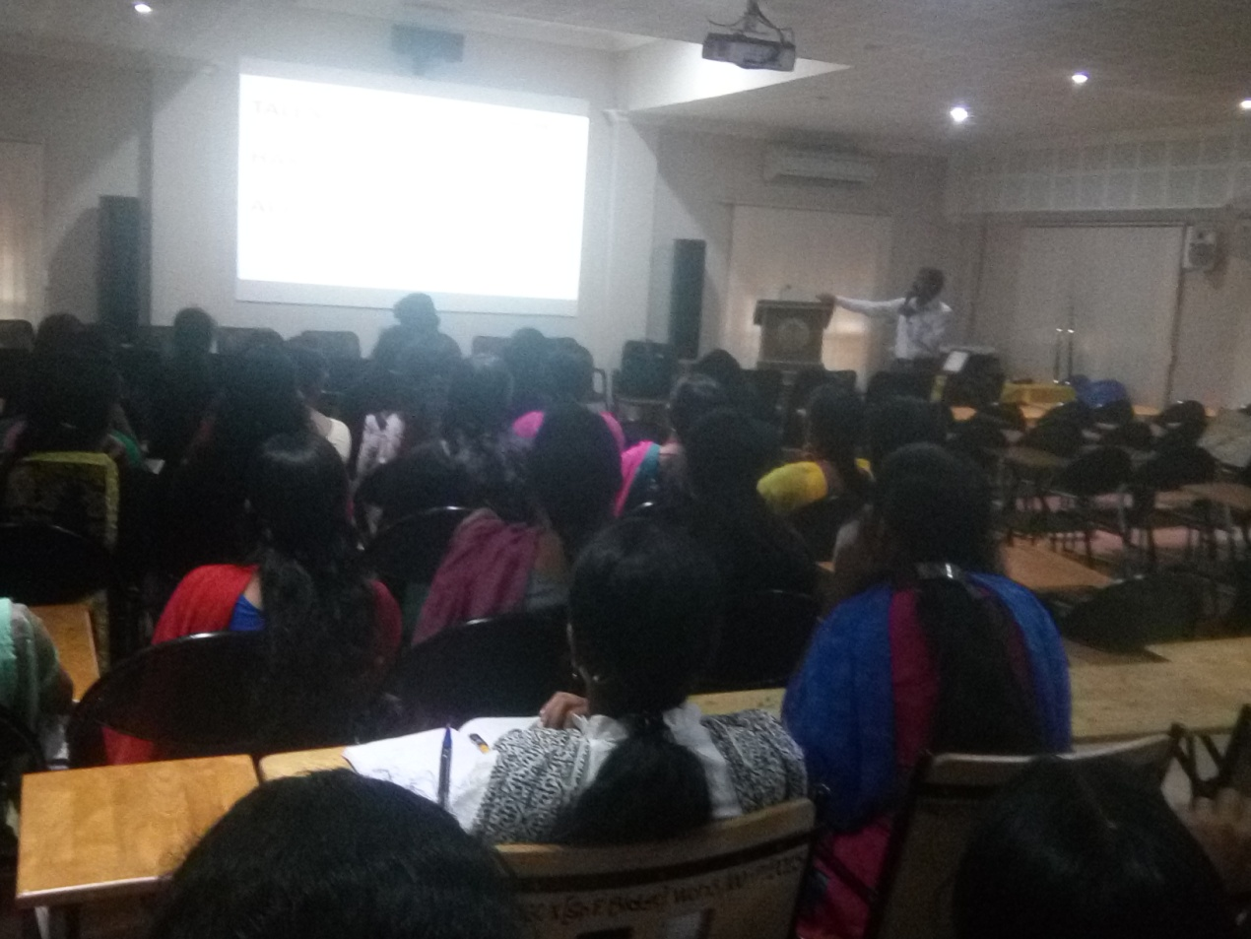

V R RAJESH

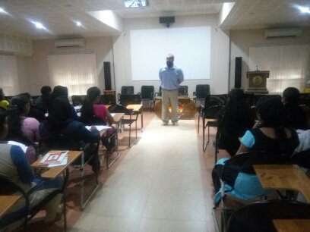
Vishnu Lona Jacob.

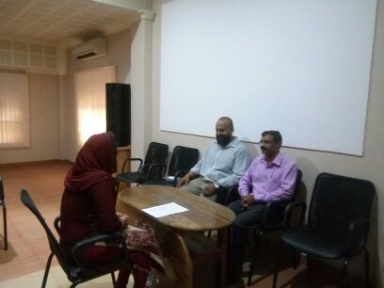
VISHNU LONA JACOB&RAJESH V R in an interview session.

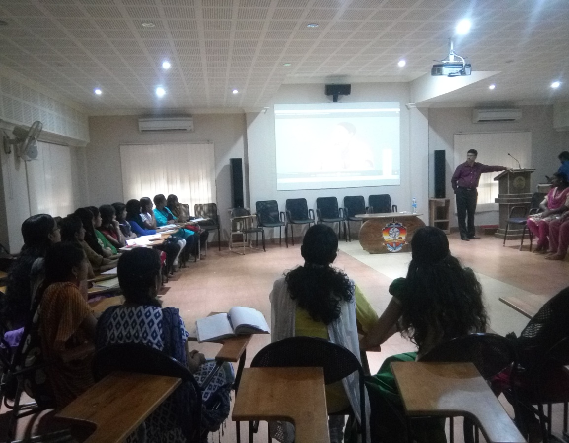

Prof.Varghesevaidyan

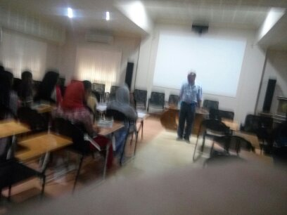

Prof. GEORGIE K E

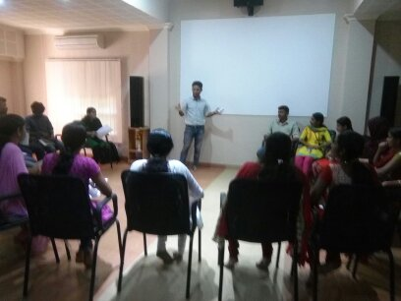

Mohammed Iqbal

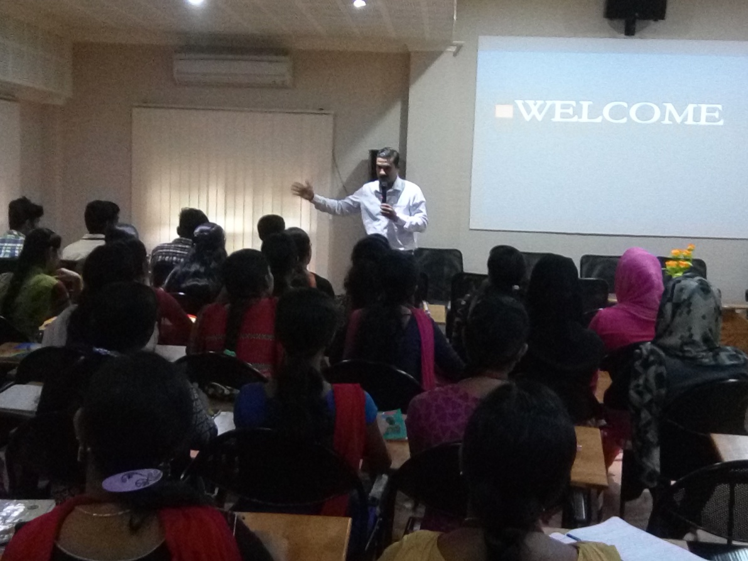
SANJU T KURIAN
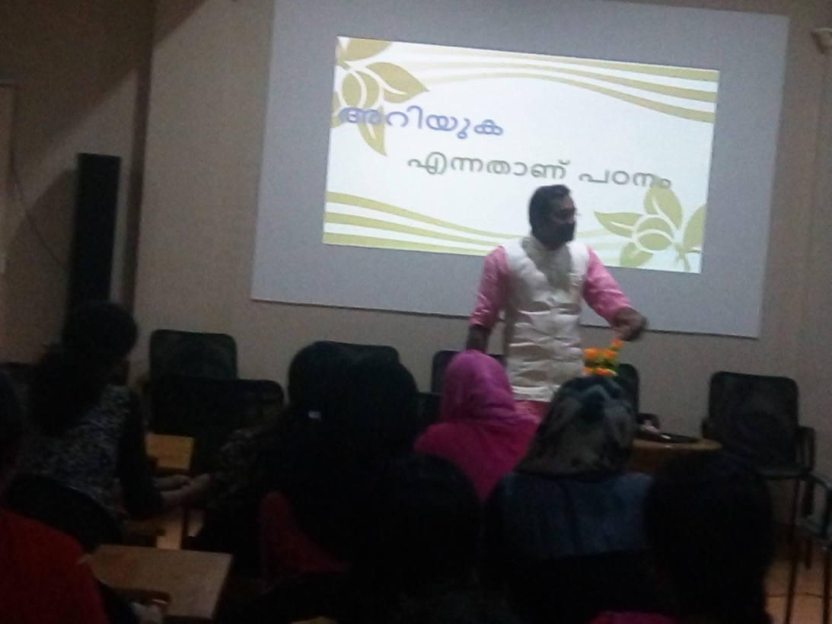
AJI GEORG
INTERNAL MENTORS PHOTOS
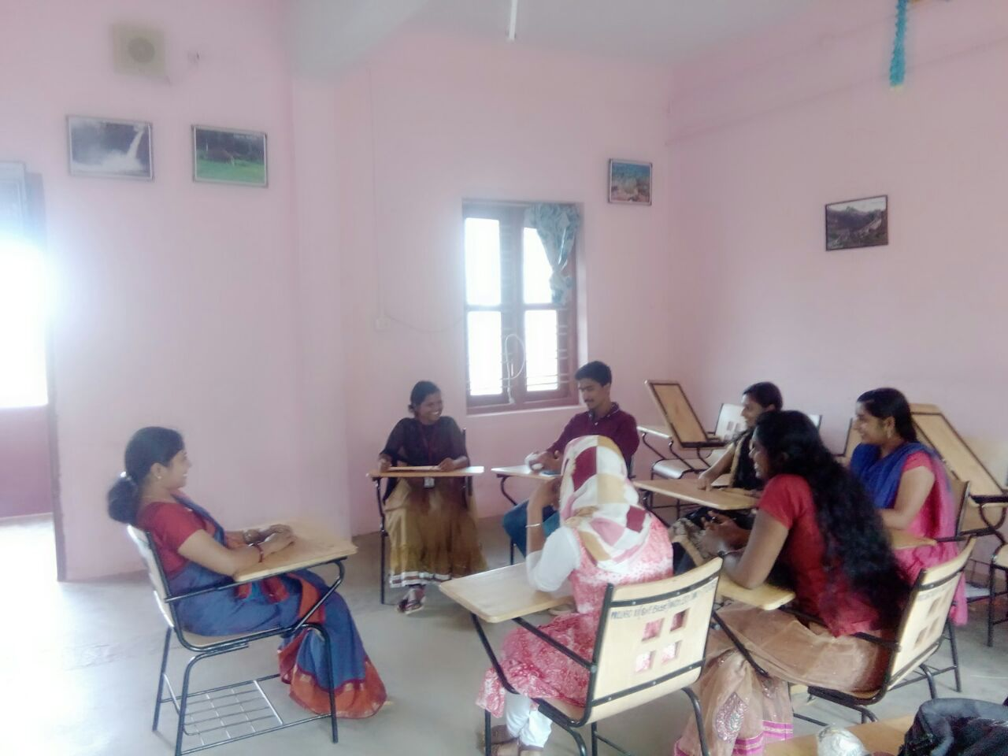
SMITHA CHACKO
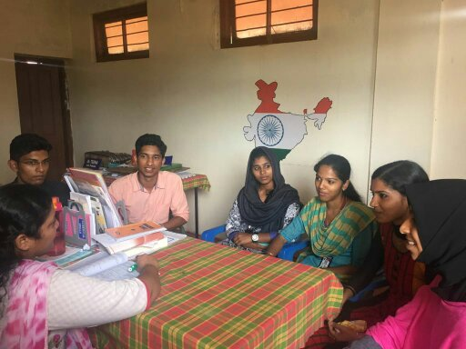
Dr. TEENA
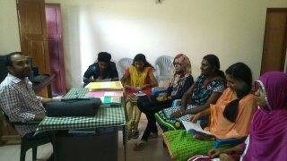
AMAL MARCUS

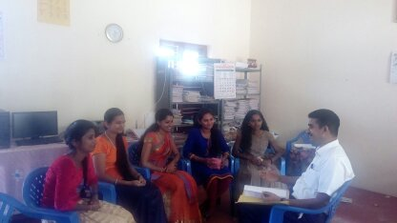
Dr. JOSHY MATHEW
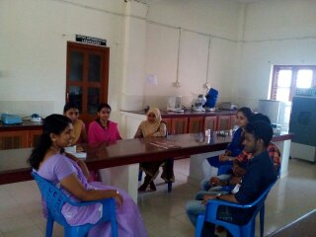
NEETHU GEORGE
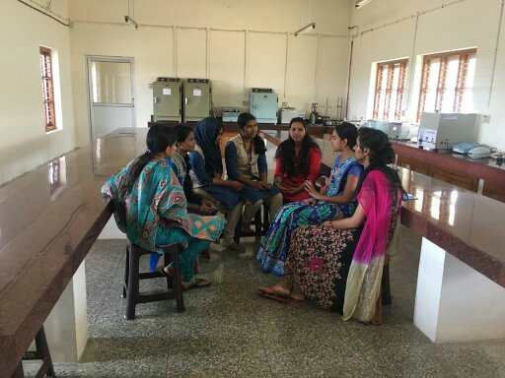
LINTU JOSE
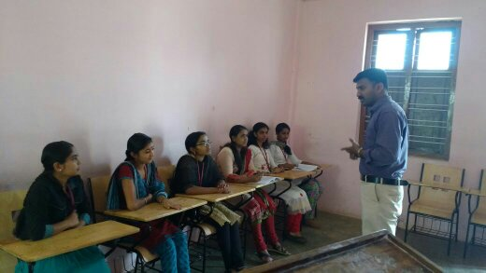
SUSMIN JAMES
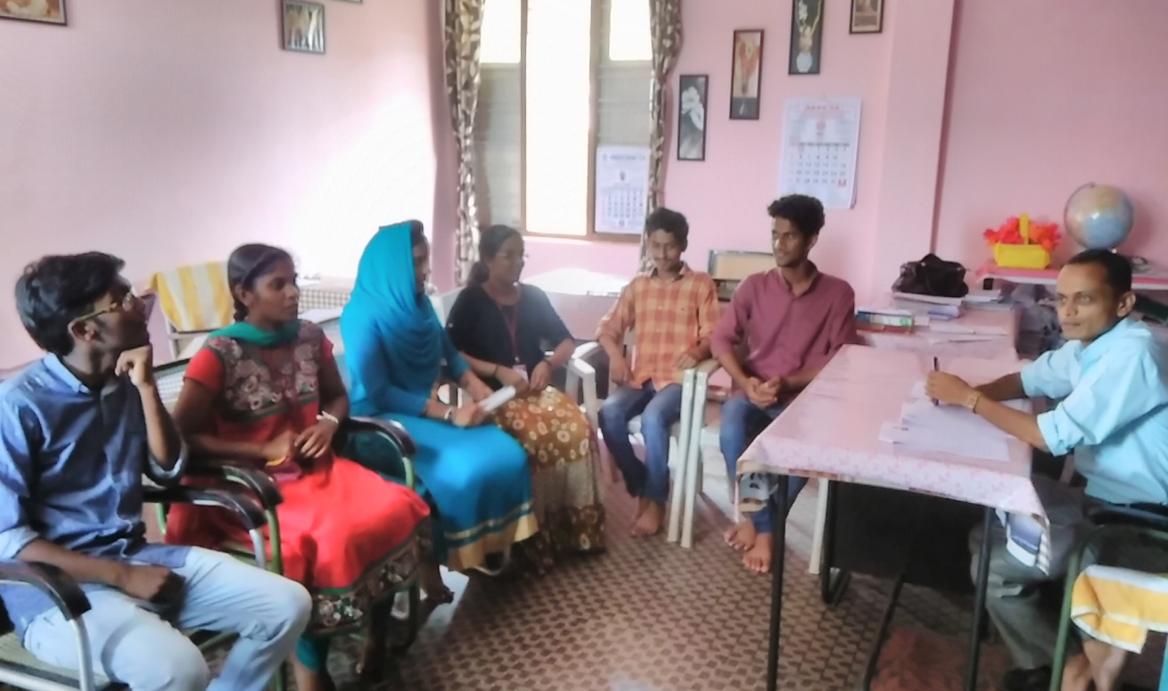
SHAIJUMON P V

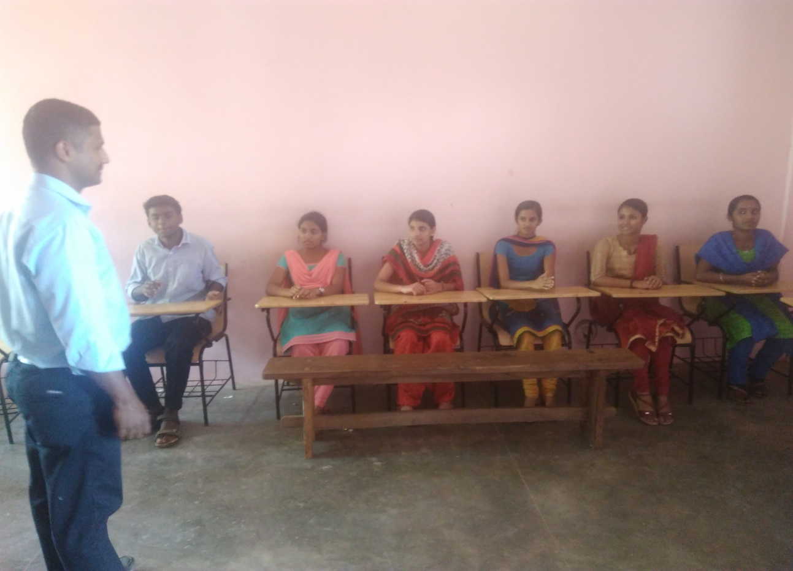
NITHEESH K T
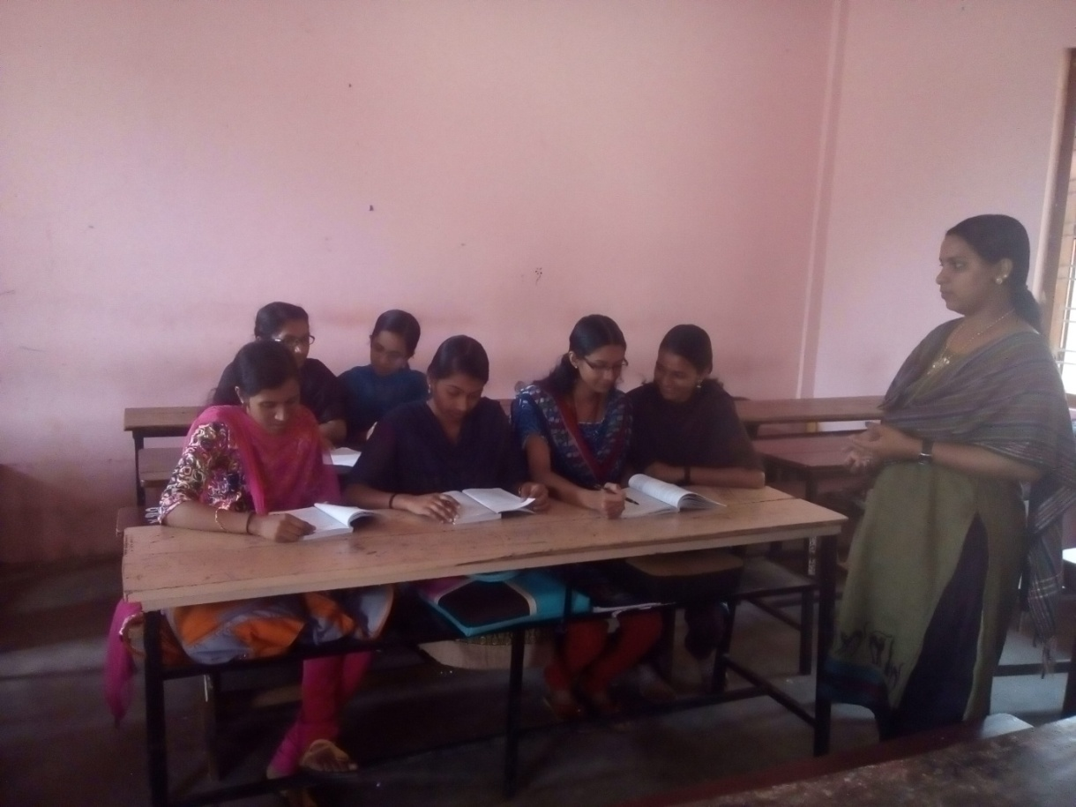
VIMYA K P
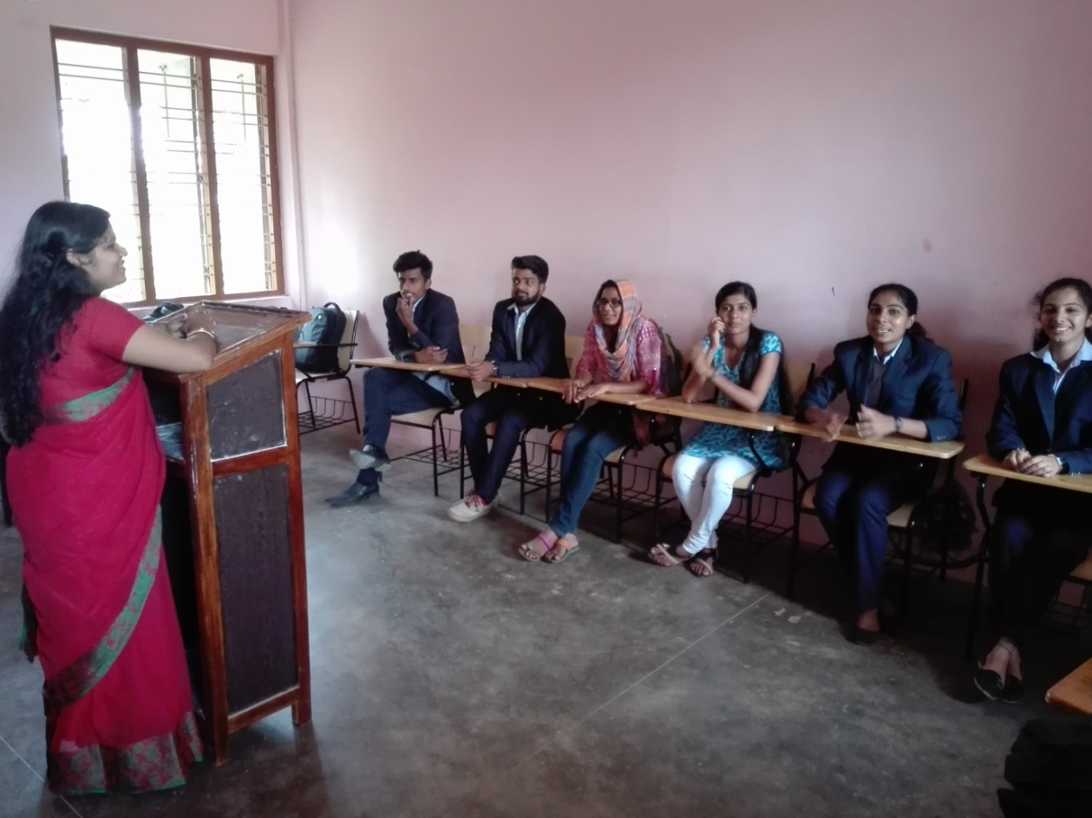
NIRANJANA C
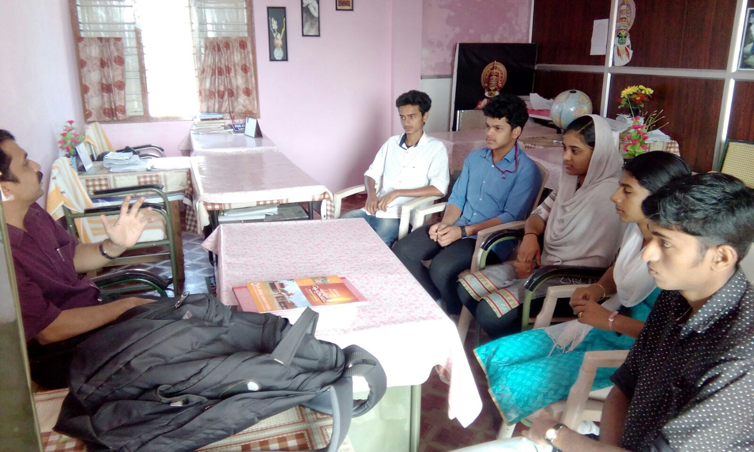
SANOOPKUMAR P V
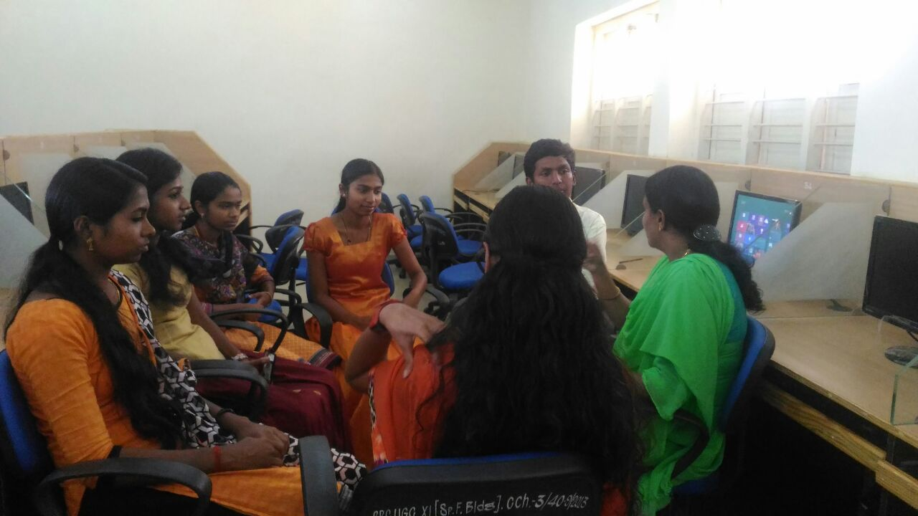
NEETHA FRANCIS
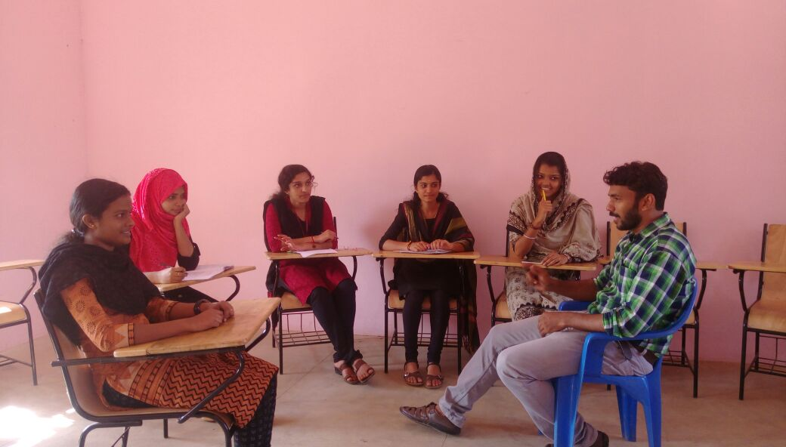
ABDULBARI K K
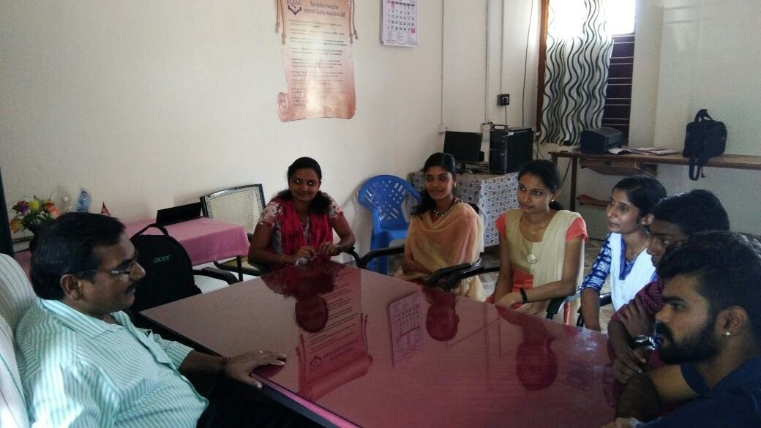
SALEEL M M

Photos of Motivational Visit

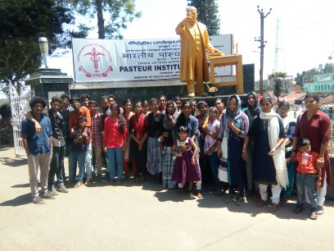

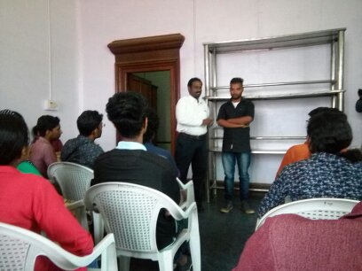
Interacion of the students with the faculty of Pasteur institute.

