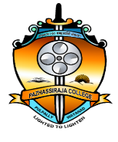
DEPARTMENT OF TRAVEL AND TOURISM MANAGEMENT
Pazhassiraja College, Pulpally, Wayanad, Kerala 673579
Follow the link for your syllabus, Study Materials and Question Bank.
1 | Syllabus | https://drive.google.com/drive/folders/1I9d5kz2Jy9gOWEa1xc0s7KtO-xi45XeW
2 | Study Material | https://drive.google.com/drive/folders/1lcTgg1J7VwDyANQT8m8i2mVxcQ_lwUvc
3 | Question Bank-MTTM | https://drive.google.com/drive/folders/1lvb7XOmVyZ_NeEy9mDWS7QFdoxsl_ZrU?usp=sharing
 | Question Bank-BTTM | https://drive.google.com/drive/folders/1ZGO22Gls1xjqIPVZ4KoOoOXhLuzs_ti9

