PAZHASSI RAJA COLLEGE, PULPALLY
ENTREPRENEURSHIP DEVELOPMENT CLUB

Three days’ Workshop cum Exhibition on
“Biofertilizer production and its application on farm land”
5th January 2020

Three days’ workshop and exhibition was conducted in association with B.Voc Agriculture at PG research Microbiology laboratory, Pazhassisraja College, Pulpally. The workshop was intended to give the participants hands-on experience in the production of Biofertilizers in order to equip the participant students to take up this as an enterprise. The three-day workshop was designed in a way where participants were given theoretical knowledge in the first session and hands-on experience and practise were given in the second session and the third session place one exhibition stall in our college itself to raise the knowledge and importance of Bio-fertilizer for the public.
The teachers in the Microbiology and Biochemistry departments are also actively participating in a more practically oriented manner where the participants were given hands-on experience in isolation, identification, cultivation and fermentation of industrially important strains of Nitrogen fixers. The students and farmers in Pulpally Panchayath visited our exhibition stall and interacted with our students regarding the knowledge while using bio fertilizers in farmed lands. This would boost their confidence to take up this as an idea of enterprise.
The three-day workshop was formally inaugurated by the Principal Dr. K. Anilkumar at Chithrashala, Pazhassiraja College. Mr. Abdul Bari K. K (Head – Department of Microbiology & Nodal Officer – B. Voc Programmes) welcomed the gathering. Mr. Dillep, Vice president, Block Panchayath, Panamaram, Wayanad District gives presidential address and he also addressed the role and importance of Bio fertilizers in the current scenario. Dr. Dileep M R (IQAC Coordinator), Fr. Varghese Kollamavudy (CEO Pazhassiraja College), Fr. George Alummoottil (Bursar, Pazhassiraja College) gave felicitations for the function. Dr. Dinesh M D (Coordinator, ED Club) gave the vote of thanks for the function.

Inauguration of three days’ Workshop cum Exhibition on
“Biofertilizer production and its application on farm land”
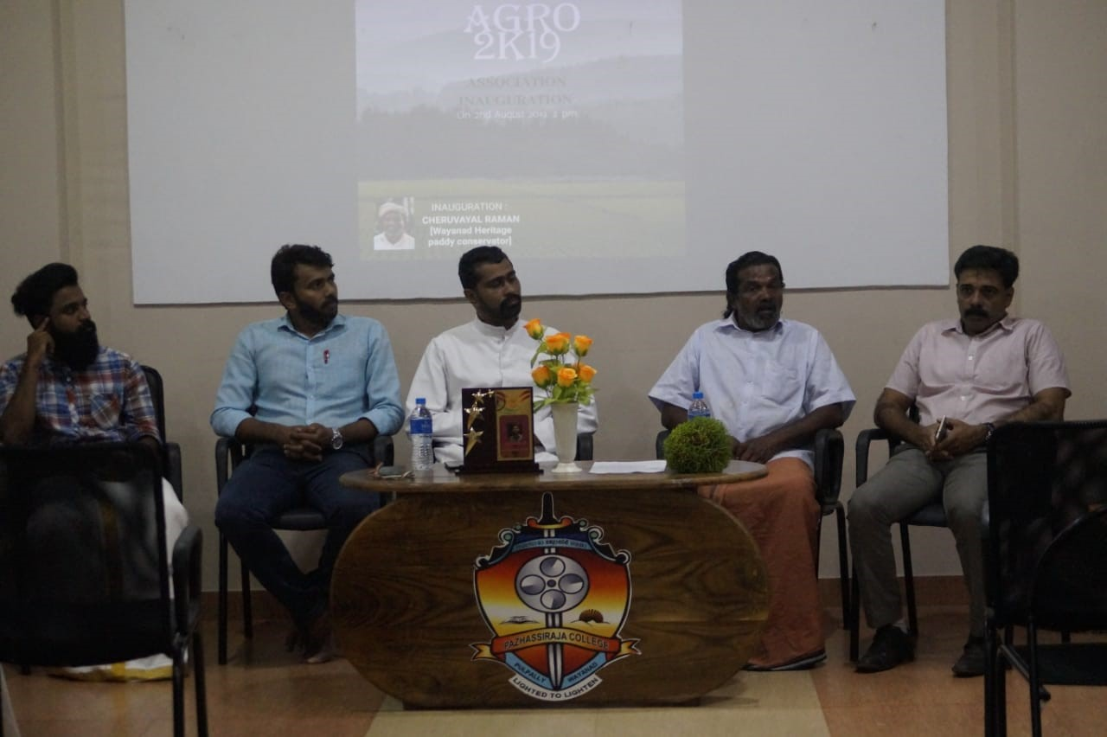

Teachers delivering the theoretical and practical session of formulating bio fertilizers

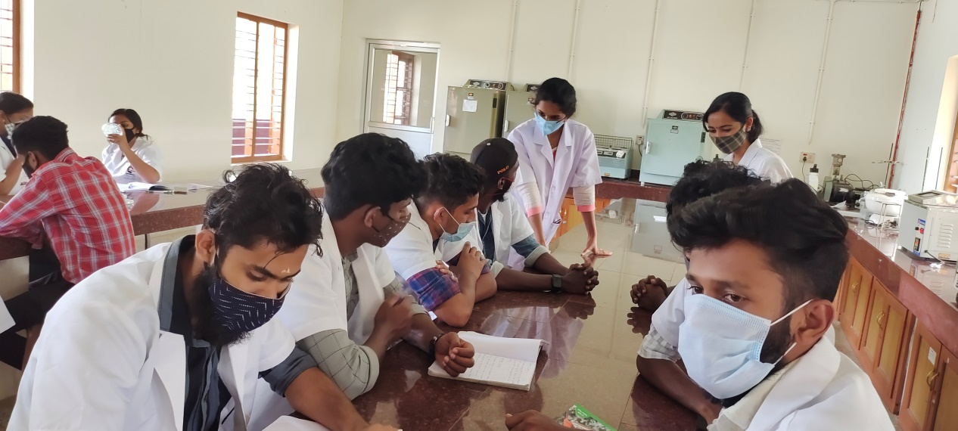

Teachers delivering the theoretical and practical session of formulating bio fertilizers
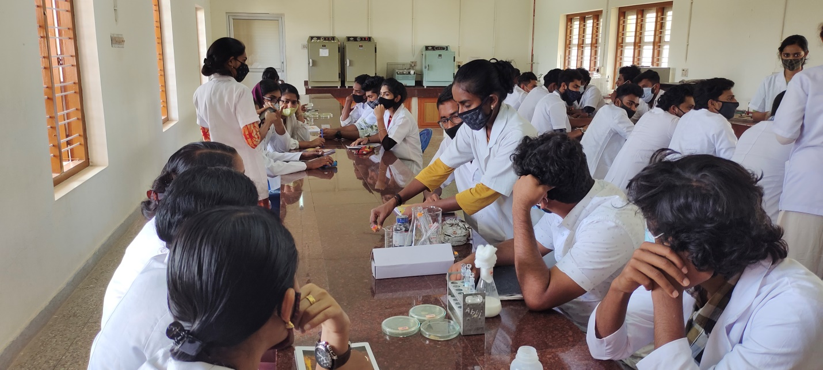

Students interact with various participants from other institutions

