Department of History
National Webinar on
Ethnic Painting in India with Special Reference to Kurumba Community of the Nilgiris
10 October 2020
The Department of History has organised a National Webinar on the topic Ethnic Painting in India with Special Refernce to Kurumba Community of the Nilgiris. The Resource Person of Seminar is Dr. Manjula Poyil, Head of the Department of History, Kannur University.
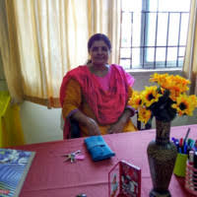

Her Talk was on the ethic paintings of one of the primitive tribal groups in the Western Gahts known Kurumbas. Their paintings are related to the themes of agrarian and pastoral society in this region. War scenes, honey collection, festivals, harvest, animal hunting etc, are the main depictions of the painting. The pastes of fruits, vegetables, special pigments and minerals are used for making paints. These painting are a very important source for the study of the social history of south India.

