REPORT OF FINANCIAL LITERACY PROGRAM AMONG STUDENTS
FINANCIAL LITERACY PROGRAM AMONG STUDENTS
GLP SCHOOL PAKKAM- PULPALLY

Title: FINANCIAL LITERACY PROGRAM AMONG STUDENTS
GLP SCHOOL PAKKAM- PULPALLY WAYANAD

Date :14/02/2020
Program Coordinator: JINCY P V

Participant’s Profile: A total of 14 students

Department of Commerce of Pazhassiraja College Pulpally, conducted one day FINANCIAL LITERACY PROGRAM AMONG STUDENTS GLP SCHOOL PAKKAM- PULPALLY WAYANAD
Financial literacy is considered as an important factor that promotes financial inclusion. Due to the importance of financial literacy Reserve Bank of India and Central Government are undertaking many projects and programmes to make the people financially literate. Even then many of the individuals are unfamiliar with even the most basic economic concepts needed to make sensible saving and investment decisions. This has serious implications for saving, retirement planning and other financial decisions.
OBJECTIVES
- To make students aware about the basics of financial concepts,.
- To understand the root level of finance
- To develop a community who are aware about the financial concepts

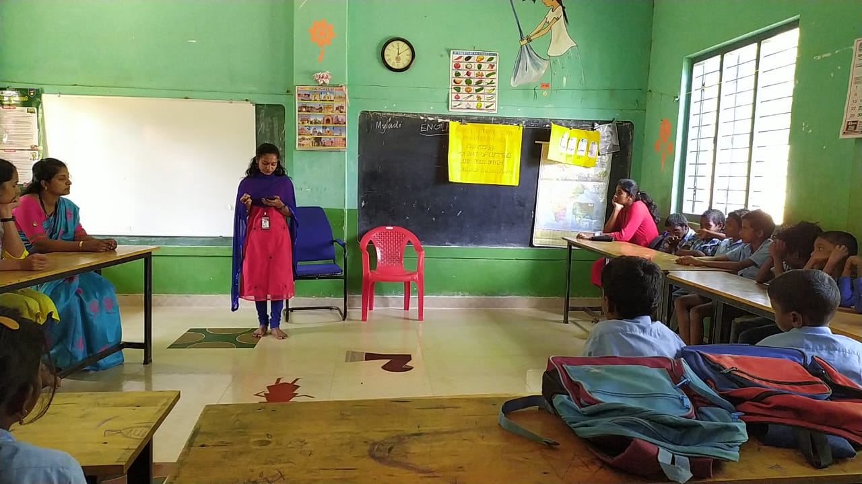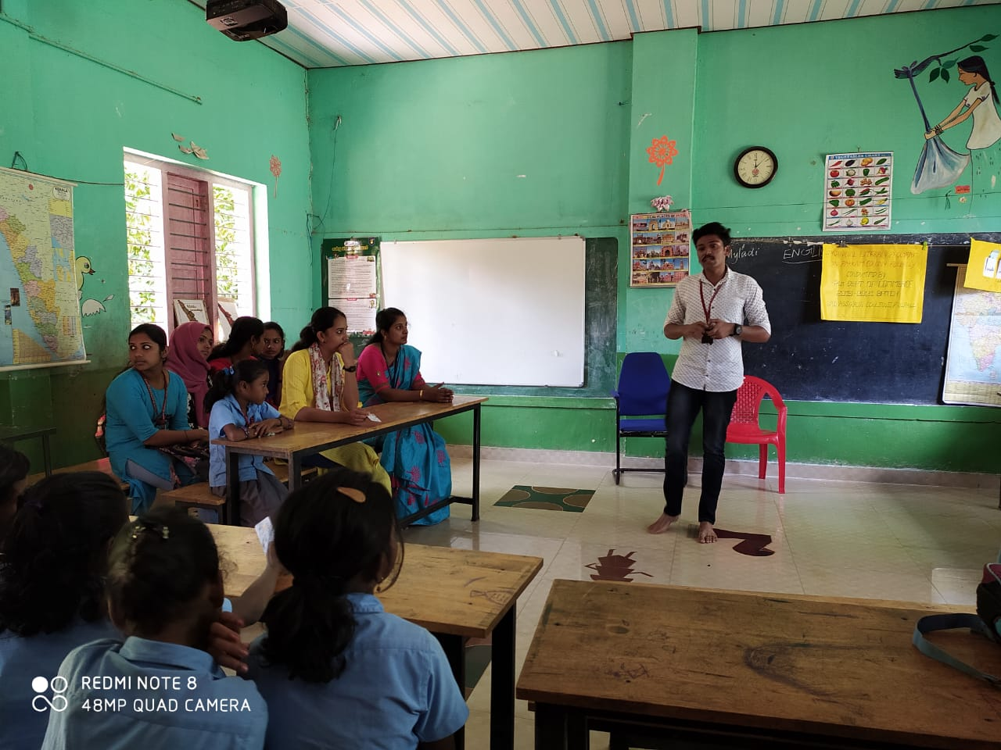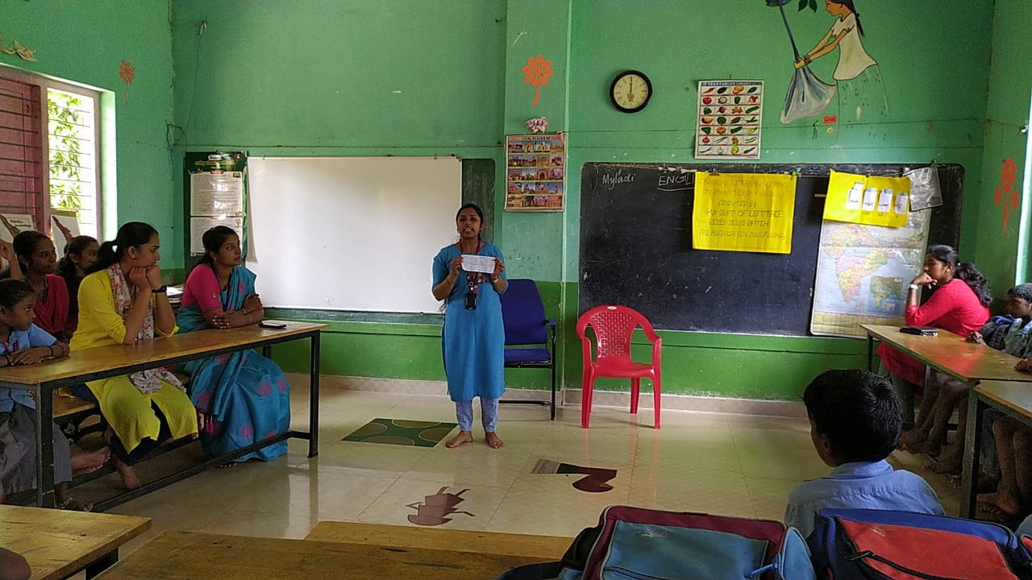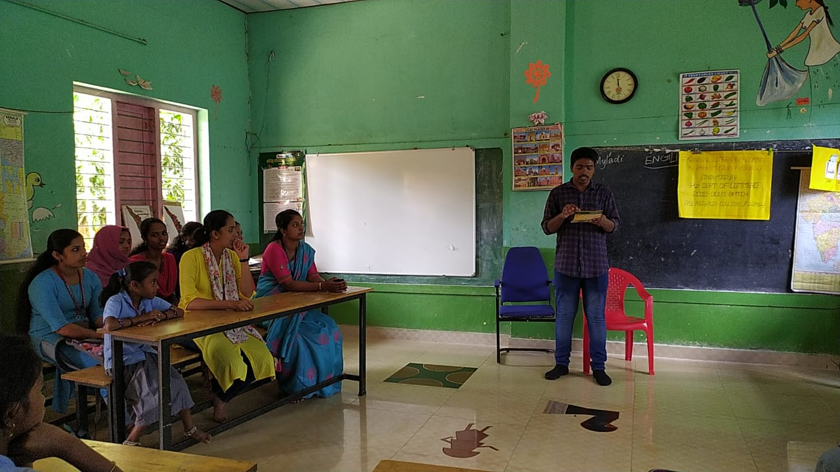

Name Of Participants
