ICT/Computing Skills
ICT/Computing Skills
Orientation Programmes on ICT/Computing Skills
Two day workshop was organised for selected students from UG Departments on ‘ICT in Education’ in order to create awareness on the importance of ICT tools. The programme was conducted on 15-10-2016 and 22-10-2016 and aimed to make the students aware about the use of ICT in Education. Hands on training were also given to students in the computer lab. 31 students attended the workshop.
Sl.No. | Name | Signature
1 | AMRUTHA DAS
2 | ANCY T MANOJ
3 | ANJANA JOHNSON
4 | ANOOP K
5 | ARYA A V
6 | DELNA SHAJI
7 | FATHIMA HIBA K
8 | GREESHMA M G
9 | JASNA RUBY K
10 | MUHAMMED THASLEEM
11 | ASWATHY P P
12 | AMRUTHA MOHANDAS
13 | ELDHO M REJI
14 | FATHIMA NOURIN
15 | RAYONA N J
16 | ABHIJITH K V
17 | SOORYA M
18 | ANASWARA P R
19 | ANSHIK P
20 | ARUN M V
21 | ATHIRA K S
22 | BIBIN BABU
23 | GEORGE KURIAN
24 | JIJIL A V
25 | JITHIN K SAJI
26 | JITHU TITUS
27 | LEEMA SAJIL
28 | MANJUSHA
29 | MELBIN
30 | MIDHUN
31 | NIKHIL T G

Attached Photographs
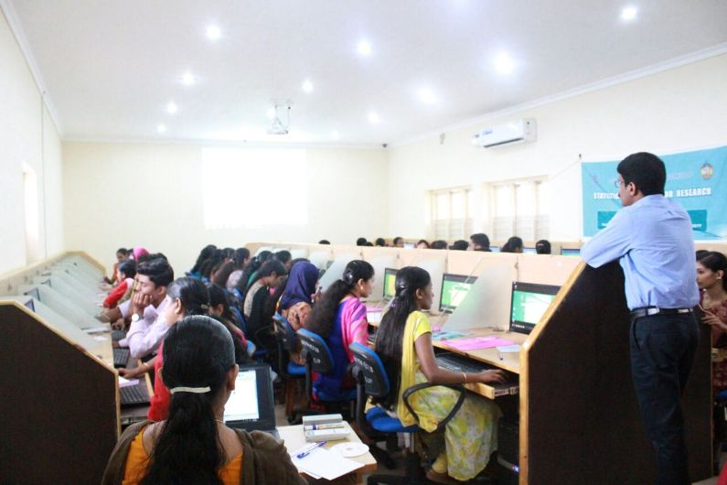

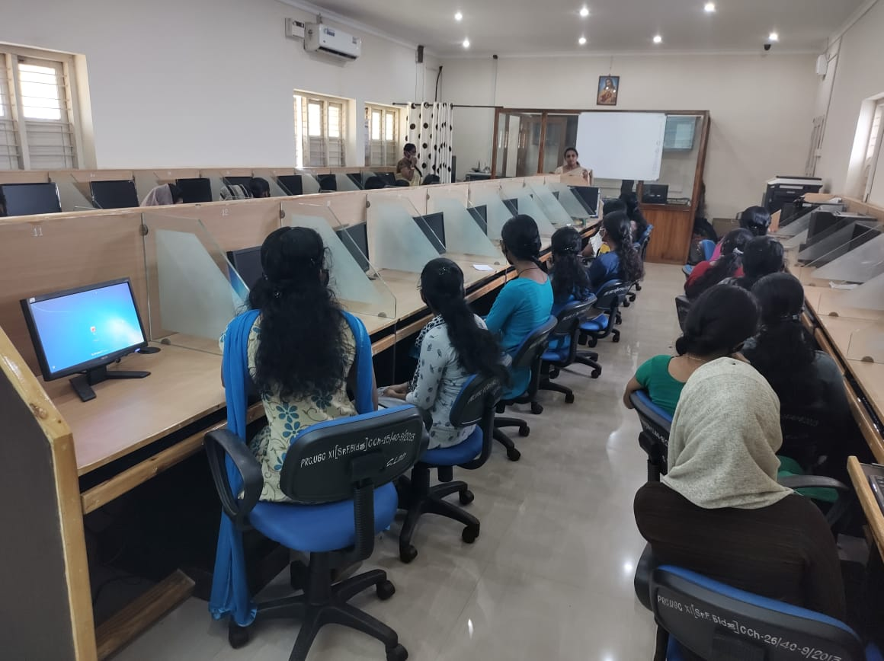
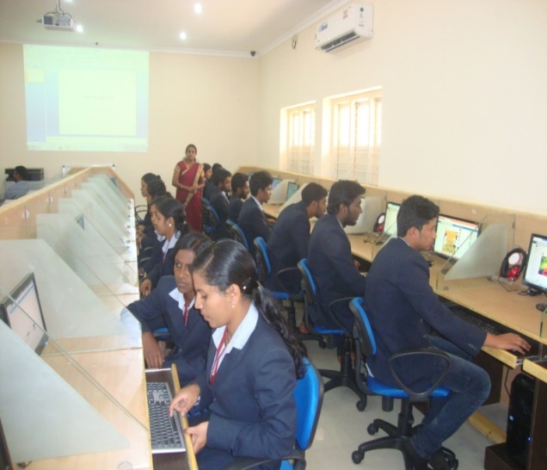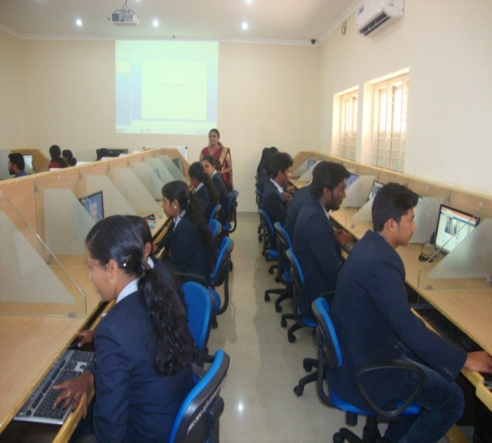

Neetha Francis
Dept. of Computer Applications

