REPORT ON THE ONE DAY WORKSHOP ON FINANCIAL EDUCATION
ORGANAISED BY
DEPARTMENT OF COMMERCE IN ASSOCIATION WITH SEBI
As part of creating financial education awareness among the college students, a one day workshop on financial education was conducted on Pazhassiraja college on July 17th 2017 organized by Department of Commerce, Pazhassiraja College in association with SEBI.
The sessions were handled by Manu M Senior Associate and it really benefited the students in terms of creating awareness about the financial instruments and about the investment ideas.
The programme has been simplified enough for graduates as well as non-finance students to understand and benefit from. The official programme started with a prayer and Principal Dr.A.O.Roy, HoD Mr. Susmin James, Convenor Mrs. Vimya K P conveyed their wishes for the programme. Session was started at 10.30 AM by Mr.Manu.M. Students were really benefited from the programme and they got a basic education about all financial matters.
.

18/07/2017
Pulpally

PARTICIPANTS LIST

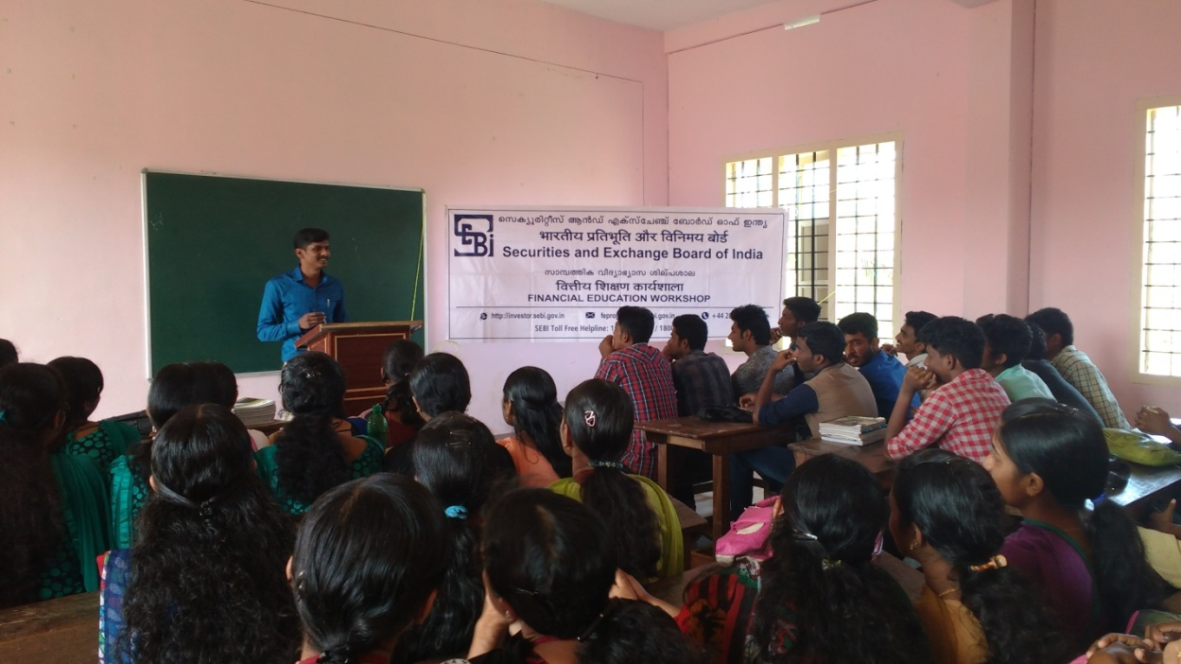

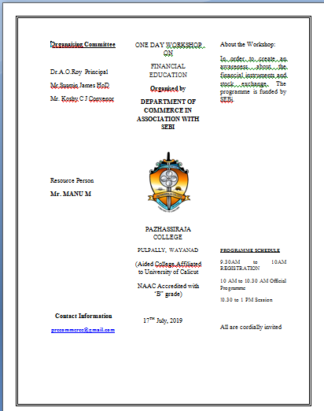
NOTICE
