ICT/Computing Skills
Orientation Programmes on ICT/Computing Skills
Hands on session on ‘Basics of Internet’ were conducted on 19-10-2019 and 26-10-2019 in the computer lab as part of the skill enhancement programme. Students from various departments were given training on creation of email ids, usage of open resources, searching for information, job portals. The programme made the students to explore different features and uses of Internet. 28 students became the part of the initiative.
No | Name | Signature
1 | ANASWARA SANTHOSH
2 | ANINA
3 | APARNA K. P.
4 | ASWATHY A. P.
5 | IRFANA SHERIN
6 | MARIA MATHEW
7 | MIRNA PARHANA
8 | ASWATHY A. A.
9 | EBINA VARGHESE
10 | GOPIKA K.
11 | HARISHMA P. C.
12 | HARISHMA P. H.
13 | M. RINSHY NAFEESA
14 | MUHSINA K. M.
15 | NAYANIKA V.
16 | ALPHY PAUL
17 | ANUSREE
18 | DRISHYA C
19 | NIDHU V P
20 | NOORBINA P B
21 | SANDRA SURENDRAN
22 | SOUMYA K S
23 | VYSHNAVI M
24 | ABHIJITH K M
25 | ASWANTH K
26 | ATHUL LAL K V
27 | FATHIMA NAJDIYA PP
28 | HIBA K
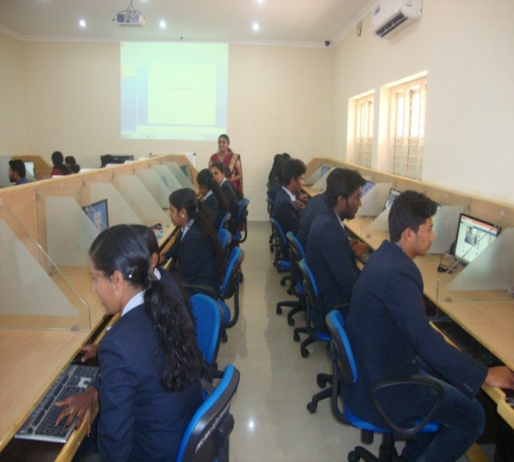

Neetha Francis
Dept. of Computer Applications

