Report on the one day national webinar organized by Department of Commerce,Pazhassiraja College in association with Securities Exchange Board of INDIA's (SEBI) on 2/08/2021

Department of Commerce, Pazhassiraja College in association with in association with Securities Exchange Board of INDIA's (SEBI), organized one day national webinar on 'Ways of Effective Wealth Creation' on 02 of August 2021 for the students.
Programme started by 10.30 AM in Zoom Platform with prayer followed by the Inaugural Address Vimya K P HoD Commerce. Mr. Koshy CJ Asst.Prof Pazhassiraja College addressed the students.

Webinar was highly successful and fruitful by the active participation over 50+ students. Students really got involved in to the seminar by the interesting presentation of the resource person Rahul Dhawan Equity Research Associate.
Resource person mainly focused on the following areas
- Impact of inflation
- Goal Based Investing
- Appropriate Asset Allocation
- Understanding of Mutual Funds
- Mutual Funds Structure & Scheme Categorization
- How to Invest in Mutual Funds with focus on SIPs
- SEBI Complaints & Redressal System
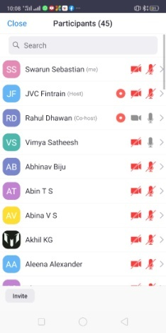

HoD Commerce/convenor Principal

