ICT/Computing Skills
Orientation Programmes on ICT/Computing Skills
An awareness programme and training on ‘Office Automation’ was conducted for the selected students of UG departments on 20-10-2018 and 27-10-2018. They understood the basics of Microsoft Word, Excel and Power point and also learned by practical sessions. The programme helped the students to learn the fundamentals of office automation. 29 students participated in the training programme.
No | Name | Signature
1 | ABIN SUNNY
2 | ADHITHYA RAJ
3 | AFSHAD P K
4 | AMAL UNNITHAN
5 | ANJALI DEVARAJ T K
6 | MUHAMMED ANAS V
7 | MUHAMMED ARSHAD M C
8 | NIDHIN C M
9 | RAHUL P K
10 | SWATHI S NAMBIAR
11 | VISHNU VISWANATHAN
12 | ADWAITHA K R
13 | AKHIL FRANCIS
14 | AKHIL RAMACHANDRAN
15 | DHANISHA V D
16 | MAYA T R
17 | MRIDULA C M
18 | NANDITHA T R
19 | NIRMAL SAJI
20 | RASHA BABU
21 | SIVAJA S D
22 | THULASI P T
23 | VISMAYA P T
24 | AKSHAYA DAS
25 | ATHUL T CHACKO
26 | AKHIL DAVID
27 | VYSHNAV S B
28 | SONA SAJI
29 | NAVANEED V P

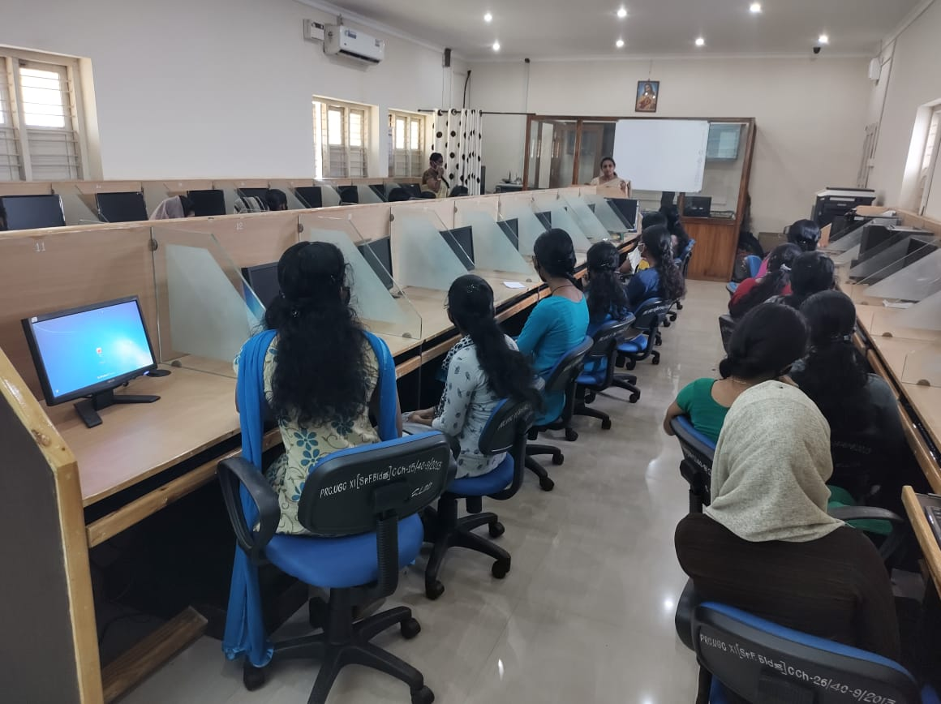
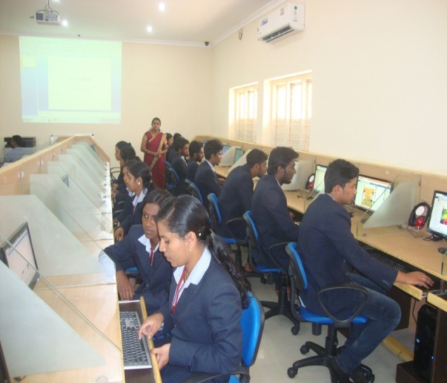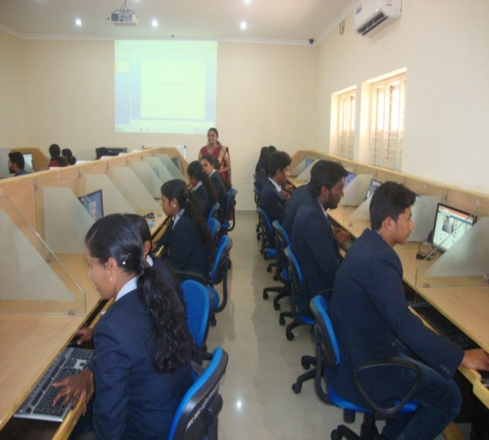

Neetha Francis
Dept. of Computer Applications

