ICT/Computing Skills
Orientation Programmes on ICT/Computing Skills
A skill enrichment programme was conducted on 21-10-2017 and 28-10-2017 in the computer lab on ‘Computing Skills’. Students from various departments were given training as Information Technology is inevitable in this digital world. Students understood the fundamental concepts of computing skills through hands on training. 26 students benefitted by the programme.
SL.NO. | NAME | SIGNATURE
1 | ADARSH NARAYANAN A. Y.
2 | AISWARYAMOL
3 | ANAGHA LAKSHMI
4 | ATHIRA P. N.
5 | JIPSA JIJI
6 | PARVEENA N.
7 | SHAHLA C.
8 | SOORYA C. S.
9 | SREETHA A. S.
10 | NANDHU NARAYANAN
11 | ANJITHA A. P.
12 | ASHNASABU
13 | BASIL P. S.
14 | DERIN GEORGE T. G.
15 | FATHIMANASREENA A.
16 | JASHEENA P.
17 | REETHU MATHEWS
18 | SNEHA K. S.
19 | ABIN KURIAKOSE
20 | ABIN SCARIYA
21 | BASIL N JOY
22 | E JOSHU AJOON
23 | NASILA A
24 | RONY VARGHESE
25 | SANJU T
26 | ABINA RAJ

Attached Photographs
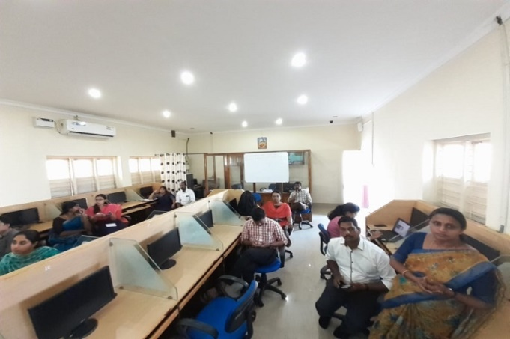

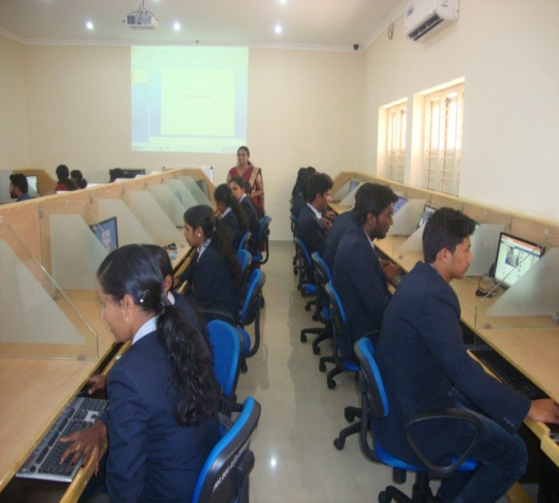

Neetha Francis
Dept. of Computer Applications

