Report-International Seminar
(Traditional Medicine and Wellness Tourism)

Held in

Pazhassiraja College , Pulpally , Wayanad
On 21 and 22 February 2017

Submitted to
Principal,
Pazhassiraja College, Pulpally

Introduction
India is the home of the oldest living medical system – Ayurveda; and the holistic yoga. Parallel to this, there exist other traditional healing systems ranging from the Siddha medicine to a number of regional and local healing traditions of various tribes and families. Ayurveda – the Knowledge of Life - is a naturalistic system of medicine that has evolved over 5000 years, without changing in its core principles, and viewing a person as a whole covering the physical, mental, social and spiritual aspects of life.
Travellers had been attracted to India from time immemorial for its spices and gems, which got faded in the last century following the industrial revolution and globalisation. The Malabar coast of Kerala was the saught after land for thousands of years. The spices and herbs produced from its high lands including Wayanad drew travellers from East and West to this land. Globalisation has opened other areas at the same time. India’s yoga has become almost cosmopolitan, which has surpassed globalisation to the extent of glocalization in many developed western countries. In the wings of the wellness revolution, yoga has become a billion dollar business. Ayurveda too has got considerable attraction in the west. Yoga is a common service in almost all spas and health resorts across the globe, while certain Ayurvedic body therapies too are also getting increasingly popular.
Objectives of the Seminar
The seminar attempted to obtain a picture of Ayurveda, yoga and traditional healing systems in the backdrop of tourism at micro and macro levels. The seminar also attempted to showcase the traditional healing systems of Wayanad, keeping in mind the rights of indigenous people and to propose a model for developing Wayanad as a wellness tourism destination.
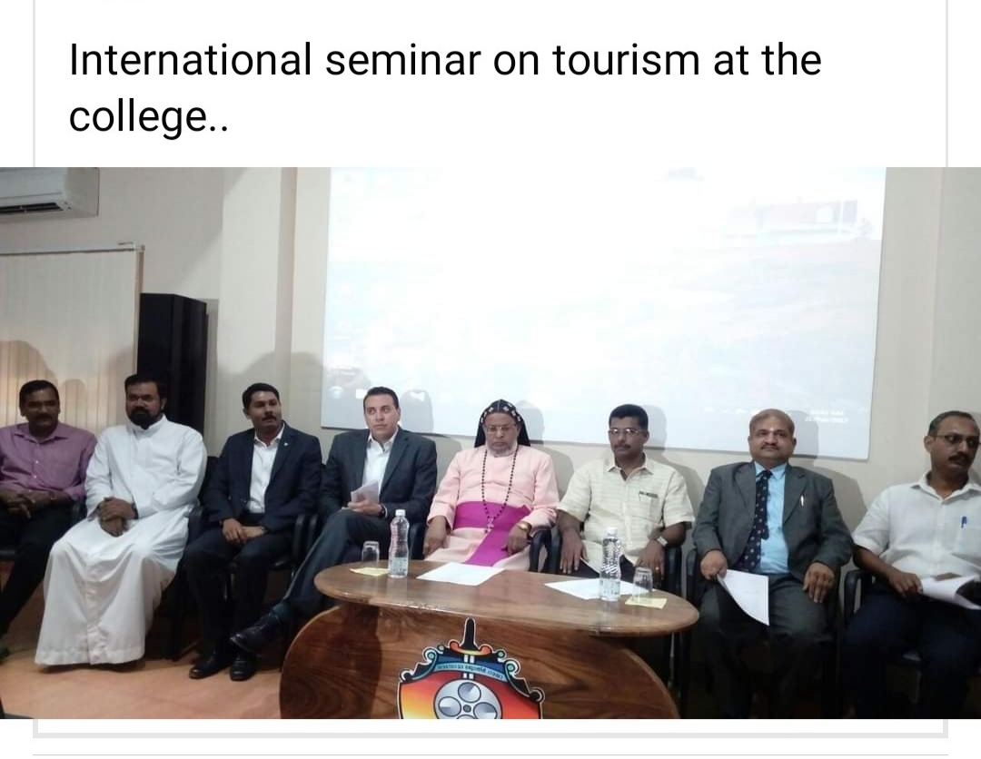
Session Highlights
1. Inauguration
2. Challenges faced/opportunities of Traditional healing – Ayurveda, Yoga, and other traditional systems – Indian and global scenario - Papers and panel discussion
3. Ayurveda and yoga health tourism: Kerala, India and World - Papers and panel discussion
4. Tribal healing of Wayanad - Papers and panel discussion
5. Honouring of the healers
6. Sharing of experiences/view-points by the tribal healers of wayanad
7. Prospects Wayanad as a health tourism destination – Papers and panel discussion
8. Valedictory session
We have conducted the seminar on 21 and 22 February 2017 at Pazhassiraja College in connection with World Tourism Day Celebrations. The seminar witnessed vibrant academic discussions and shared experiences of Indian and foreigners who have made their impressions in the field of ayurveda, yoga, and other traditional systems, and centres of health tourism. More than 50 research papers were presented during the International Seminar. More than 200 Teachers, delegates, experts (both national and international) were participated in the seminar.

Mr. Sanoop Kumar PV
Asst Professor of Tourism & Teacher Coordinator of International Seminar
Pazhassiraja College, Pulpally.

