REPORT OF WORKSHOP CONDUCTED ON 22/07/2019

Topic _ Capital Market Awareness
By
Resource person
Mr.Venogopal Rayirath
Senior Associate of Lotus Know Wealth (LKW).

Department of Commerce of Pazhassiraja College Pulpally, conducted webinar on 22nd of July 2019 on the topic “Capital Market Awareness " The resource speaker was Mr Venugopal Rayirath, a Senior Associate of Lotus Know Wealth (LKW). He educated the students about Capital market, key initiatives of BSE, dos and don’ts of key investors, importance of annual report, e-trading and Mutual funds. This session was interesting and informative to the students as they were made aware about BSE and how trading of shares takes place in the Stock exchange.

The speaker started off with an overview on the Securities Market and went on to describe the existence of BSE, since its inception in 1875. He threw light on the various regulators of the market like SEBI, RBI, DEA and DCA. Further, he elaborated on the various offerings of BSE, which makes it a market open to the common men. The concept of Mutual Fund was also a topic of discussion, for the session.
The speaker also made the audience aware of various redressal forums, guarantee funds like Trade Guarantee Funds, Investor Protection Fund and investor rights, and other that’s in favor of the investors. The market dynamics and the ‘T+2 settlement’ system in stock exchanges were also explained in simple terms for the benefit of the students.
The speaker concluded the session with sharing some valuable insights on Financial Planning with the students. He discussed the various motives and justifications for why it is necessary to have a strong foothold on one’s financial and investment decisions. The session left the students pondering on strategic and prudent financial goal setting.
Description
Vimya K P, Assistant professor (Head of the Department,) welcomed the audience, College principal Dr. Anil Kumar inaugurated the program,the program moderated by Anterressa 2nd year BBA
The participants of the programme were from department and also from outside. The staff coordinator of the program was Ms. Vimya K P, Program secretaries were Mr. Koshy K J, and Mr. Swarun Sebastian, program felicitators were bursar, and CEO of the College and the program thanked by Mr. Swarun Sebastian

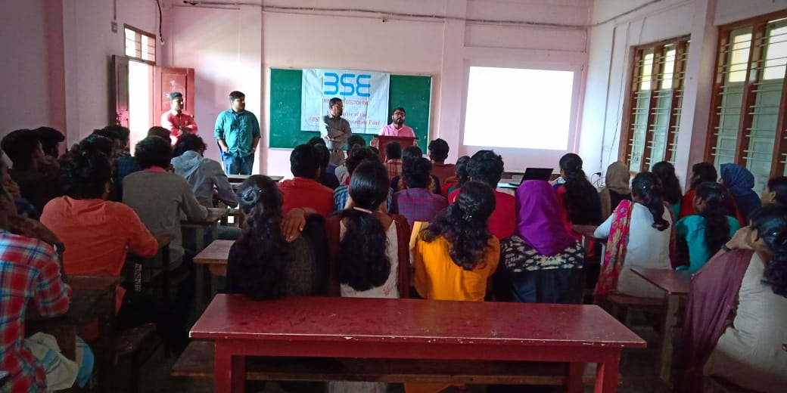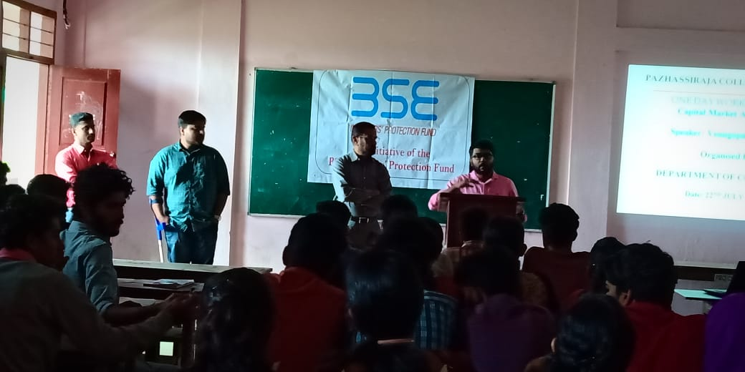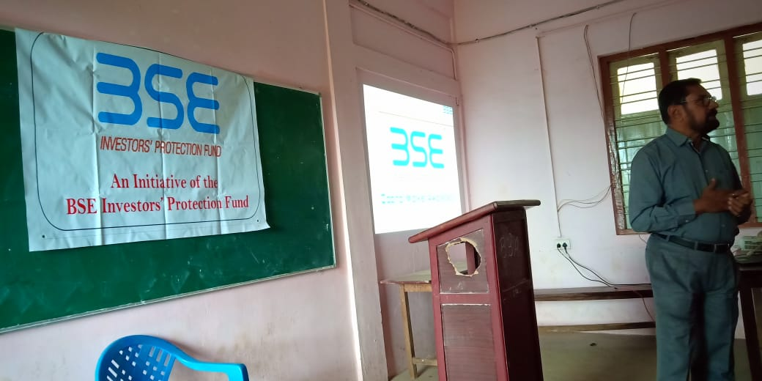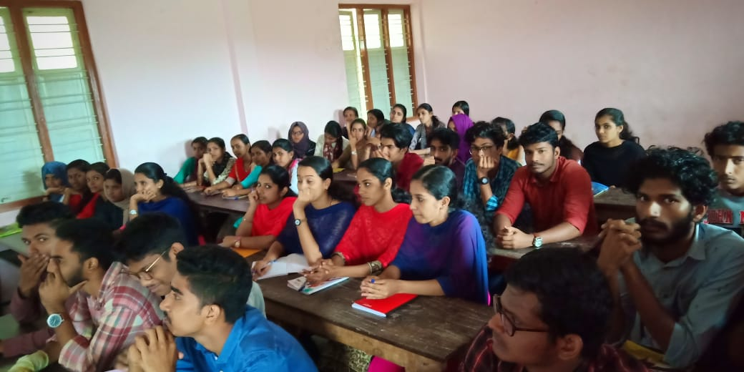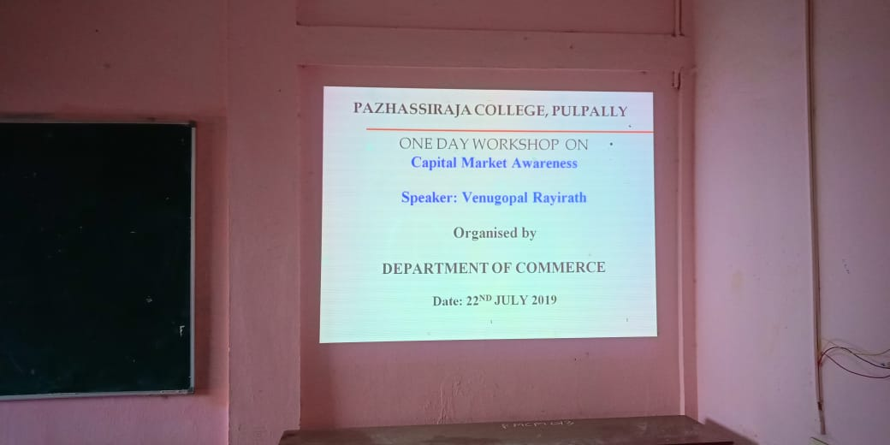
NAME OF THE PARTICIPANTS
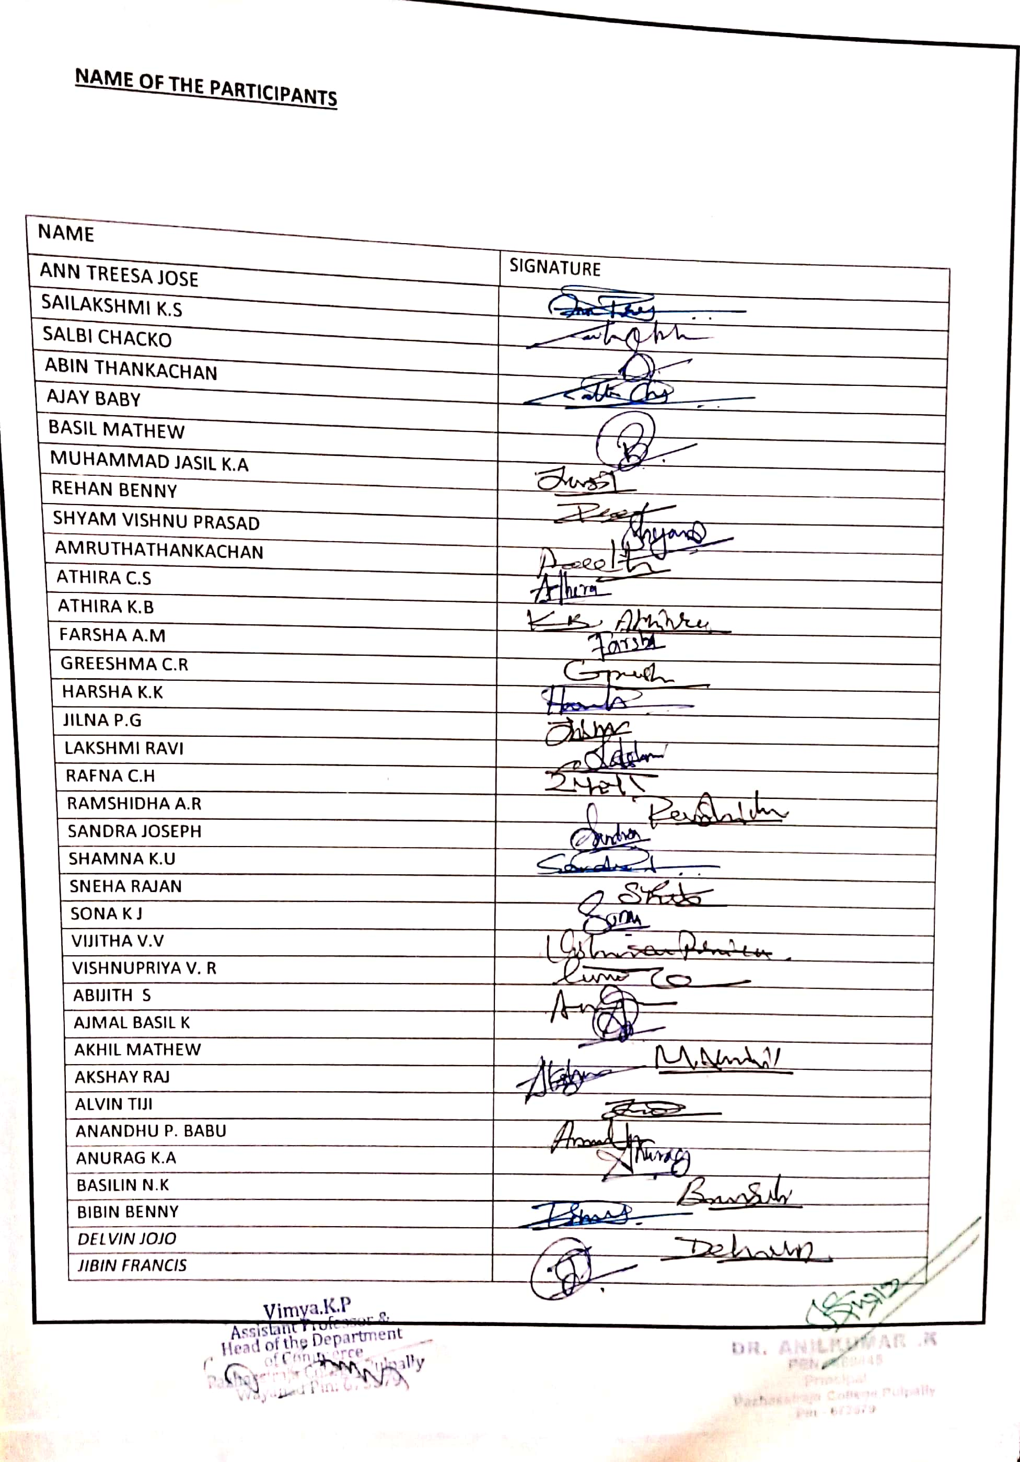

NOTICE

