Report on the national Webinar Organized by Department of Commerce, Pazhassiraja College, Pulpally
Department of Commerce Pazhassiraja College organized one day webinar "Career as a company secretary for students" with association of The institute of company secretaries of India on 23rd July 2020. The ICSI Calicut chapter introduced a Giga Online Career Awareness Programme and Pazhassiraja College, Department of Commerce conducted the programme with the topic Career as a company secretary for students. The webinar was well planned and executed. Many dignitaries including Dr. KC Sunny VC of National University of Advanced Legal Studies participated in the webinar. Programme was anchored by Final year BBA student Anntresa and programme was inaugurated by VC. Blessing message was given by Rev.Fr. Dr. Joseph Mar Thomas, Manager of Pazhassiraja College, Pulpally. Dr. AnilKumar.K Principal of Pazhassiraja college along with Vimya K P HOD Commerce Pazhassiraja College was the programme oraganaizer and coordinator.
Speaker of the programme Sri.Ashique AM, FCS really impressed the students by his thoughtful messages and students got real insight about the career as a company secretary. Speaker explained different opportunities and challenges in the field of CS. He also shared the information regarding the
The different papers and groups in CS. The importance of coaching for the CS course is explained and he suggested some of the major coaching centres in Kerala giving extraordinary coaching in CS.
Speaker tried to conclude by motivating students by sharing his own personal experience as a company secretary. The way he interacted with the students was nice and students really got inspired by his valuable words. The programme ended at 4 PM with the vote of thanks of Mrs Vimya KP

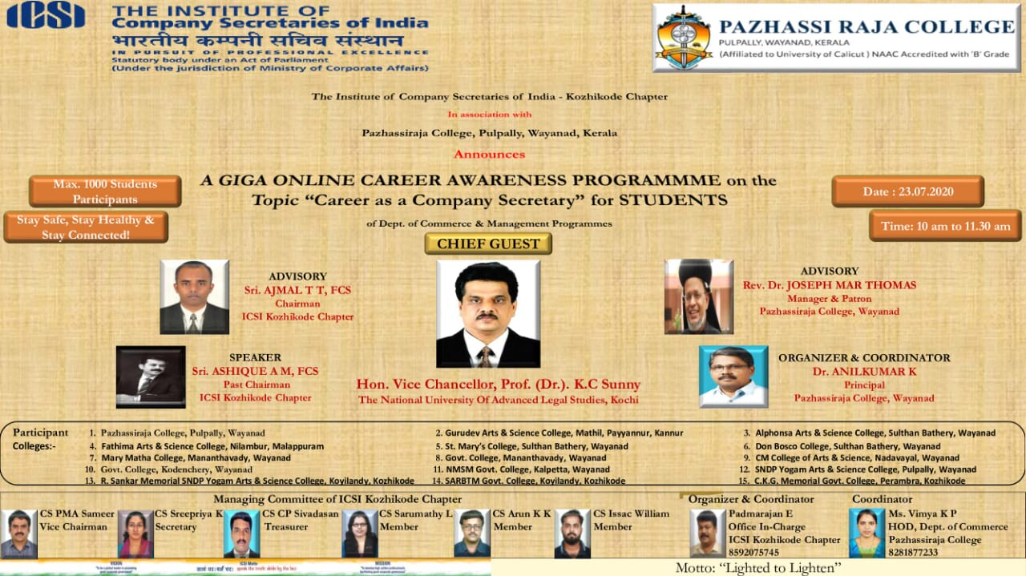

List of the students participated the programme

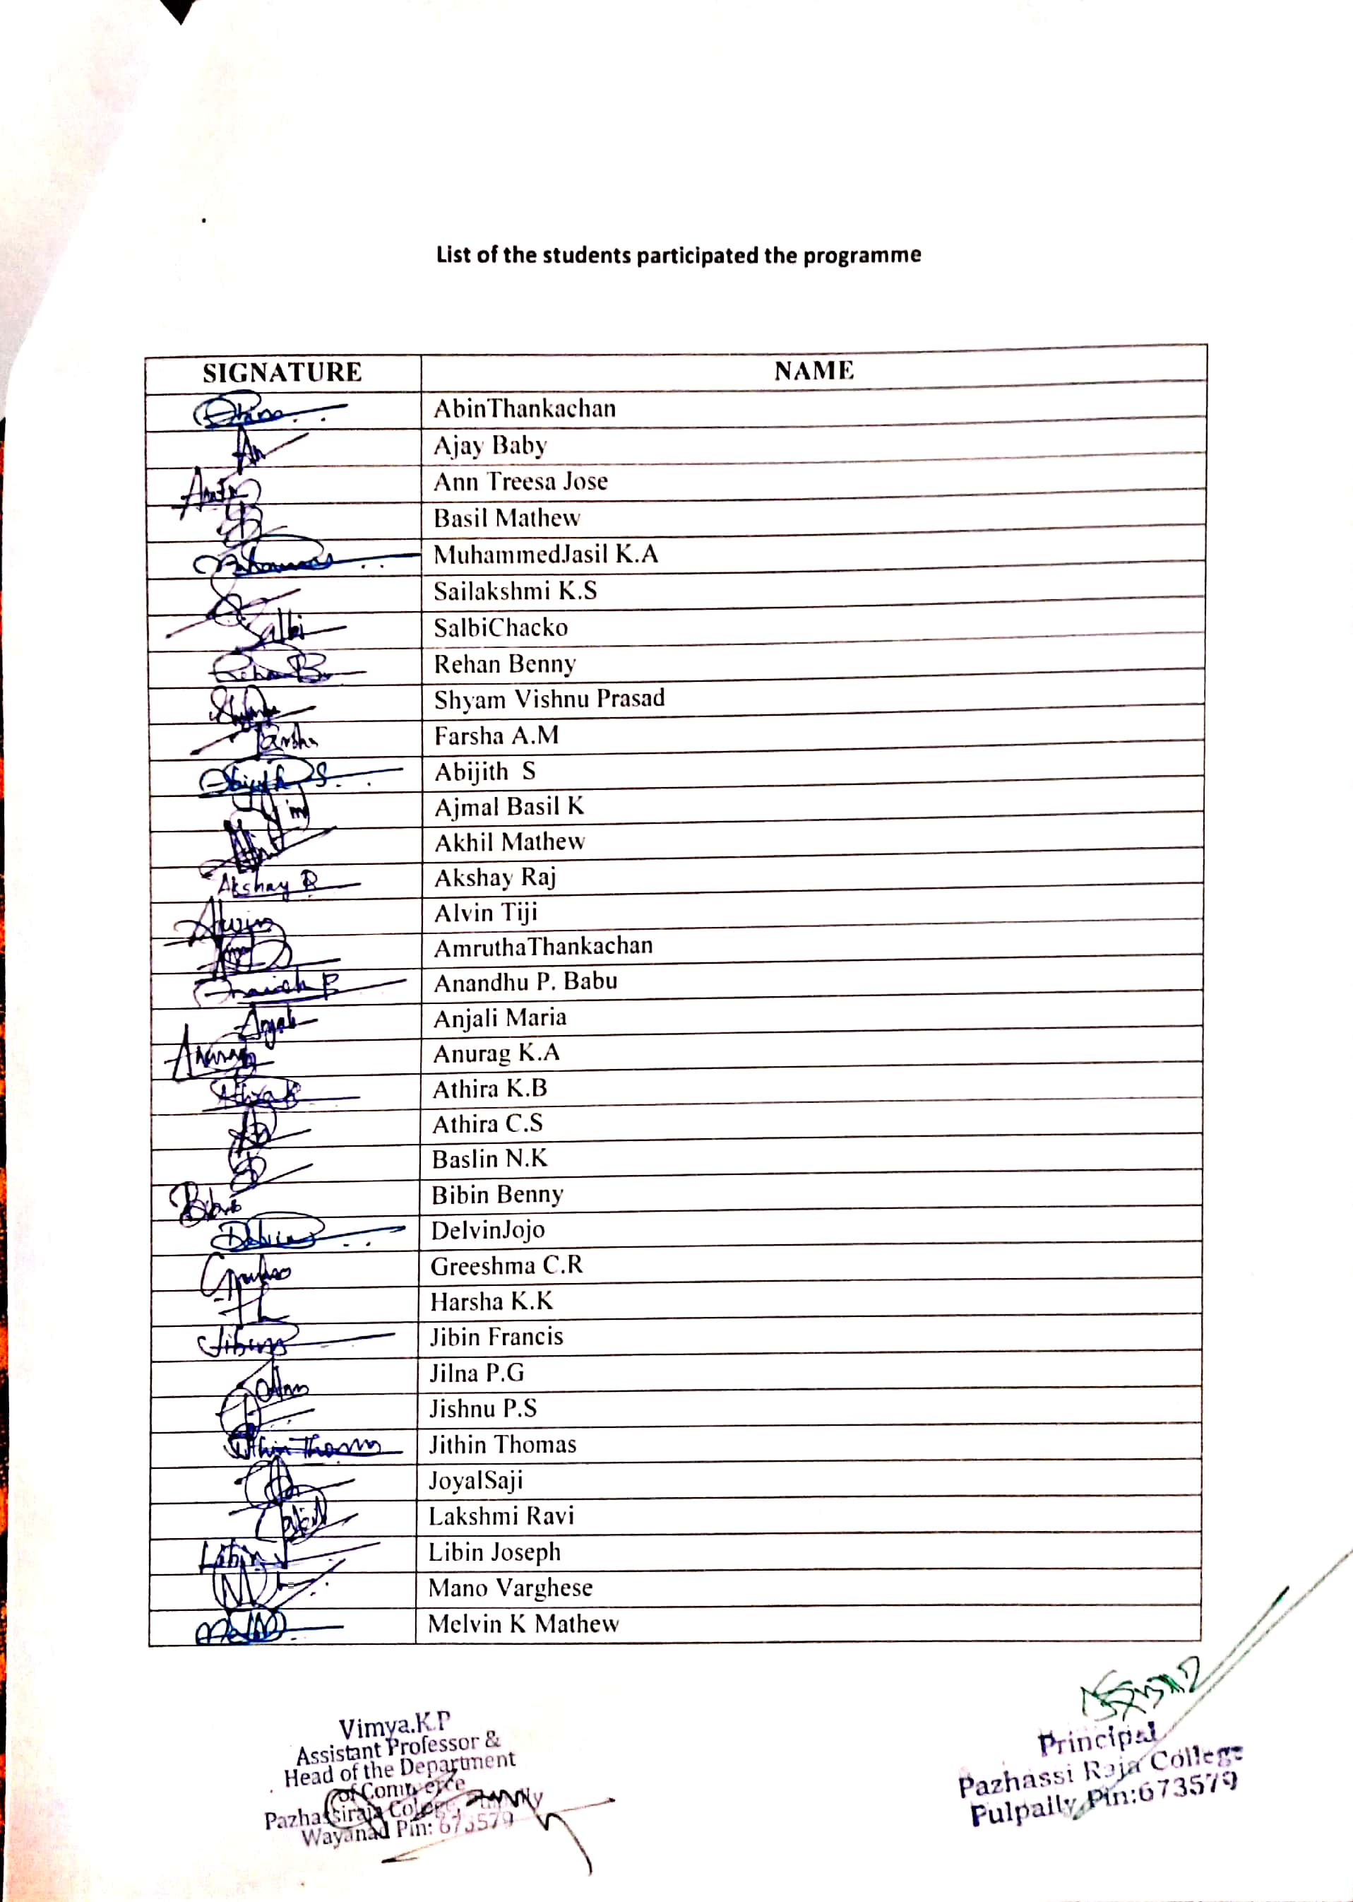

NOTICE

