Webinar on Capital Market Awareness dated 24/11/2021

Department of Pazhassiraja College,Pulpally in association with Bombay Stock Exchange (BSE-IPF) conducted national webinar on "Capital Market Awareness" For WORLD INVESTORS WEEK-2021 on 24/11/2021. Programme was in Zoom platform and started with welcome speech of Programme coordinator and HoD Vimya KP at 10.00 AM.
There were an active participation of around 70 students. The sessions were handled by Venugopal Rayirath Senior Associate LKW and it really benefited the students in terms of enhanced Capital Market Knowledge and Awareness as well as the ability to make more informed Investment Decisions.
The topics covered in this Program will be :
1) Capital Market Offerings
2) Do’s & Don’ts of Investing
3) Asset Class Offerings
4) Equity Vs Debt
5) Mutual Funds & Financial Planning
The programme has been simplified enough for graduates as well as non-finance students to understand.

HoD/Coordinator Principal
Vimya KP Dr.AnilKumar K

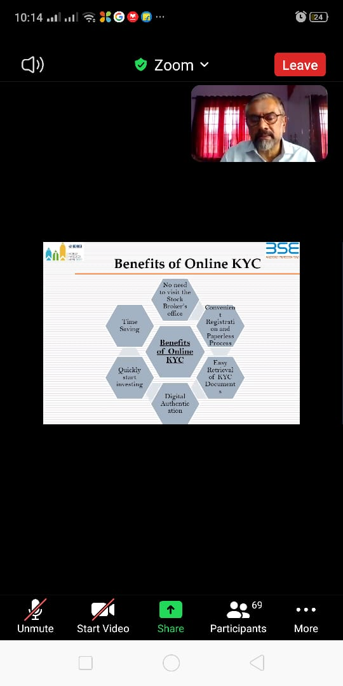

HoD/Coordinator Principal
Vimya KP Dr.AnilKumar K

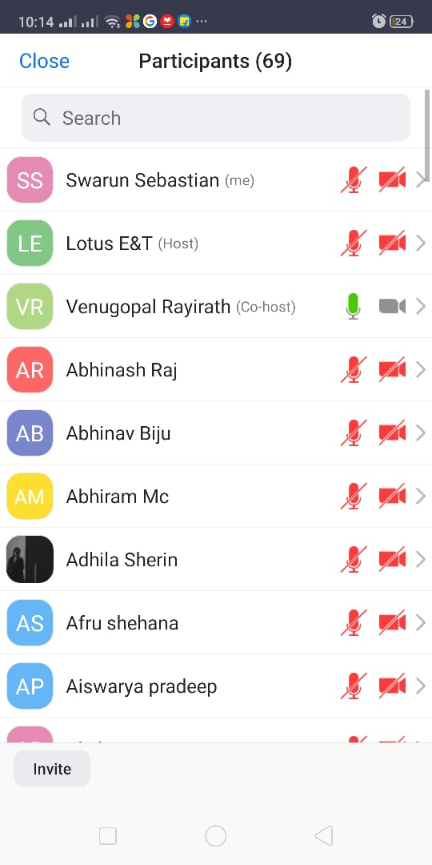

HoD/Coordinator Principal
Vimya KP Dr.AnilKumar K

