Biofest 2020 (Genesis 2020)
1. Inaugral section
Biofest 2020 named as Genesis 2020 was organised by department of biochemistry, pazhassiraja college, pulpally under Calicut university.The programme was inaugurated by bindu prakash, panchayath president of wayanad. The welcome speech was done by Dr. Jomet Sebastian, the head of the department of biochemistry,pazhassiraja college, pulpally. The presedential address was done by Dr. Anil kumar, principal of pazhassi raja college, Wayanad. The felicitation speeches were done by Fr.varghese kollamavudy, CEO, Fr.George alumootil, bursar, Prof.Thara Philip,Course coordinator and Ajay das,Chairman of the college. The programme committee has principal as Chairman and Prof. Thara Philip, Fr.George alumootil and Fr.varghese kollamavudy as convenors. The staff coordinator of the programme was Dr. Jomet Sebastian and student coordinator was Ashish. K.S. The cheif special guest of the genesis 2020 was Dr. Adeela Abdullah I A S, District collector of wayanad took class on the role of woman in science. The speech of the collector motivates and influence the students. The fest was scheduled with different sections and programmes.
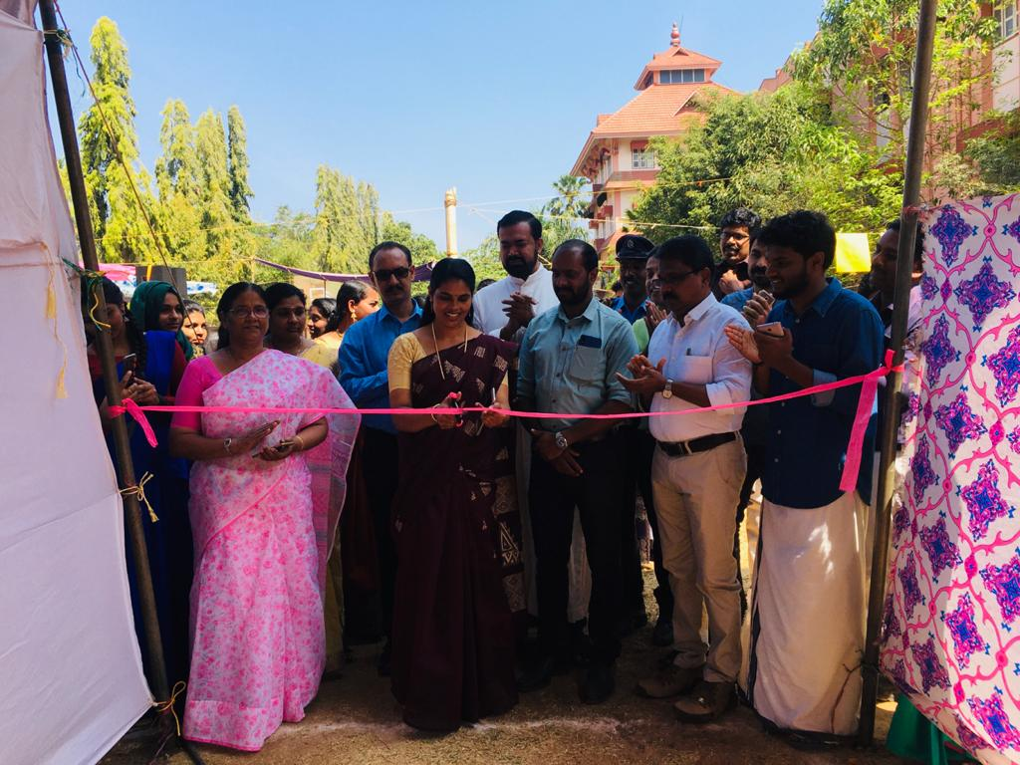
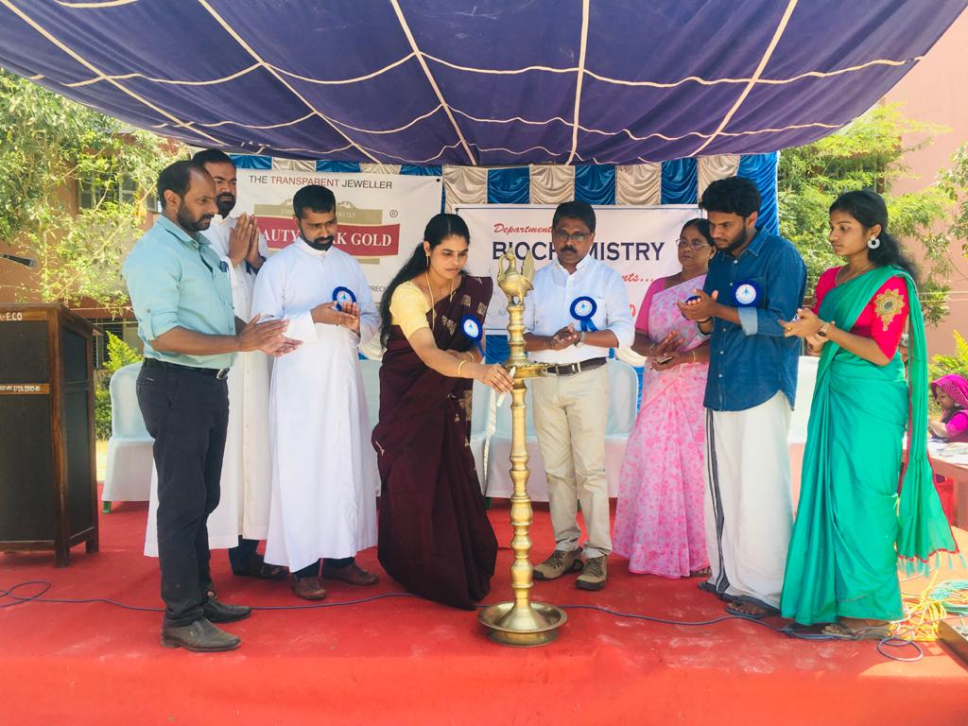
Inaugration by Bindu prakash, panchayath president of wayanad
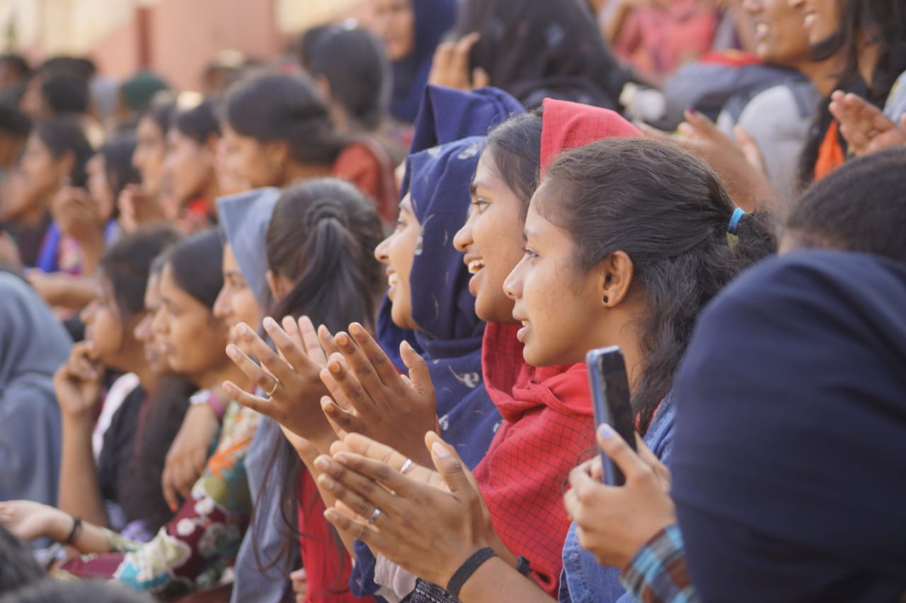

Genesis 2020
The programme was started with an inaugural section handled by several resource persons. The intro of the programme with a flash mob conducted by the department of biochemistry. The graduates and post graduates of biochemistry department participate in the flash mob successfully.
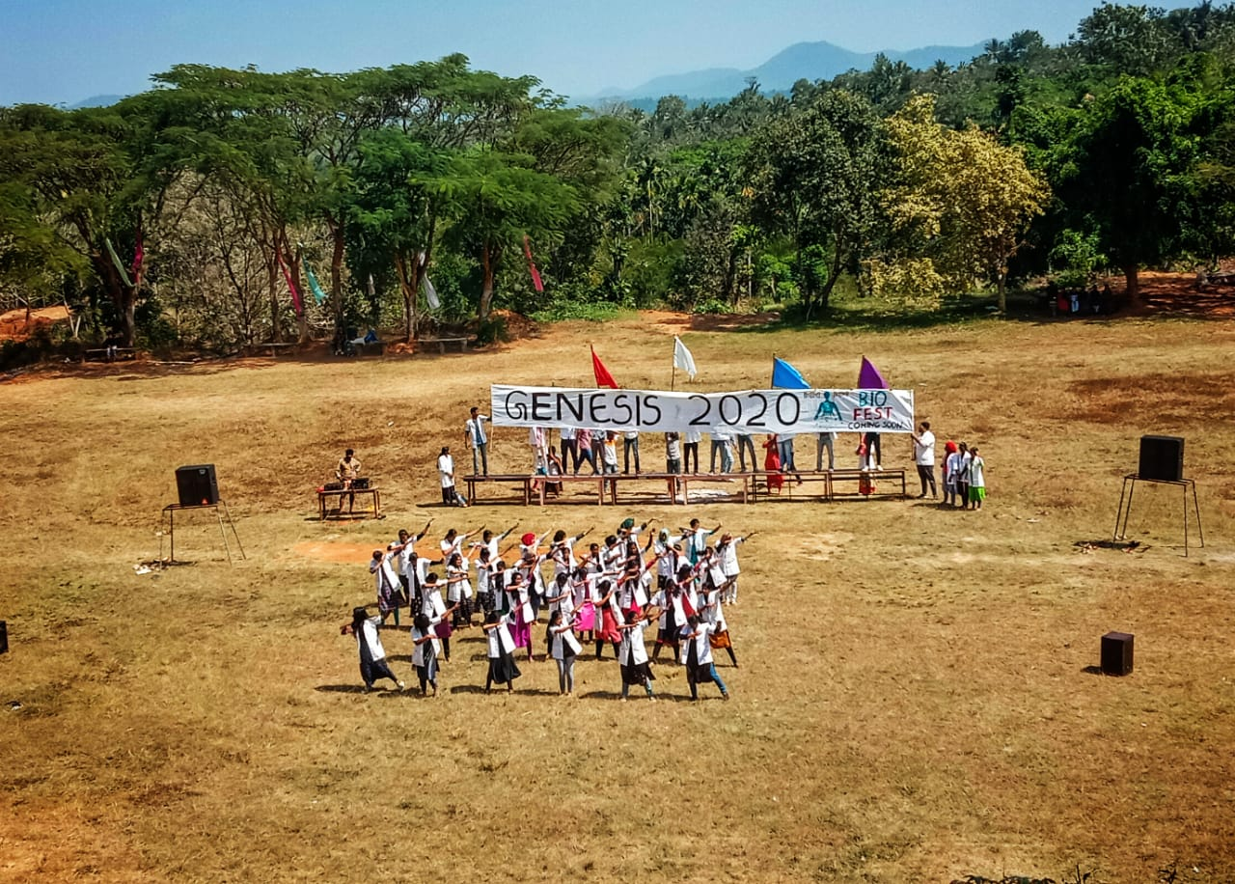
Collector’s speech
The cheif special guest of the genesis 2020 was Dr. Adeela Abdullah I A S, District collector of wayanad. She took class on the role of woman in science. The speech of the collector motivates and influence the students, who have participated in the programme.
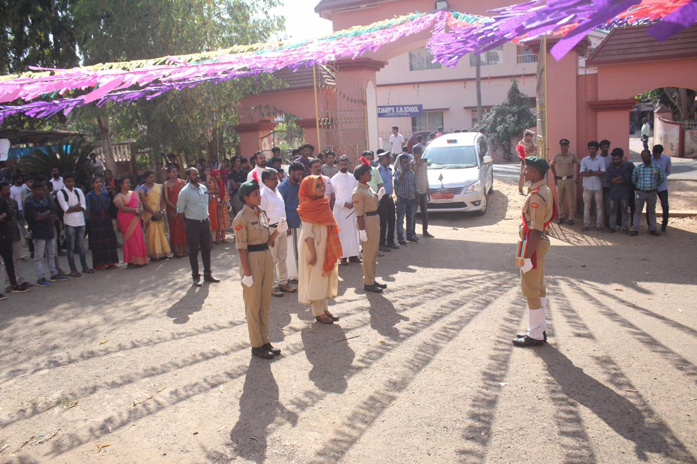
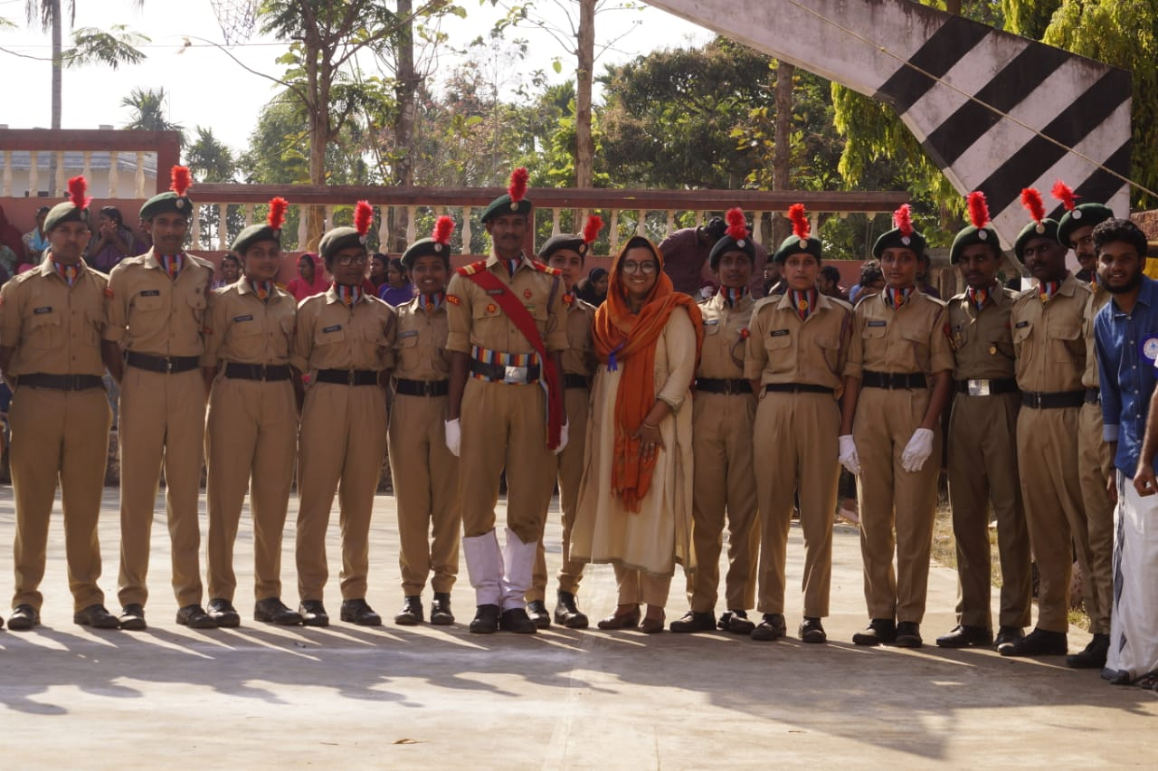
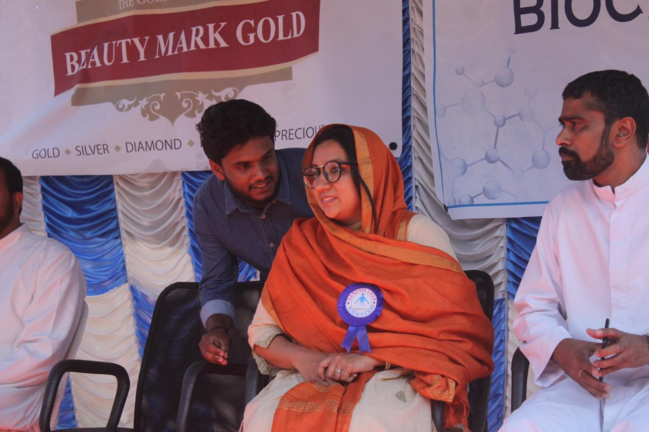
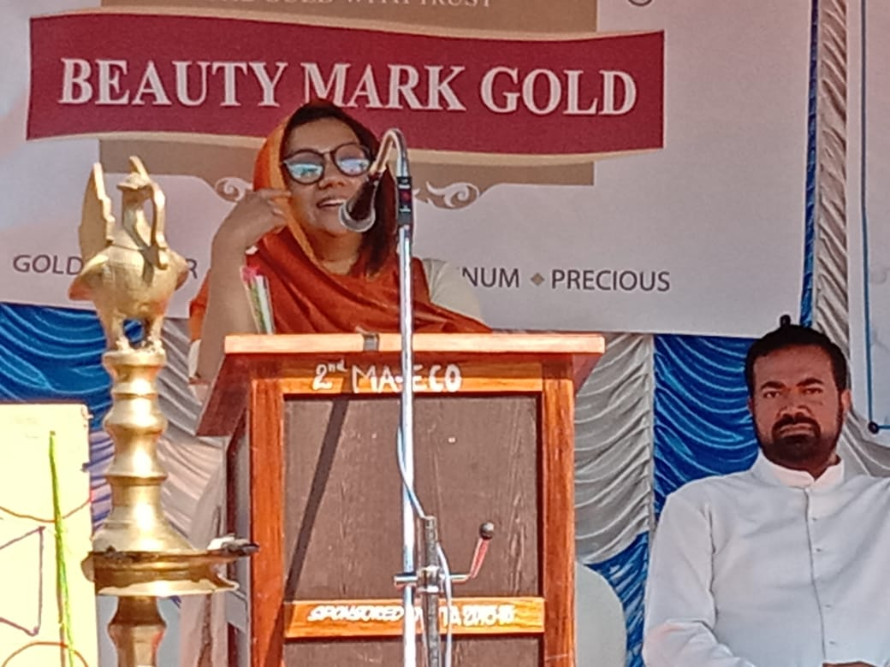
Speech by Dr.Adeela Abdulla, District collector of Wayanad
Medical camp
The medical camp was conducted by biochemistry department as a part of the fest.The camp was leaded by expert Dr.Hashim and paramedical staffs from LIABA medical lab panamaram,Wayanad. The medical camp include the checking of sugar, pressure, the level of haematological and biochemical parameters for the diagnosis of several diseases. The medical camp facilities was utilised by the staffs and students of various departments of our college. The camp also consulted the patients,those who have symptoms of any disease. Blood donation camp
The blood donation camp was conducted as a part of biofest in the college. The staffs and students of the college donate the blood and the blood donation camp was success fully finished in the college. The blood donated was collected by the thaluk hospital, Bathery for their blood bank. This was a successful attempt from our department for the patients who needs blood.
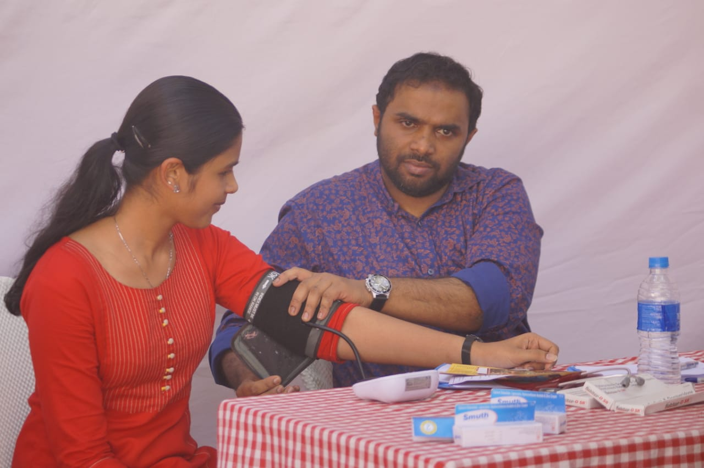 Automobile Exhibition
The automobile exhibition was shown by the students of polytechnic from wayanad. A buggy was formed from autorickshaw engine and charging of phone using candle was exhibited. It was a new experience for the students to visualise the automobile exhibition. This was a new experience of the students, those who are participated in the function.
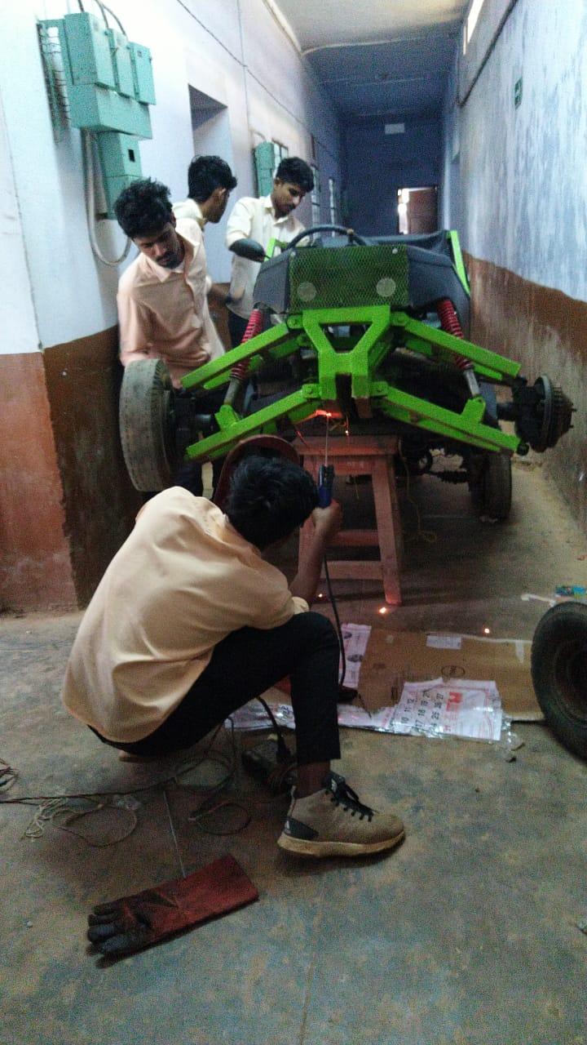

Exhibition by Calicut medical college
The exhibition was done by the students of government medical college,Calicut,kerala. They exhibited different internal organs and diseased stages of internal organs in the human body. The showed the demo of internal organs which are affected by the excess consumption of alcohol and smoking. It was an inspiration for the students, those who are participated in the biofest.The exhibition also involve the embryonic development of a zygote during fertilization or different stages of an zygote in womb. The exhibition was further proceeded by showing different snakes . This was a new information for the audience gathering in the programme. This Organ exhibition was a wonderful experience for us.
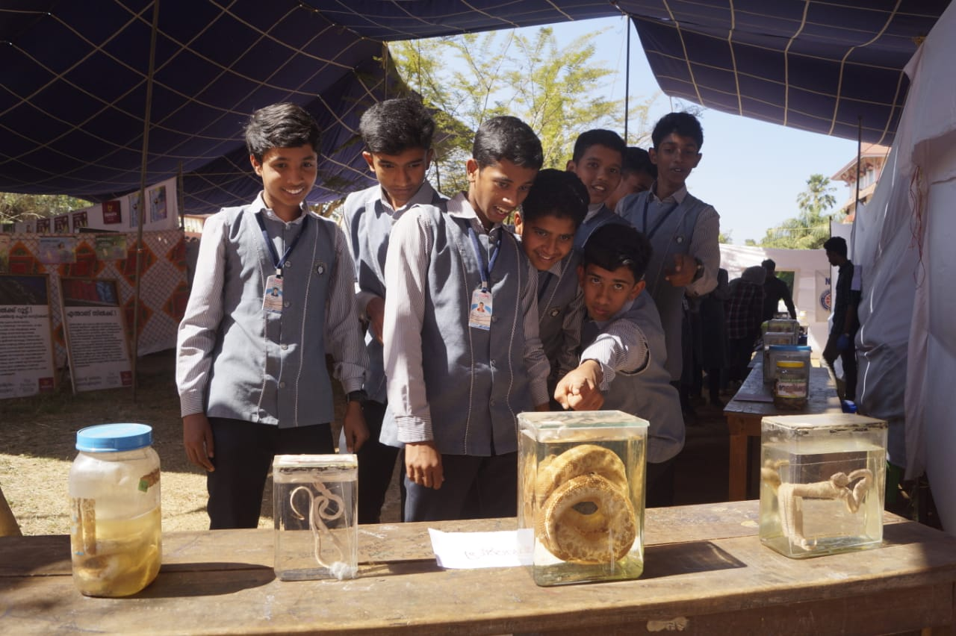
Exhibition by sasthra sahithya parishath (KSSP)
KSSP exhibited several books and magazines which are useful to the students. KSSP publishes two monthly magazines, Sastrakeralam (for secondary school students) and Sastragathi, and a biweekly, Eureka (for primary school students) and also a newsletter Parishad vartha. Eureka and Sastrakeralam are intended for children and the newsletter for members. Sastragathi is the organization's main magazine. Also KSSP's major contribution is in publishing science books in Malayalam with more than 700 titles already published. One of the latest books published is Jeevarekha by Dr.M.P.Parameswaran. In addition, KSSP has already published hundreds of small booklets, related to different issues. LUCA is the online science portal of KSSP. They also exhibited a box which stabilises and maintains the heat. It was a novel information for the students about the boxes.
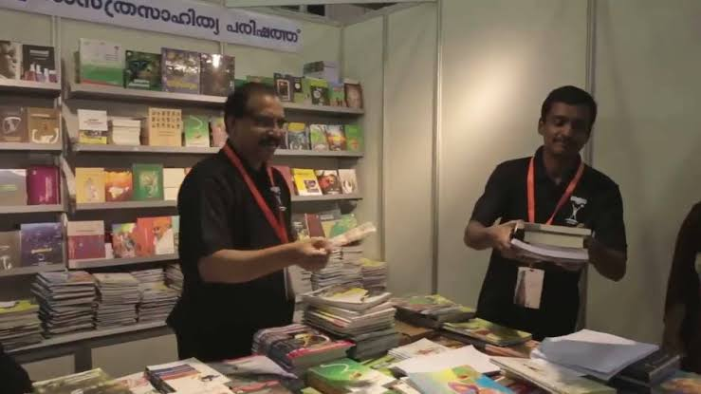
Chemical lab specimen exhibition by Pazhassiraja college Biochemistry students
The students of our department exhibited several models and experiments.The biochemistry students of our college are very much interested in presenting the models and explain the biochemical experiments. The biochemical experiments includes the qualitative analysis of carbohydrates includes monosachrides, oligosachrides and polysachrides, proteins and lipids. Students showed the models of dialysis unit and scanning techniques like MRI. They give an awareness programmes related to several viral disorders including Corona viruses. Explanation of microscopy and microbiological specimens were conducted by the students. Experiments and its evaluations provide a scientific knowledge to students,those who are participated in the programme.
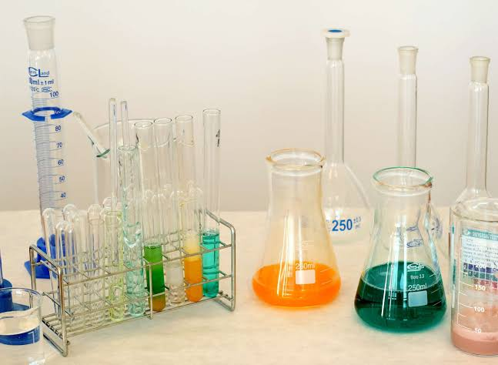
Process of formation of silk from Silk worm
The preparation of silk from silk worm was conducted as a part of biofest. They demonstrate different stages of silk formation from silk worms. The process of silk production is known as sericulture. The entire production process of silk can be divided into several steps which are typically handled by different entities.Extracting raw silk starts by cultivating the silkworms on mulberry leaves. Once the worms start pupating in their cocoons, these are dissolved in boiling water in order for individual long fibres to be extracted and fed into the spinning reel.

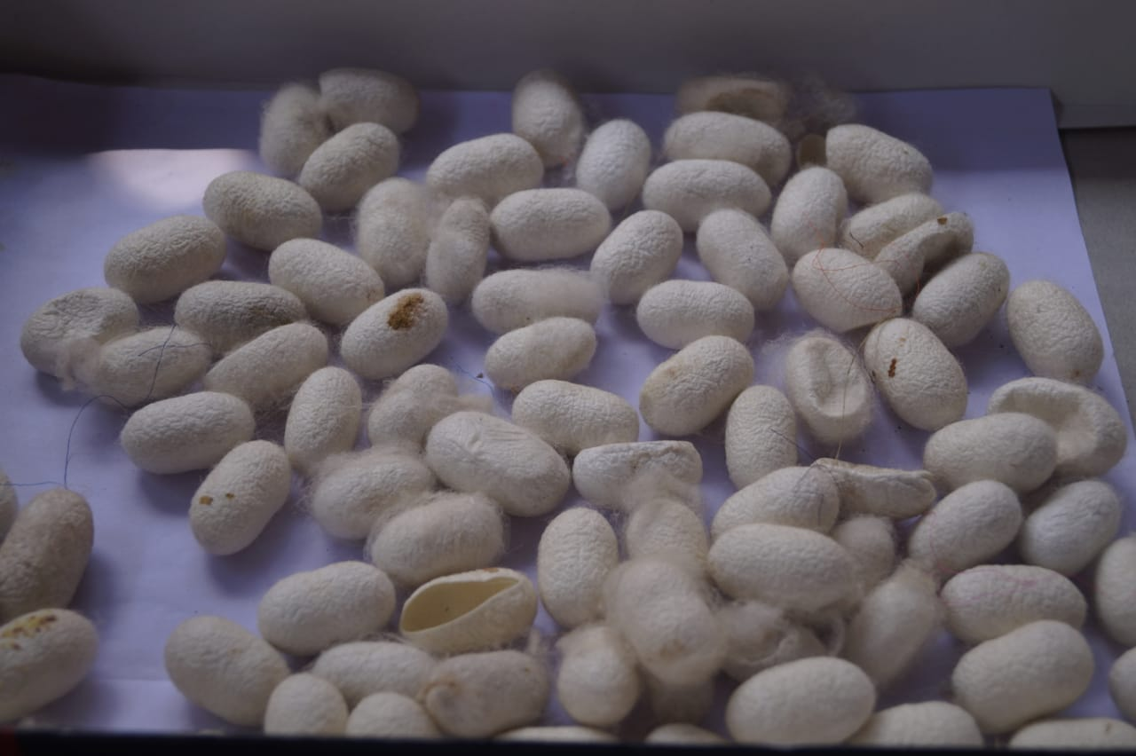

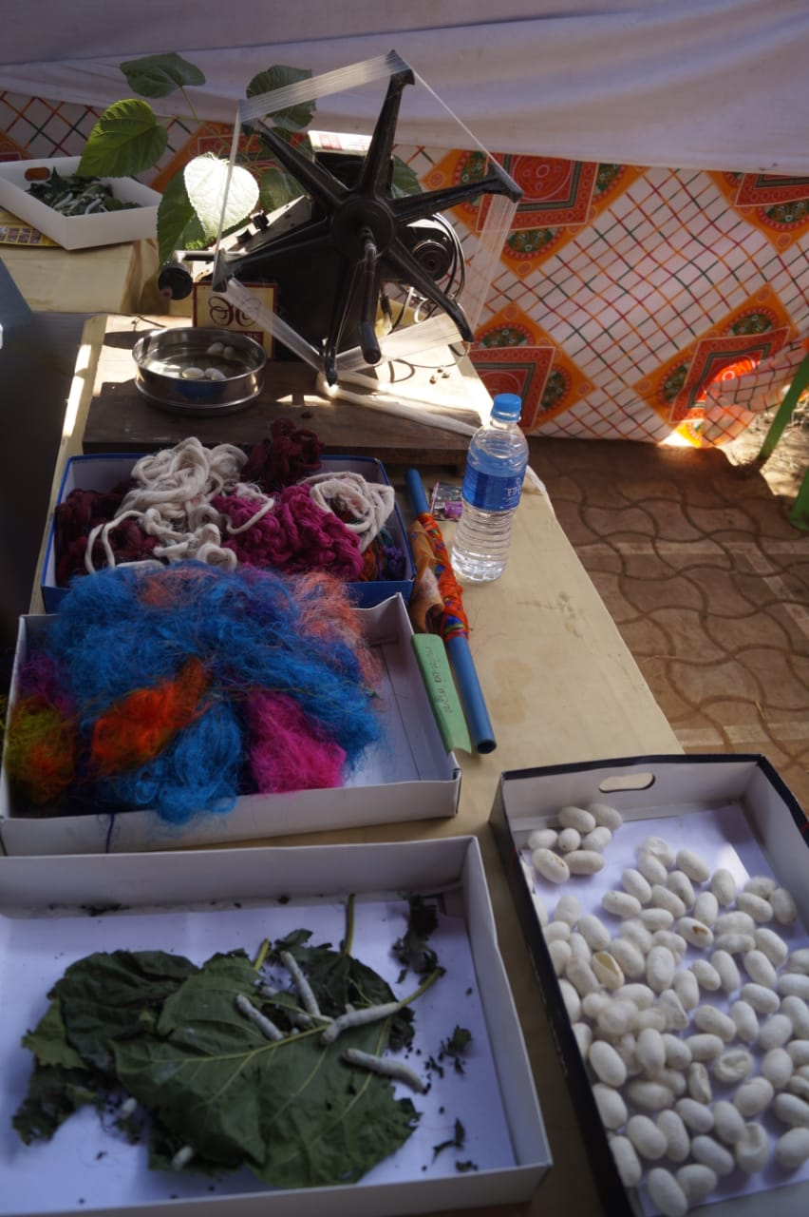

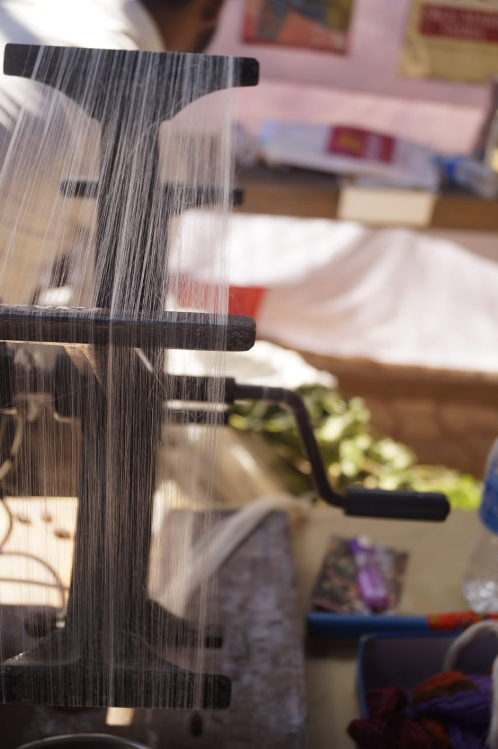
Stage programmes
There are several dance programmes conducted by biochemistry students includes cinematic and classical dances. The charming dances by disabled students of kripalaya, wayanad, was a wonderful experience for the audiances. A triple five music band was conducted at the final of the biofest.
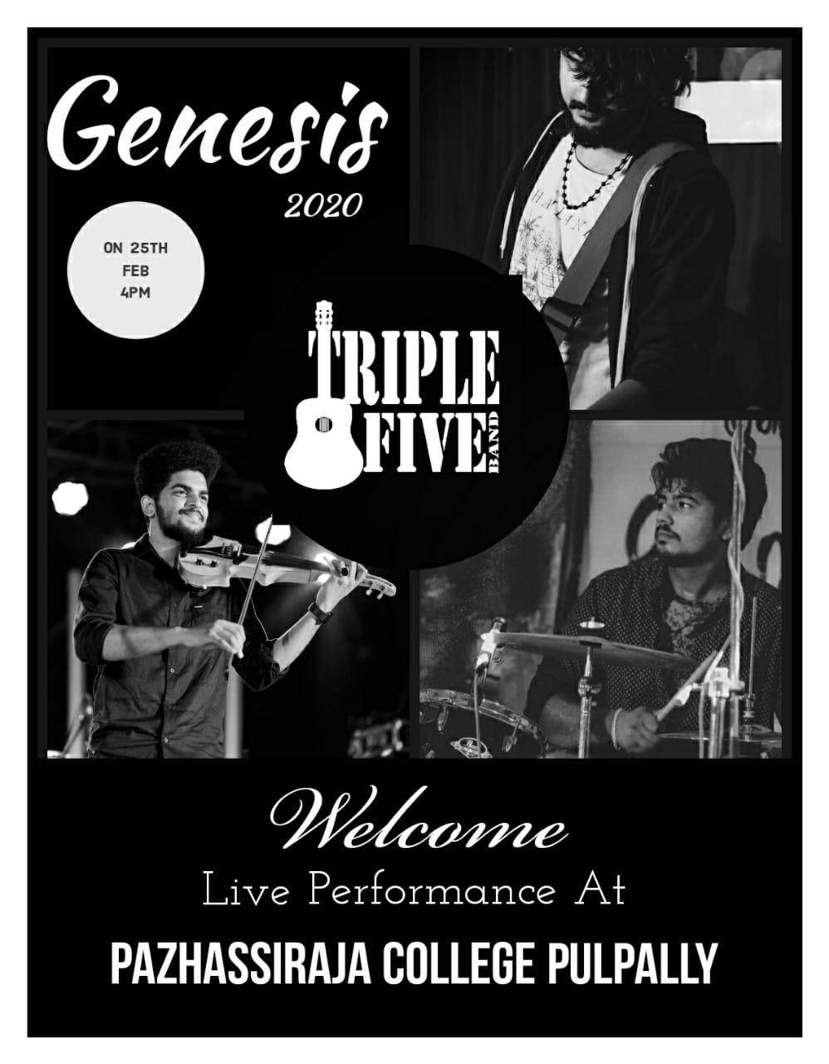
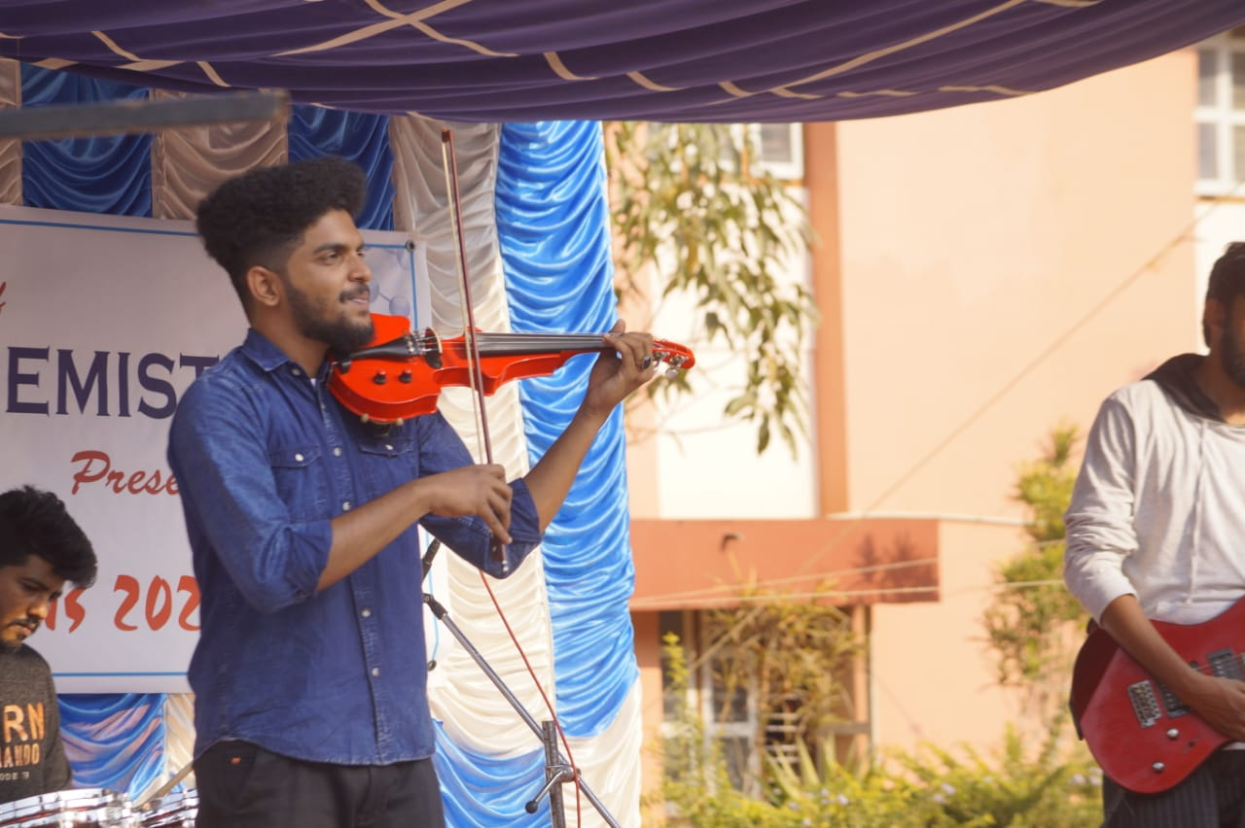
The End
The end of the programme with a triple five music band arranged by the students. A concluded speech by the head of the department to express his gratitude to all of them participated in the biofest on behalf of the department. He also thanks all the sponsors for the programme.
