PAZHASSIRAJA COLLEGE, PULPALLY, WAYANAD
WEBINAR SERIES ON PROMOTING
RESEARCH IN
SCIENCE, HUMANITIES AND SOCIAL SCIENCES
Dear Colleagues,

With great pleasure I invite your kind presence and participation in the Webinar series on Promoting Research in Science, Humanities and Social Sciences organized by the IQAC and Research Promotion Council of our College commencing on 26th June 2021
Inauguration: (Time: 11 am)

Dr.Vinod Kumar.KP, Member, Syndicate, University of Calicut

Key note Address:

HE Most.Rv.Dr.Joseph Mar Thomas,
Chief Patron and Manager Pazhassiraja College,
Bishop Catholic Diocese of Bathery

WEBINAR 1: (26th June 2021)

Formulation of Research Question and Planning Research Work in Sciences
Resource person: Dr.K.Satheesh Kumar, Director, Dept. of Future Studies, University of Kerala.

WEBINAR 2: (30th June 2021 at 2 pm)

Publishing in Impact Journal: A Social Sciences Perspectives

Resource Person: Dr.Tony K Thomas, Head, School of Tourism Studies, MG University,

Webinar 3: (7th July, 2021 at 2 pm)

Resource Person: Dr.Tony K Thomas, Head, School of Tourism Studies, MG University,
From the title to Implementation-Developing and Project Proposal

Regards,
Anilkumar.K, Principal
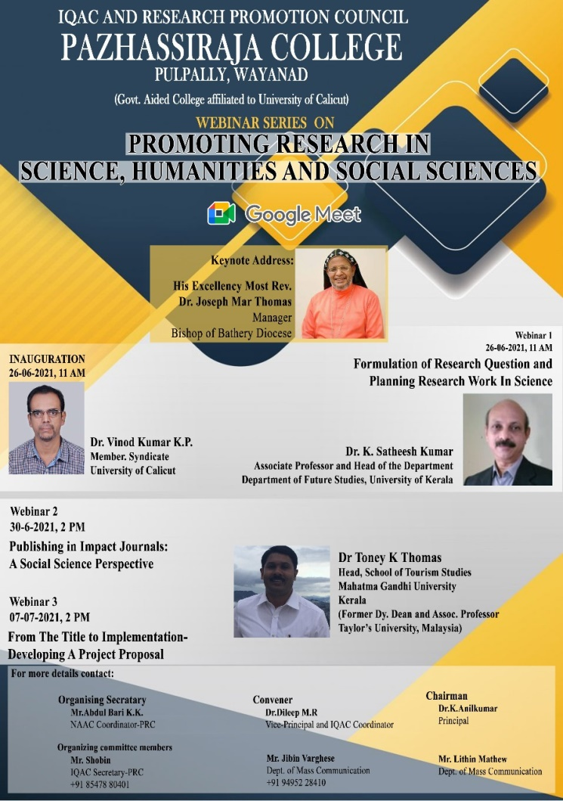

Report of Webinar 1 (25-06-2021)
IQAC in association with Research Promotion Council of Pazhassiraja College conducted a three days webinar series through google meet on promoting Research in Science, Humanities and Social Sciences.
Inauguration session of the webinar series was held on 25-06-2021 at 11:00 am. The Convener of the programme Dr. Dileep M.R. (Vice-Principal and IQAC Coordinator) delivered welcome speech. The meeting was presided by Dr. K. Anilkumar, Principal of the College. Dr. Vinod Kumar K.P., Syndicate Member of University of Calicut inaugurated the function and addressed the gathering. He said that though our country was much backward in research contributions, in recent days, it has made some significant improvements in this field. The keynote address was delivered by His Excellency Most Rev. Dr. Joseph Mar Thomas, Manager and Patron of the college. He stressed on the importance of innovative research. He also pointed that a research culture shall be enhanced with these efforts. The Expert Speaker of webinar was Dr K. Satheesh Kumar, Associate Professor and Head of the Department, Department of Future Studies, University of Kerala. The topic of the webinar was ‘Formulation of Research Question and Planning Research Work in Science’. He explained about the methods to get access to literature related to Science. He discussed on Web of Science and related aspects. He also explained the funding agencies related to the area. The participants interacted with the resource person at the end of the session. The webinar was concluded with the words of gratitude by Mr.Abdul Bari K.K., NAAC Coordinator of Pazhassiraja College.

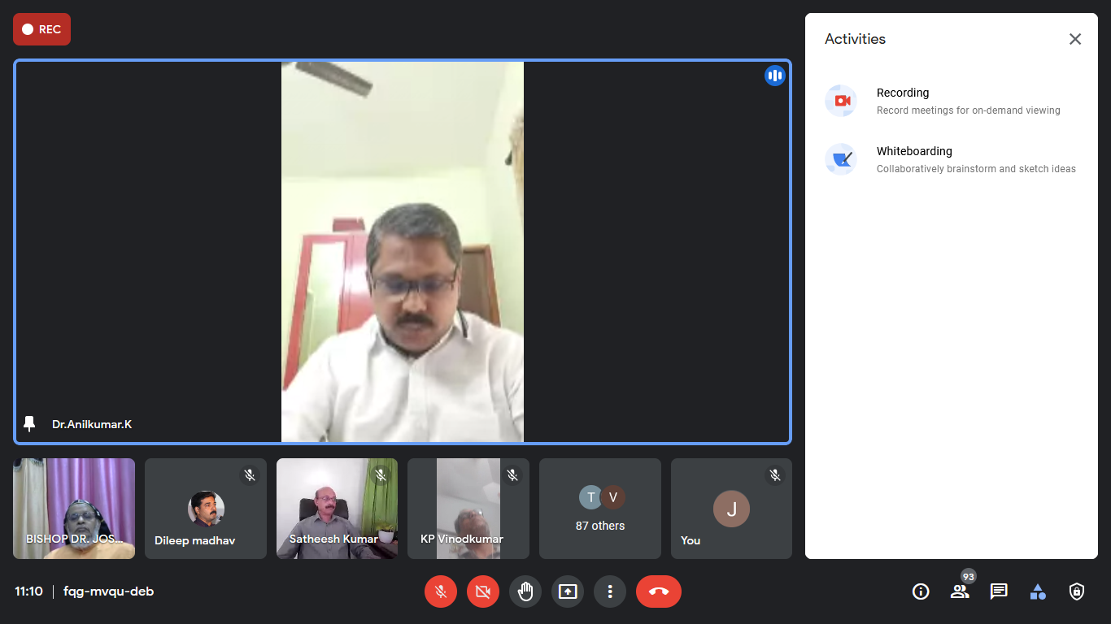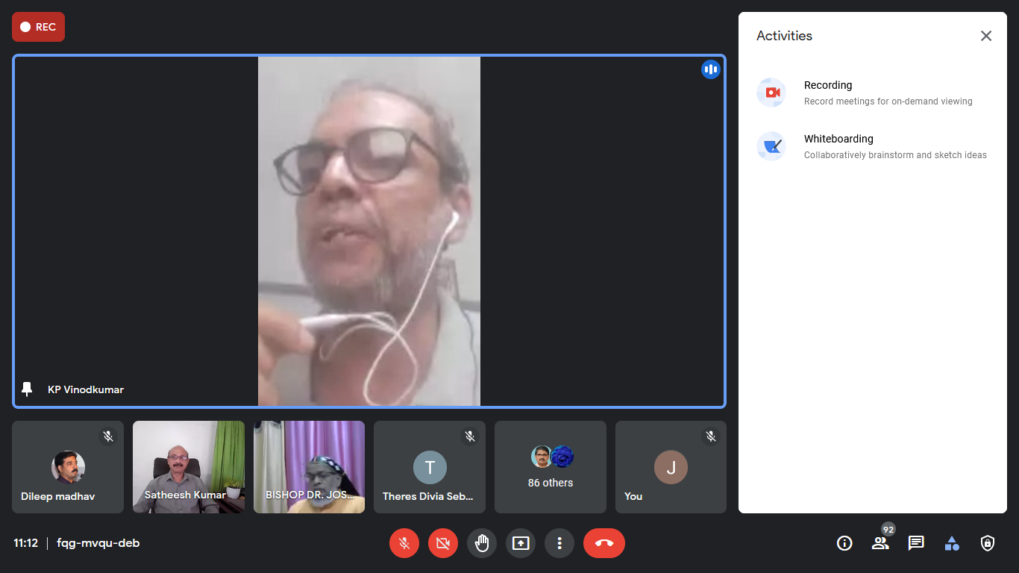
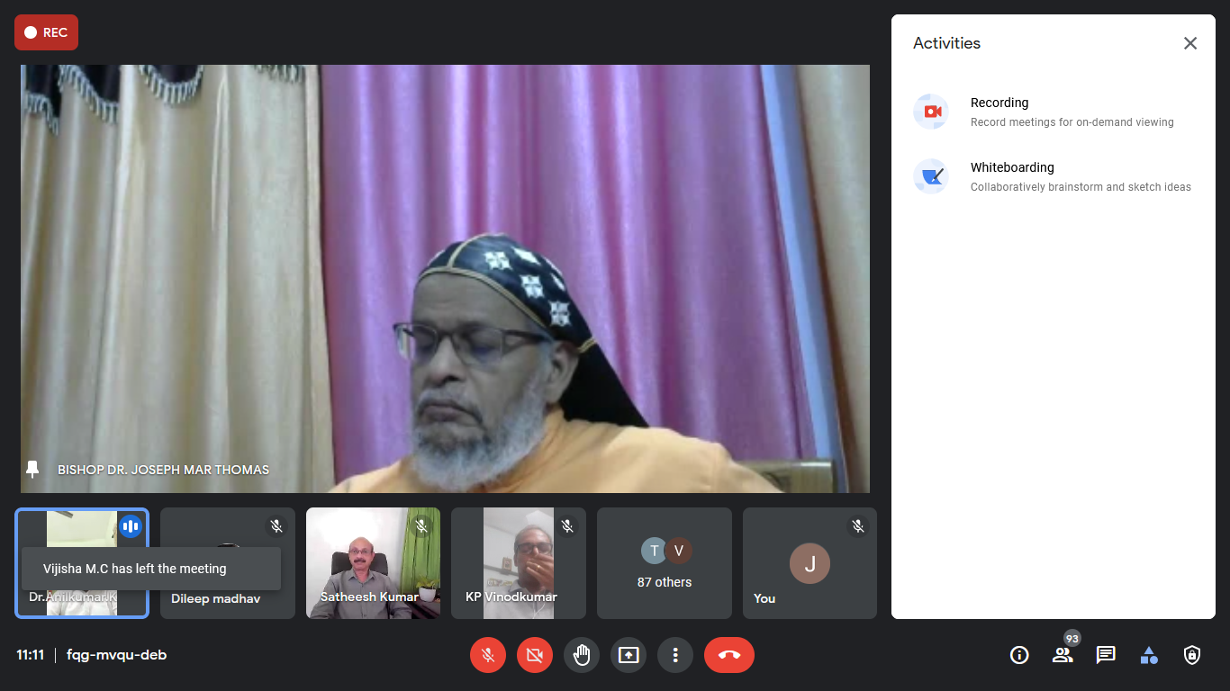
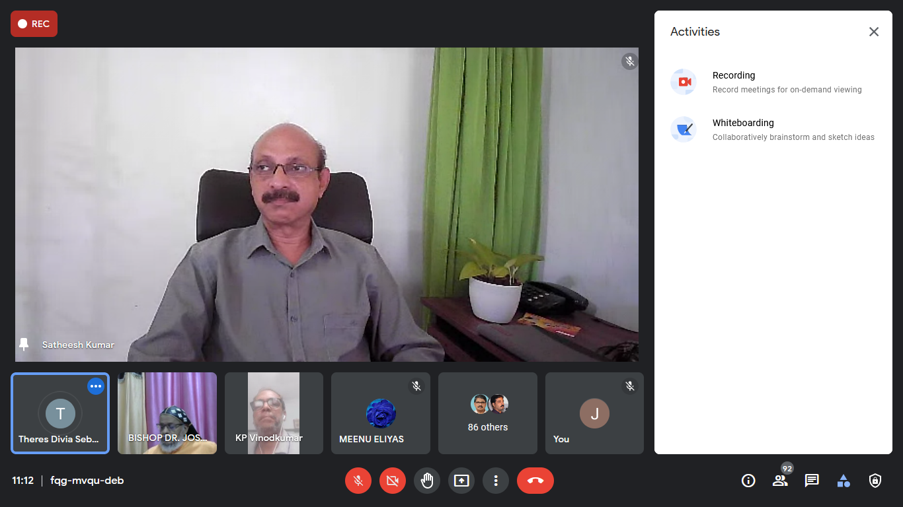

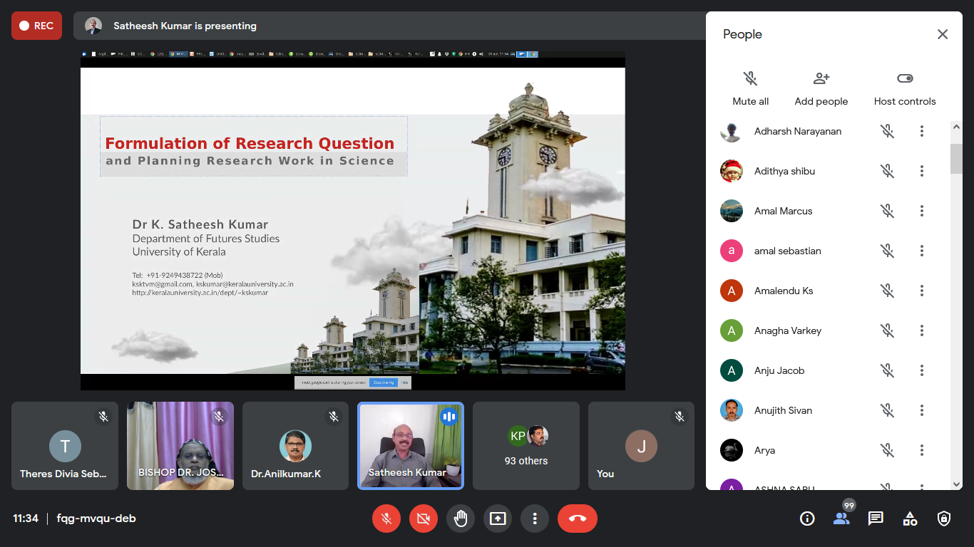
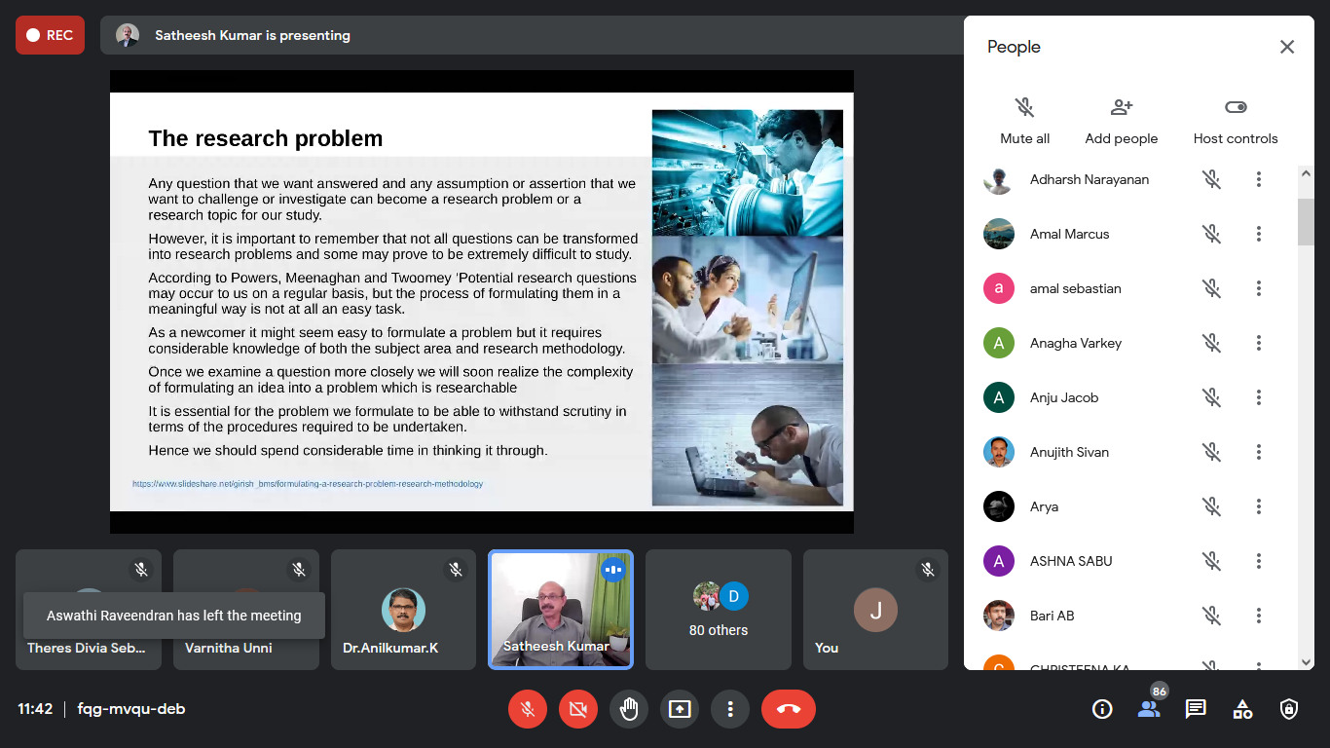
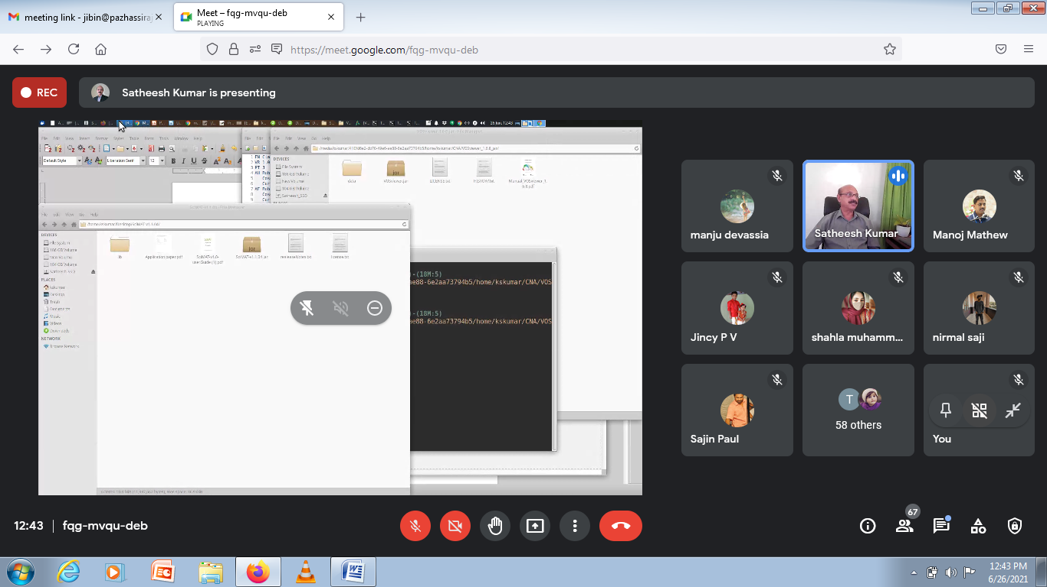
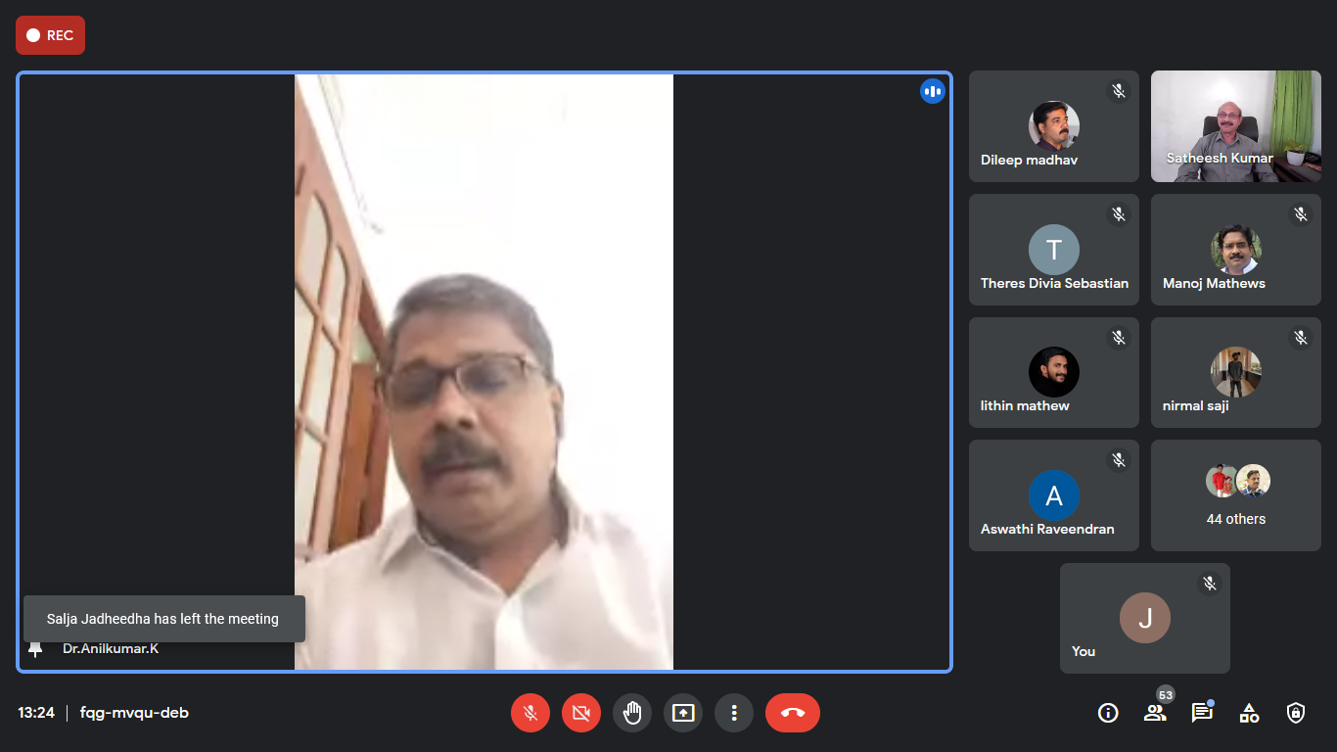

List of Certifificates Issued
