Webinar Report
Three Day National Webinar Series
The Department of English, in association with IQAC conducted a Three Day National Webinar Series, Horizons: An Exploration into the Scopes of English Studies, from 21 October 2020 onwards. The programme was intended to create awareness about various career opportunities for English graduates other than the traditionally sought academic field. Experts from various industries were invited to talk about their respective fields. The webinar was conducted over zoom platform.
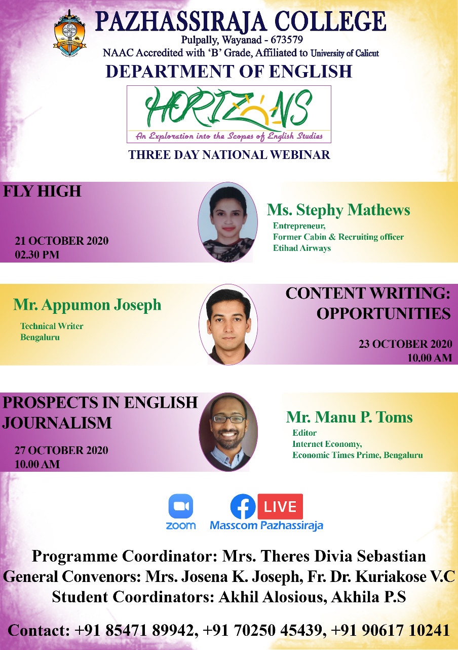
Day 1
Fly High: Career Aspects in Aviation Industry
The webinar series commenced on 21 October 2020 with the topic Fly High: Career Aspects in Aviation Industry at 2:30 p.m. Ms Stephy Mathews, Ex cabin Crew, Etihad Airways led the session.
Objectives
- To create awareness about various opportunities in Aviation Industry.
- To create awareness about the significance of linguistic skills

Outcome
The programme was a huge success. About 160 participants attended the programme. The resource person delivered the content in an effective manner. The programme gave the participants an insight into the various career opportunities that lay before them in the Aviation Industry. The students also recognized the significance of acquiring proficiency in languageskills especially spoken skills.
Description
The Head of the Department, Ms. Josena K Joseph welcomed the gathering. The webinar was inaugurated by the principal Dr. Anilkumar K. The webinar was moderated by Ms. Sunisha V C, faculty member from the department. The vote of thanks was delivered by Ms. Akhila P S, student from II B A English.

Day 2
Content Writing: Opportunities
The second webinar of the series was conducted on 23 October 2020 at 10:00 a.m. The session was handled by Mr. Appumon Joseph, Technical Writer working with Unisys, Banglore. The resource person focused on various avenues of content writing.
Objectives
- To create an awareness about content writing
- To create awareness about techniques of writing
- To create awareness about challenges of writing
Outcome
The session was teemed with 140 participants from various colleges in and outside Kerala. The participants were blessed with knowledge about the various fields that comes under the umbrella term content writing. The participants were also made aware the challenges and techniques in writing.
Description
The programme was moderated by Ms Sunisha V F. Ms Theres Divia Sebastian gave the welcome address and introduced the guest. Mr. Shivaprasad from III BA gave the vote of thanks.

Day 3
Prospects in English Jouralism

The third webinar of the Horizons webinar series was conducted on 27 October 2020 with the topic Prospects in English Journalism at 10:00 a.m. Mr Manu P Tom, journalist, Economic Times Prime, Bengaluru led the session.

Objectives
- To create awareness about various opportunities in journalism.
- To create awareness about the methods to develop linguistic skills

Outcome
The programme was very effective and useful for the participants. About 140 participants attended the programme. The resource person delivered the content in an effective manner. The programme gave the participants an insight into the various career opportunities that lay before them in Journalism. The students also recognized the significance of acquiring proficiency in language skills especially writing skills.
Description
Fr. Dr. Kuriakose V.C. introduced the guest. The webinar was moderated by Ms. Sunisha V F, faculty member from the department. The vote of thanks was delivered by Ms. Linta Maria Antony, student from III B A English.

Webinar Report
Language and Literature: Need for an Interface

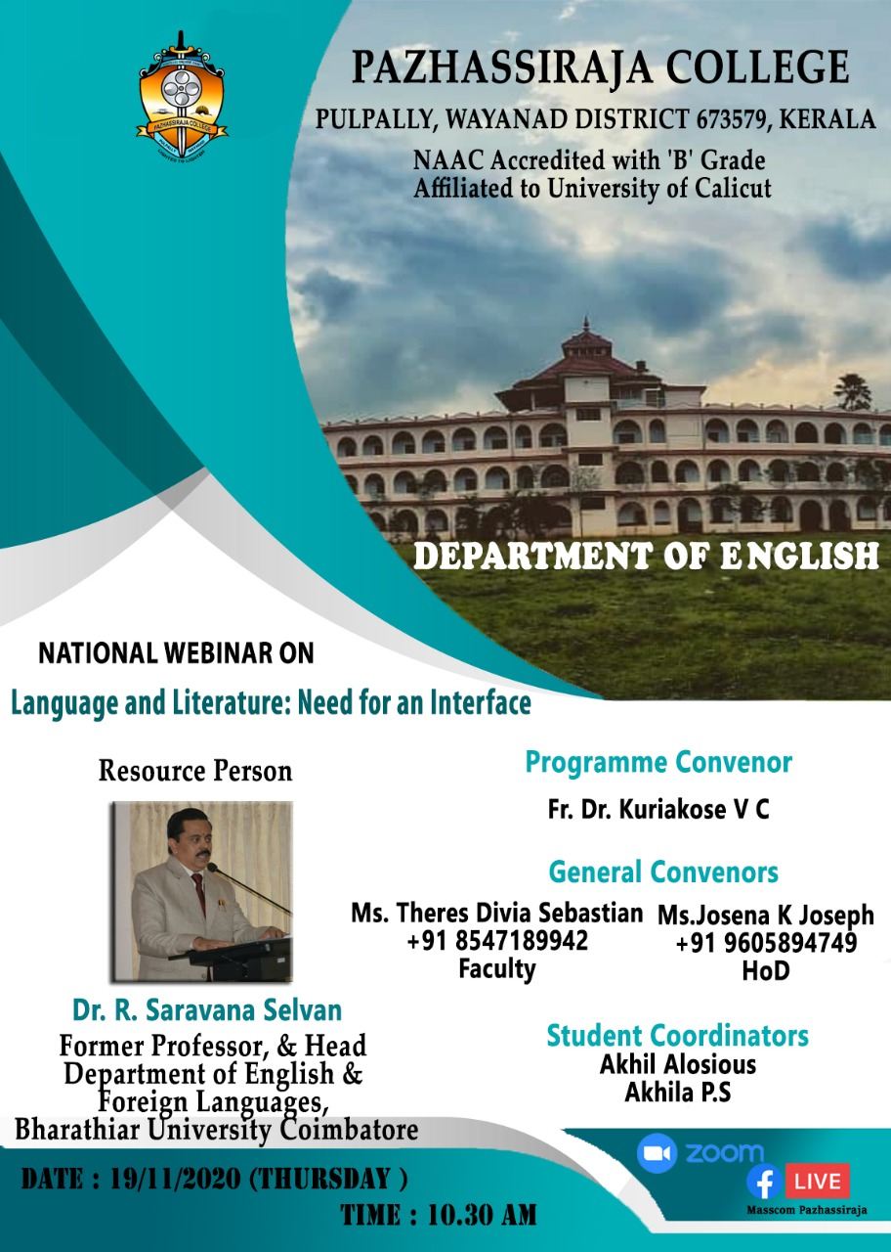

The webinar was conducted on 19 November 2020 on the topic Language and Literature- Need for an Interface at 10:30 a.m. Dr. Saravana Selvan, former Professor & Head, Department of English, Bharathiar University, Coimbatore served as the Resource Person.
Objectives
- Tips on how to develop language through literature.
- To create awareness about the significance of linguistic skills
- Language through Literature facilitates the platform to practice and acquire the skills of the language and enjoy the creative aspects of Literature.
- Such experiences give students to replicate the natural language in a non-stressed situation.
- Language without Literature is like the existence of a man without living it.
Outcome
The programme was a huge success. About 190 participants attended the programme. The resource person delivered the content in an effective manner. The programme gave the participants an insight into the tips of acquiring language skills along with reading literature. The students also recognized the significance of acquiring proficiency in language skills especially spoken skills.
Description
The Head of the Department, Ms. Josena K Joseph welcomed the gathering. The webinar was inaugurated by the principal Dr. Anilkumar K. Fr. Dr. Kuriakose V C introduced the guest. The webinar was moderated by Ms. Sunisha V F, faculty member from the department. The vote of thanks was delivered by Ms. Theres Divia Sebastian.

Webinar Report
The Politics of Gender: Feminism down the Ages
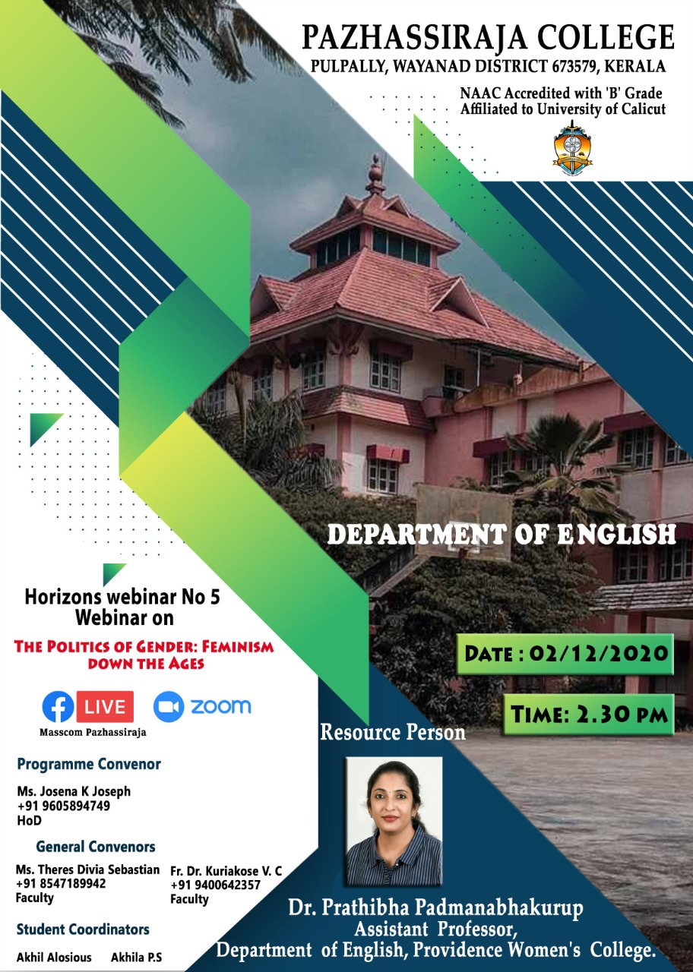
The webinar was conducted on 2 December 2020 with the topic The Politics of Gender: Feminism down the Ages at 2:30 p.m. Dr. Prathibha Padmanabhakurup, Assistant Professor, Providence Women's College led the session.
Objectives
- To create awareness about the timeline of feminism.
- To create awareness about pseudo feminism.
- To create an awareness about gender sensitization.
Outcome
The programme was a huge success. About 160 participants attended the programme. The resource person delivered the content in an effective manner. The programme gave the participants an insight into the history of feminism. The students were made aware about psuedo feminism and feminism.
Description
The Head of the Department, Ms. Josena K Joseph welcomed the gathering. The webinar was moderated by Ms. Anjali Rose, student from II BA English. The vote of thanks was delivered by Ms. Anns Mary John, student from II B A English.

