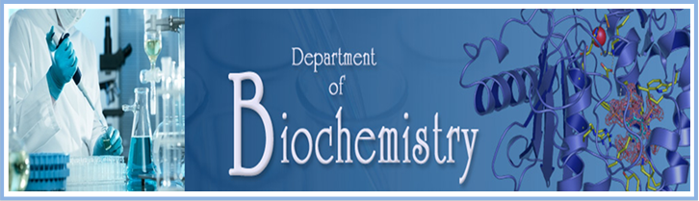
REPORT ON NATIONAL WEBINAR-07-10-2020
With the blessings of Pazhassiraja college Management, having constant encouragements of our respected Principal Dr.Anilkumar, a NATIONAL WEBINAR is conducted in order to enhance the knowledge about the role of Dermatoglyphics in genetic disorders of our faculties and students, the department of Biochemistry is hosting on the following schedule and the topic:
Topic: “DERMATOGLYPHICS AS A GENETIC TOOL IN ANALYSING GENETIC DISORDERS”
Date: OCTOBER 7^{th,} 2020
Resource person: Dr. SREENIVASA G
Time: 2.00PM to 4.00PM
About the speaker: Dr. Sreenivasa G is an Asst. Professor working in Department of studies in Zoology Davangere university. He is continuing his research in Zoology with rich experience in the field of human genetics, cytogenetic and cell biology, striving to contribute to the research and development for the benefit of human welfare. He was awarded Sri Neelakantaiah Lalithamma memorial cash award for the best oral presentation at 14th conference of the society of cytologist and geneticists and bio entrepreneurship summit BIET and SSMR Davangere 6 to 8 March 2018. His area of research focused on understanding the genetical and environmental factors affecting on human health
Description: During this webinar, he shared about the specific study of the skin ridge patterns on the fingers, toes and palms of the hand and soles of feet. Dermatoglyphics is in use as as supportive diagnostic tool in genetic or chromosomal disorders as well as in clinical conditions with genetic etiologies.
Program: For this Webinar, registration link using whatsapp and password was created. The link was circulated among students and faculties of Science departments of various colleges. More than 100 participants both Teaching Faculty Members and Students have participated. At the beginning, Dr.Jomet K Sebastian, HOD/ Biochemistry gave a welcome address to the participants and after the presentation Department secretary, delivered the vote of thanks. From the WEBINAR, the participants had the opportunity to know about the tools to develop innovative projects using science and technology.
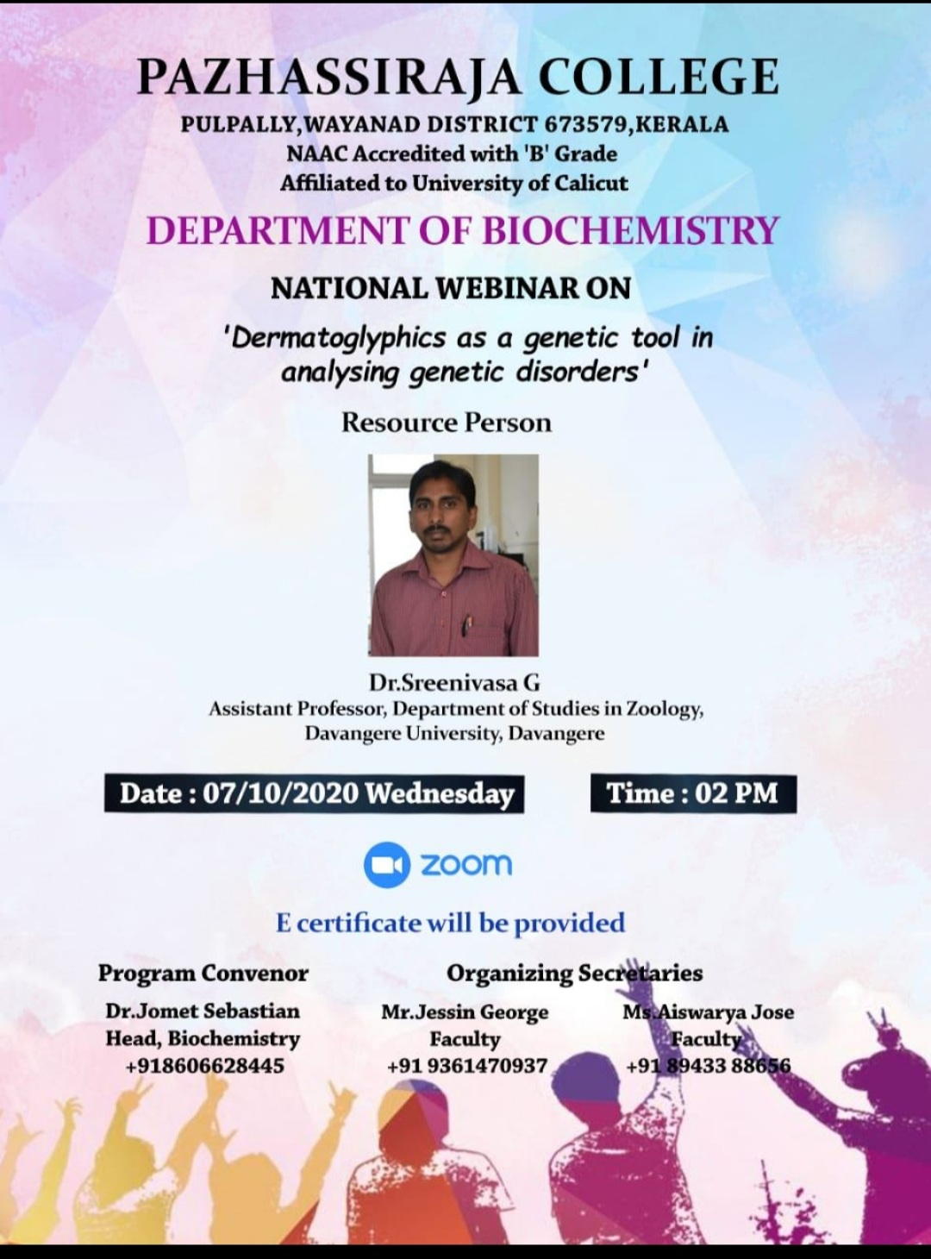
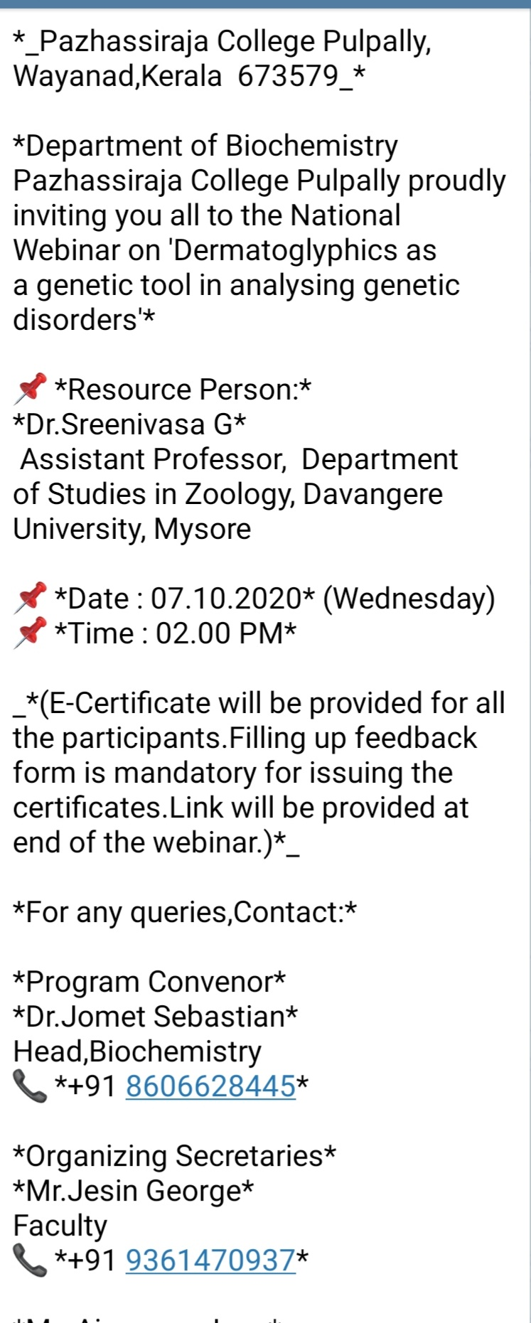

CERTIFICATES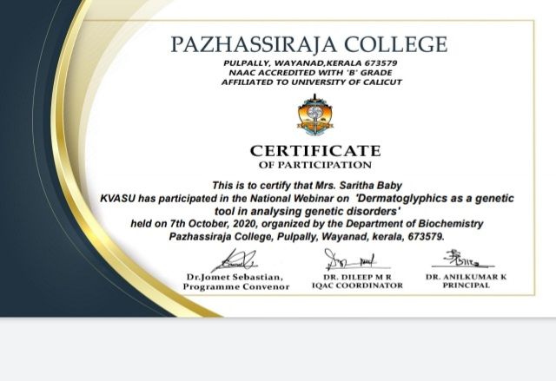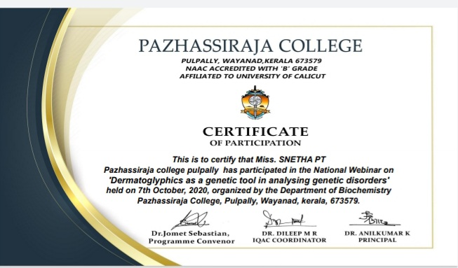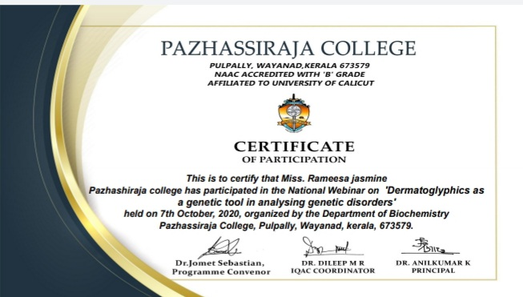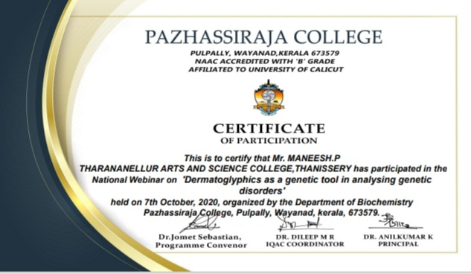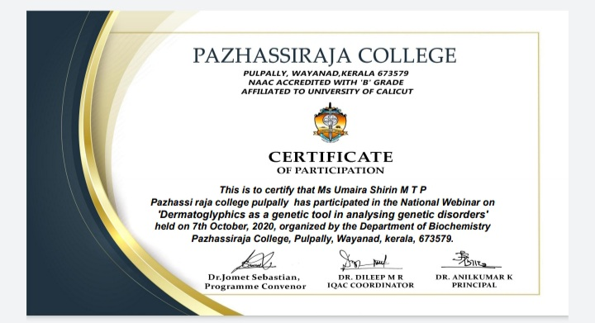

SIGNATURE OF HOD SIGNATURE OF PRINCIPAL

