07/09/2021

PERIODISTA
A National Webinar
on
Ethics and Morality in Journalistic Reporting

Report
- Session title :Ethics and morality in journalistic reporting
- WelcomeAddress :Mrs. Silpa Mathew, Assistant professor(HOD) department of MCJ
- Inagural Address :Dr.AnilkumarK,Principal,PazhassirajaCollege

Felicitation. : Fr. Varghese Kollamavudy, CEO, Pazhassiraja college

: Dr. Dileep M.R, vice principal, pazhassiraja college
- Speaker : Dr. Varghese P A, professor, Kuvempu university
- Student coordinatord :Anantharaj D R, Anusha N K
- Date and time :05/10/2020, 11AM
- Host :Miliya Sebastian, student, MA MassCommunication
- Platform :Zoom

Introduction to the event
The department of Mass Communication and Journalism, Pazhassiraja College organised webinar on 'Ethics and Morality in Journalistic reporting'. Dr. Varghese P A, Professor in Kuvempu University, Karnataka was invited to speak in the webinar. The session was organized in Zoom cloud meetings, and more than 150 participants actively attended the session. Principal, Dr Anil kumar inagurated the webinar.

Objectives of the Session
Thesessionhadthefollowingobjectives
- To discover the ethics and morality in journalistic reporting.
- To learn more about fake news and disinformation.
- To empower young journalists against fake news.

Description
The session started with welcome speech of Mrs. Silpa Mathew, HOD, Department of Mass Communication and Journalism. The webinar was inagurated by Dr. Anil Kumar, Principal, Pazhassiraja college. He gave a detailed picture on the importance of ethics in journalism. The felicitation was delivered by Fr. Varghese Kollamavudy, CEO, Pazhassiraja college.
The speaker for the webinar, Dr. Varghese P A has shared his thoughts on ethical news reporting. He also shared some examples of newspaper reoprts and detailed how the journalism is ruined because of sensationalism and TRP ratings. Besides the standard ethics, the morality should be inbuilt in journalist is also shared. He drew the attention of entire listeners by narrating plethora of examples from his own experience and current affairs.
Anantharaj D.R student coordinator proposed the vote of thanks. Ms. Miliya Sebastian, student from MA Mass communication hosted the event. Faculty member and organising secretary of the webinar, Mrs Silpa Mathew coordinated the entire event.

Out put of the session
- The participants were given an in-depth understanding on the ethics and morality news reporting.
- The various aspects of truthful reporting and relevant examples from present and ast
- The session was highly interactive and all the concerns from the audience with regard to the topic of discussion were addressed by the speaker.

EventPoster

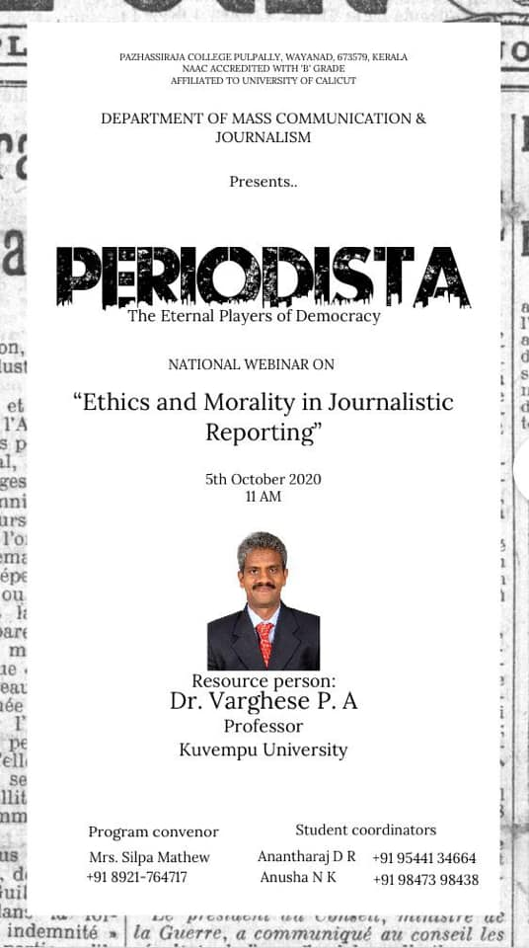

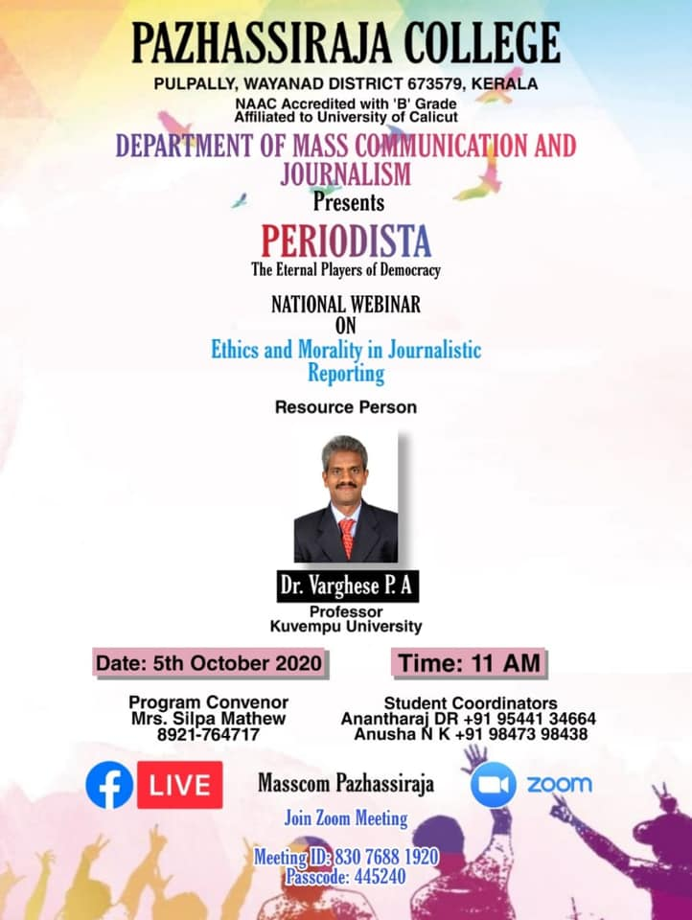

Screenshots



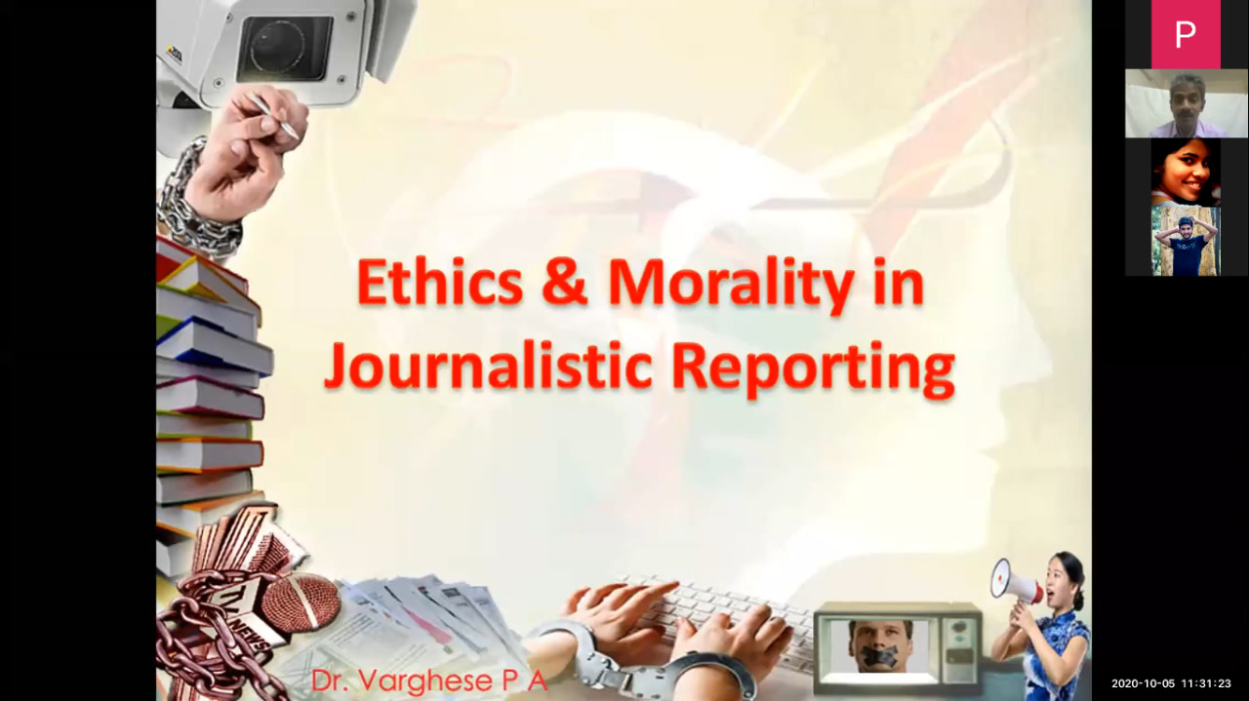
Presentation on Zoom

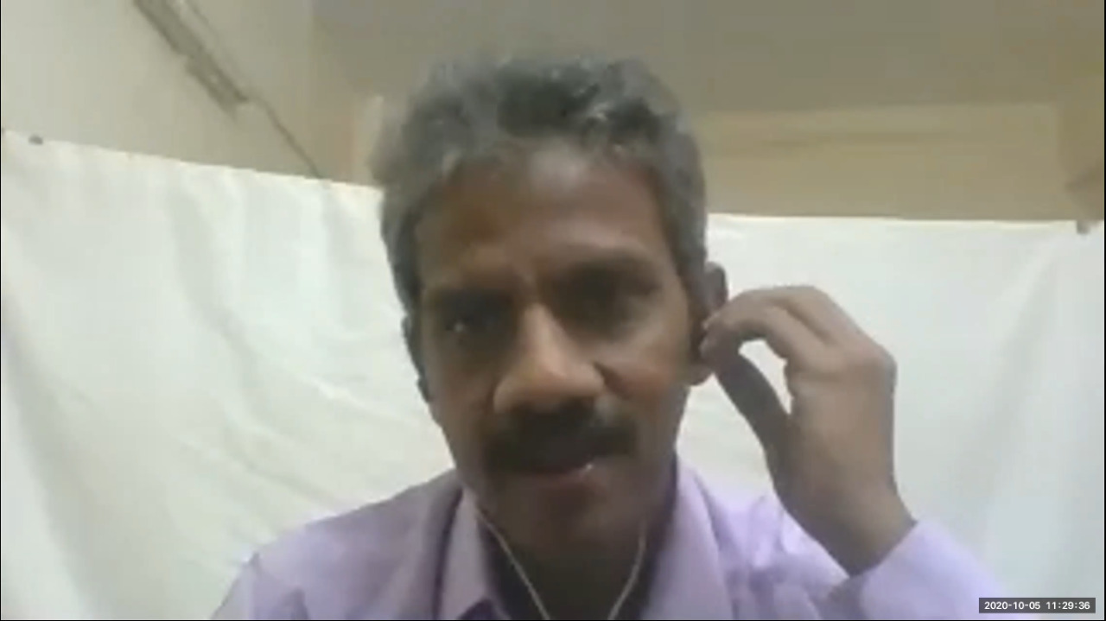

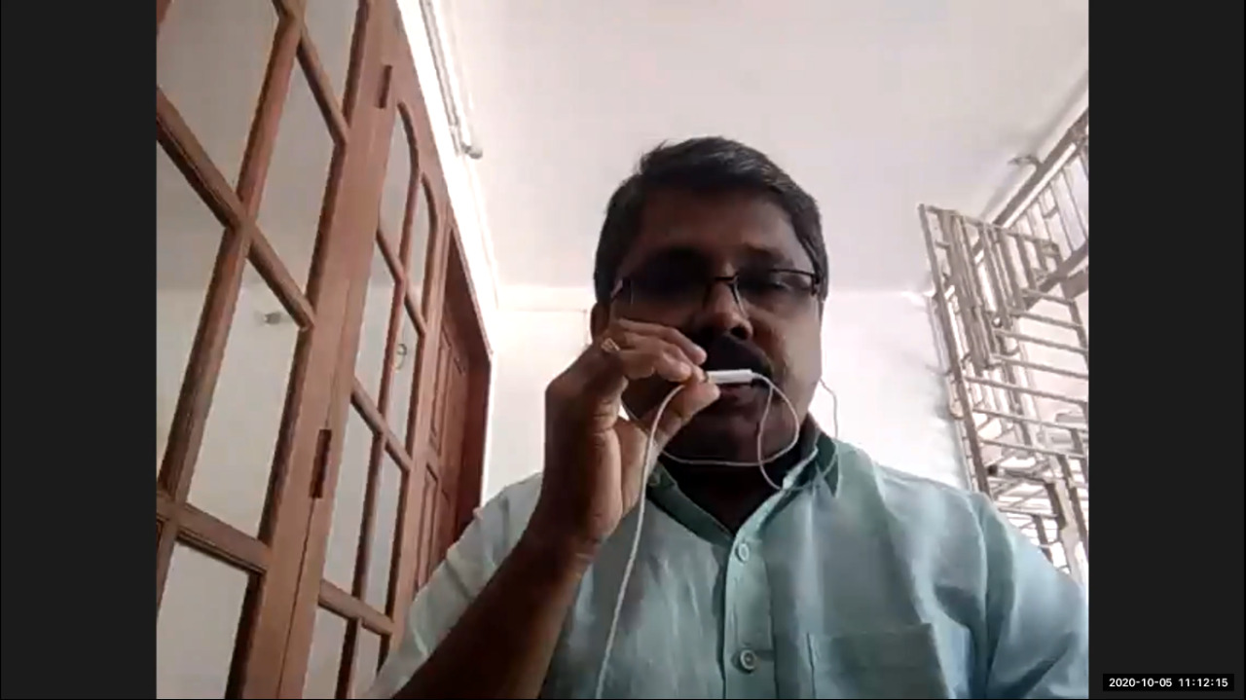
Speaker Dr Varghese P A, professor, Kuvempu University

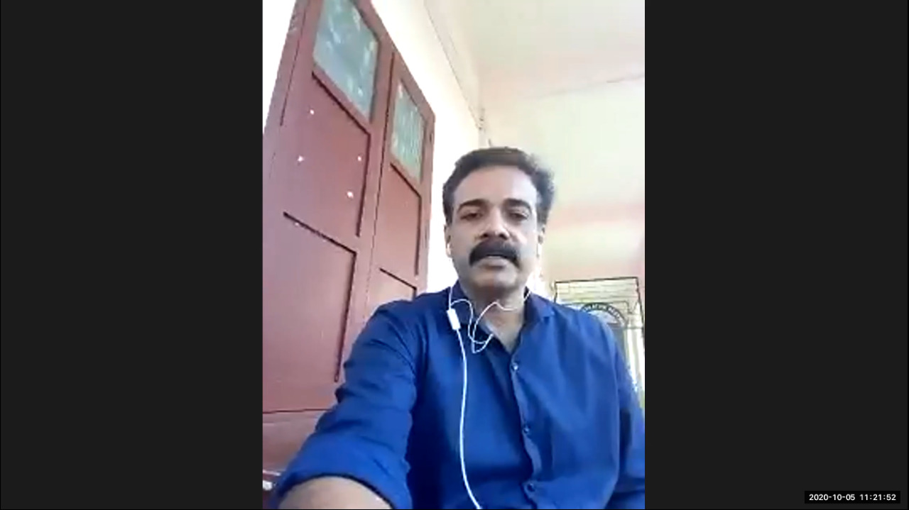
Dr. Anil Kumar, principal, pazhassiraja college

Dr. Dileep M R, vice principal, pazhassiraja college
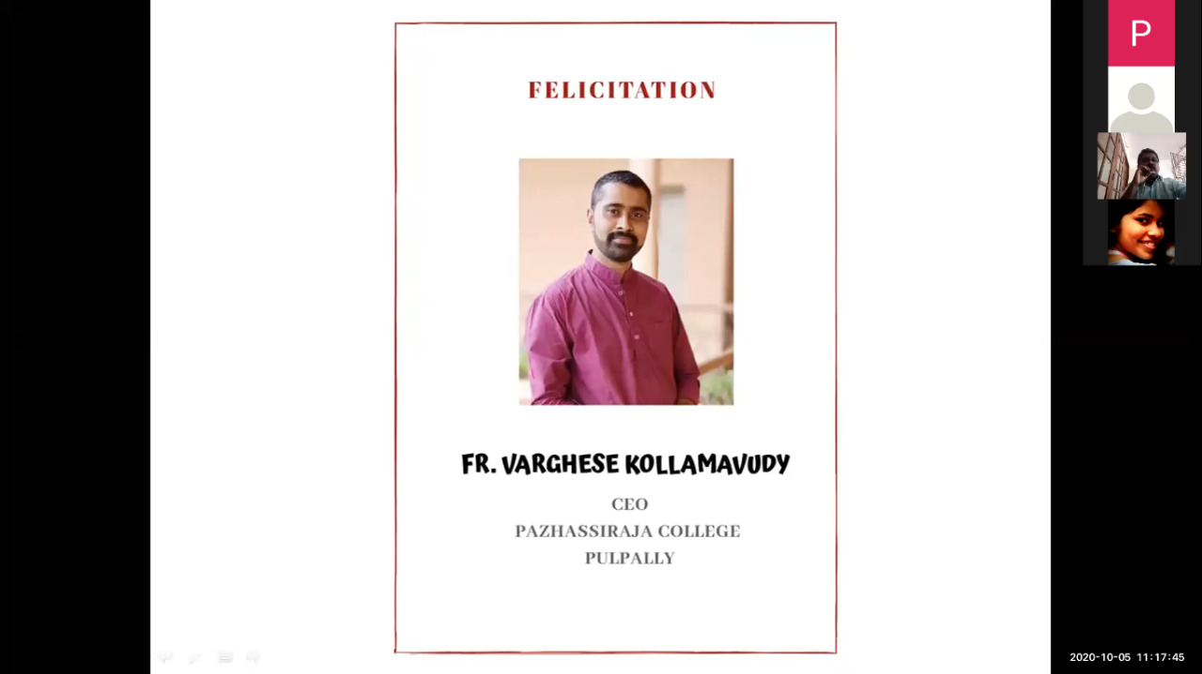

Fr. Varghese Kollamavudy,CEO, Pazhassiraja college

Program schedule
