National Service Scheme
University of Calicut
Proforma for submitting annual Report 2019-2020
1. Name of College:- Pazhassiraja College, Pulpally
2. Unit No:71
3. Name of Programme Officer:Ms. Neetha Francis
4. Adopted Village: Pulpally
5. Enrolment Details:(2019-2020)

O.C |  |  | S.C |  |  | S.T
Male | Female | Total | Male | Female | Total | Male | Female | Total
24 | 23 | 47 | 2 | 4 | 6 | 0 | 1 | 1

6. Details of special camp conducted during the year:

Details of the Camp (Place,date, Venue) | No of Volunteers attended |  |  | Work undertaken | Status of Work
Details of the Camp (Place,date, Venue) | Male | Female | Total | Socio-economic survey, Ground construction | Completed
Govt. L P School, Kaithakkal  20-12-2020 | 24 | 24 | 48 | Socio-economic survey, Ground construction | Completed

7. Training Status of Programme Officer:- Trained

8. Status of Abhayam Project (So far)

Sl No | Beneficiary name & Address | Status | Photo of House
1 | Mr. Kumaran  Palathanath House  Marakavu, Pulpally | Identified and started fund collection

9. Status implementation of “Koode”

No of Programmes Conducted
No of Children helped
No of Contact points established.

10. Environmental enrichment Programme

No of plantation Programmes Conducted | 2
No of Saplings Planted | 220
No Environmental Awareness Programmes Conducted | 1

11. Blood Donation

No of Programmes / Camps Conducted
No of volunteers donated blood
No of Units of Blood donated

12. Water Harvesting / Water resource restoration / Distilation

No of water bodies cleaned | Well
No of water bodies cleaned | Pond
No of water bodies cleaned | River
No of water bodies cleaned | Check dam
No of Water bodies restored / rejuvenated | Well
No of Water bodies restored / rejuvenated | Pond
No of Water bodies restored / rejuvenated | River
No of Water bodies restored / rejuvenated | Check dam
No Water Harvesting bodies constructed | Well
No Water Harvesting bodies constructed | Pond
No Water Harvesting bodies constructed | River
No Water Harvesting bodies constructed | Check dam
Water resource – Awareness Programmes

13. Agricultural Activities

Area of Cultivation( give details of Crops)
Monitory Value created
Assistance / Awareness to farmers

14. Awareness Programmes / Seminars

Medical Camps
Pulse Polio immunization
Anti Narcotic / Anti Drug Awareness | 1
Women Empowerment
Swachh Bharath | 1
Jal Shakthi
Basic Life Support | 1
Any other

15. Bio Diversity Parks

Bio Diversity parks Constructed | Campus
Bio Diversity parks Constructed | Public Places
Bio Diversity parks Constructed | Adopted Vilaage

Attach detailed annual report with action photographs
PAZHASSIRAJA COLLEGE, PULPALLY, WAYANAD
ANNUAL REPORT OF NSS ACTIVITIES 2019-2020
UNITS 71 & 153

JUNE
World Environment Day- 05.06.2019
World Environment Day is celebrated every year on 5th June to spread awareness, to encourage people to take action and to protect the environment. People are more reluctant today to save the environment for the future and then only it will be possible to focus on the activities protecting nature. Planting of saplings were conducted by Pazhassiraja College NSS Units. 70 volunteers actively took part in the event and planted different saplings which were distributed to them by NSS Programme Officers Ms. Smitha Chacko and Ms. Neetha Francis.
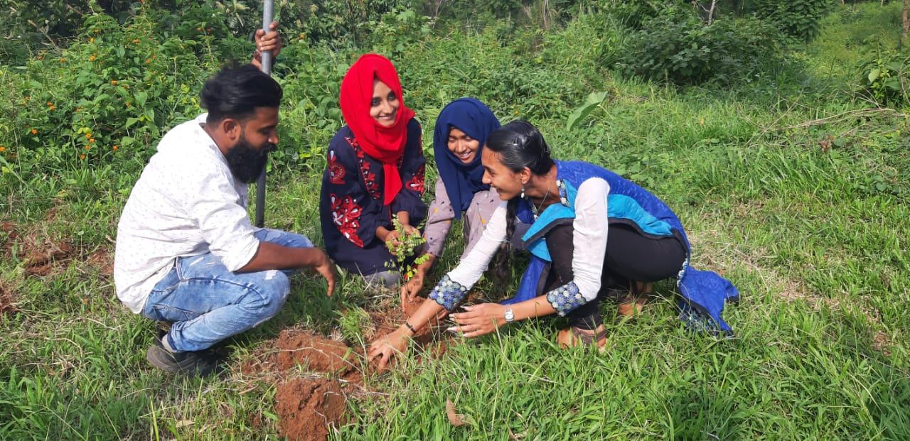
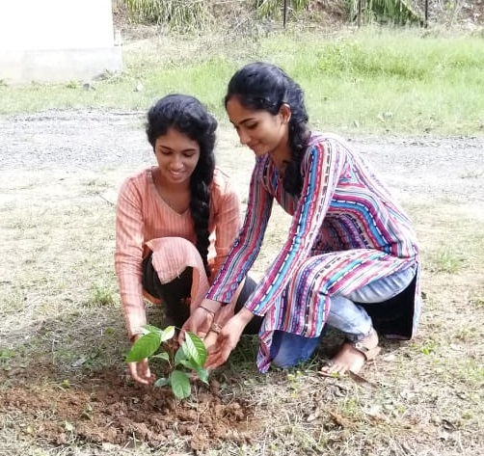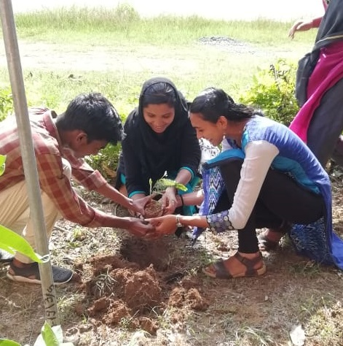
International Yoga Day- 21.06.2019
NSS Units (No. 071 & 153) of Pazhassiraja College, Pulpally celebrated International Yoga Day on 21-06-2019 at 10.00 AM in the College seminar hall. NSS Programme Officer Prof. Smitha Chacko welcomed the gathering. College Principal Dr. Dileep M R inaugurated the function and delivered the inaugural address. Mr. Prasad P D, renowned Yoga trainer handled the sessions. 72 students and 19 faculty members participated in the training programme. Students were motivated by the session and understood the importance of practicing Yoga. The function came to an end by 12.30 PM.
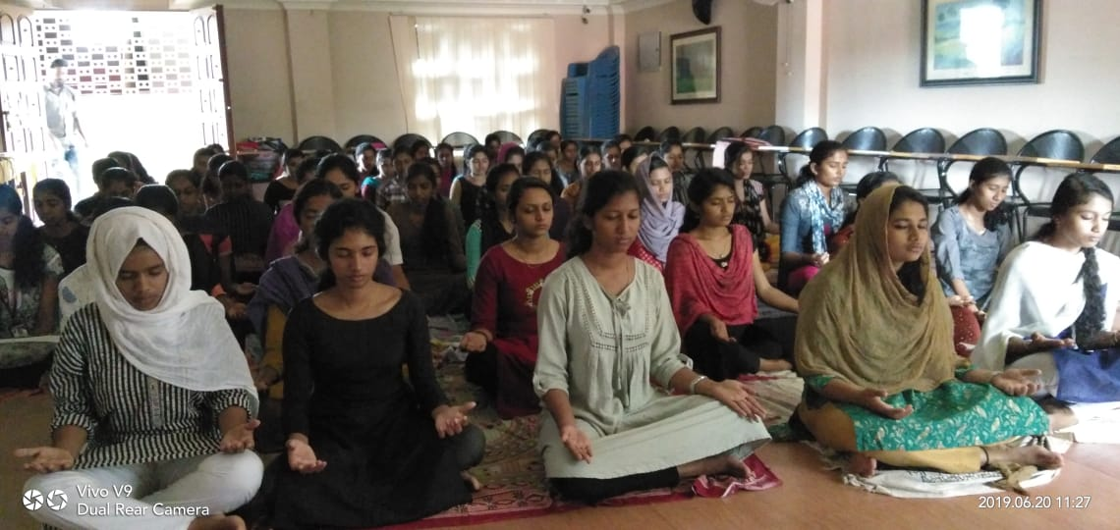
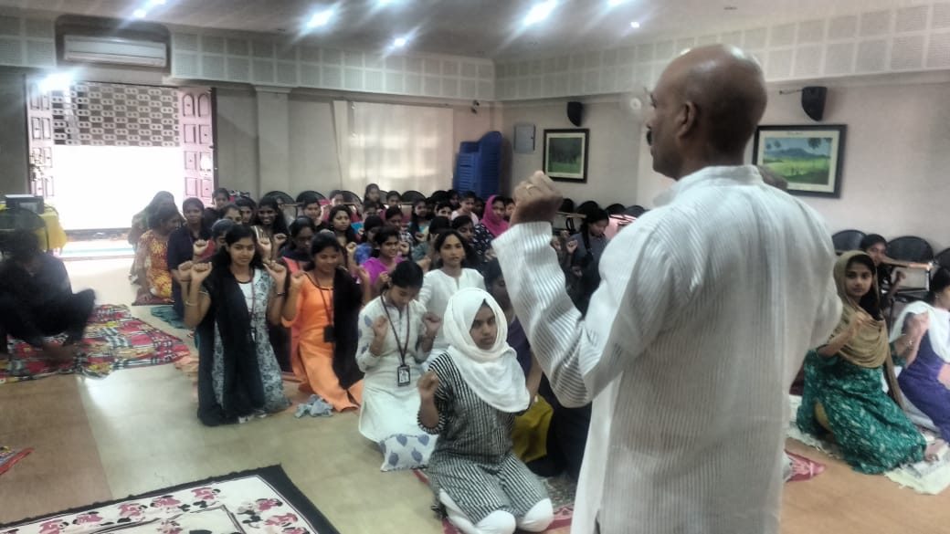
Day Against Drug Abuse on 26.06.2019
As part of day against drug abuse, NSS volunteers of Pazhassiraja College conducted an inter-departmental essay writing competition on ‘Youth and Drugs’ at 12.00 PM in the computer lab. We also conducted a rally from College gate to Pulpally town on 26th June at 2.00 PM. Principal in charge Dr. Dileep M R presided the function and CEO Fr. Varghese Kollamavudy inaugurated the rally. Around 120 students participated in the rally. NSS Programme Officers Ms.Smitha Chacko, Ms. Neetha Francis and other teachers accompanied the students in the rally. Student were made aware about negative effects of drugs and took pledge to avoid use of drugs. They displayed messages against drugs in placards. The rally came to an end by 3.00 PM.
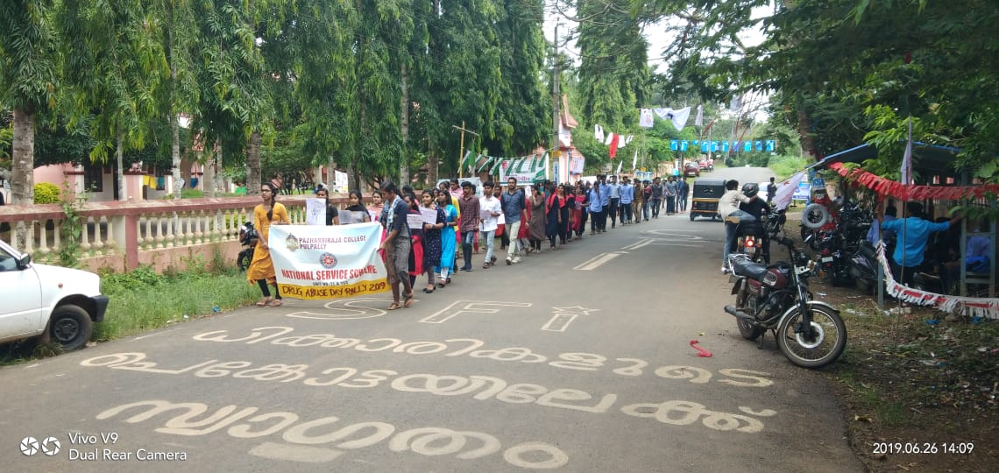
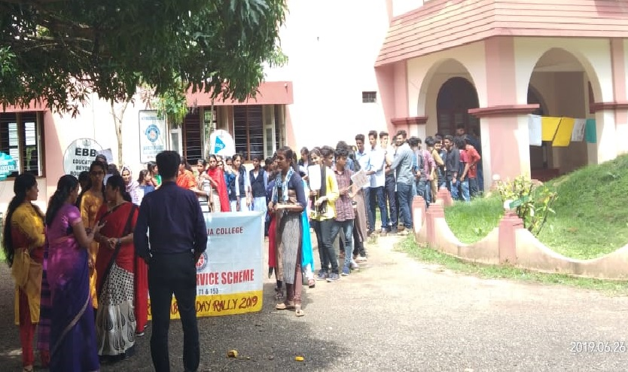
JULY
BASIC LIFE SUPPORT (BLS) TRAINING PROGRAMME

NSS Units of Pazhassiraja College organized ‘BASIC LIFE SUPPORT (BLS) TRAINING PROGRAMME’ in association with Wayanad Institute of Medical Sciences (DM WIMS), Meppadiat 10.30 AM on 19-07-2019. The programme was presided over by CEO Rev. Fr. Varghese Kollamavukudy and inaugurated by Vice Principal Dr. Dileep M R. A team of 4 members led by Mr. Nithyanand, Training Co-ordinator, WIMS handled the training sessions. 84 NSS Volunteers participated and acquired the basic life support skills through the training. The programme was so effective and useful for the participants. It was co-ordinated by NSS Programme Officers Ms. Smitha Chacko (Unit - 153) and Ms. Neetha Francis (Unit - 71). The programme came to an end by 1.30 PM.
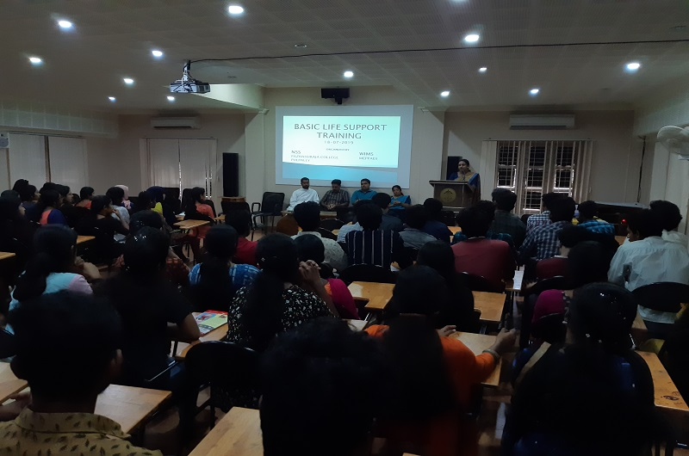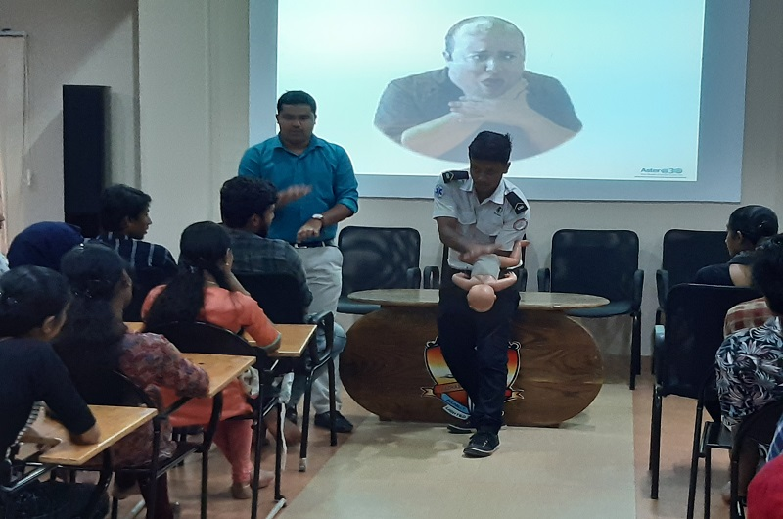
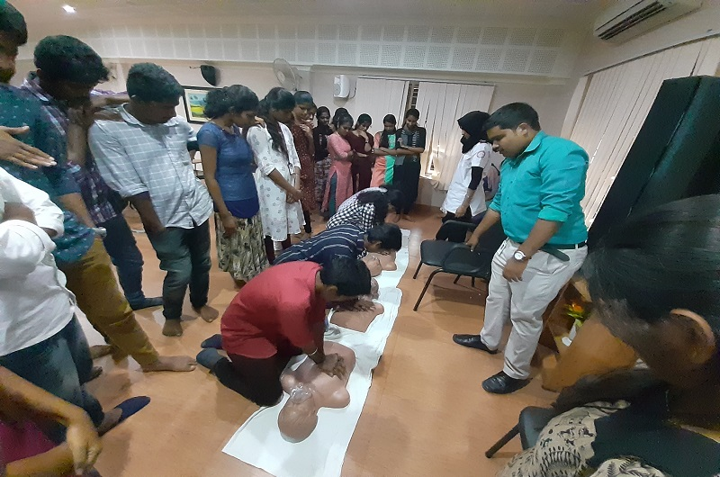

CAMPUS CLEANING
It is very important to keep our surrounding clean as it is the season of communicable diseases. So the NSS volunteers actively participated in the ‘CLEAN CAMPUS PROGRAMME’ organized on 23-07-2019. 68 volunteers participated in the programme and it was a grand success.
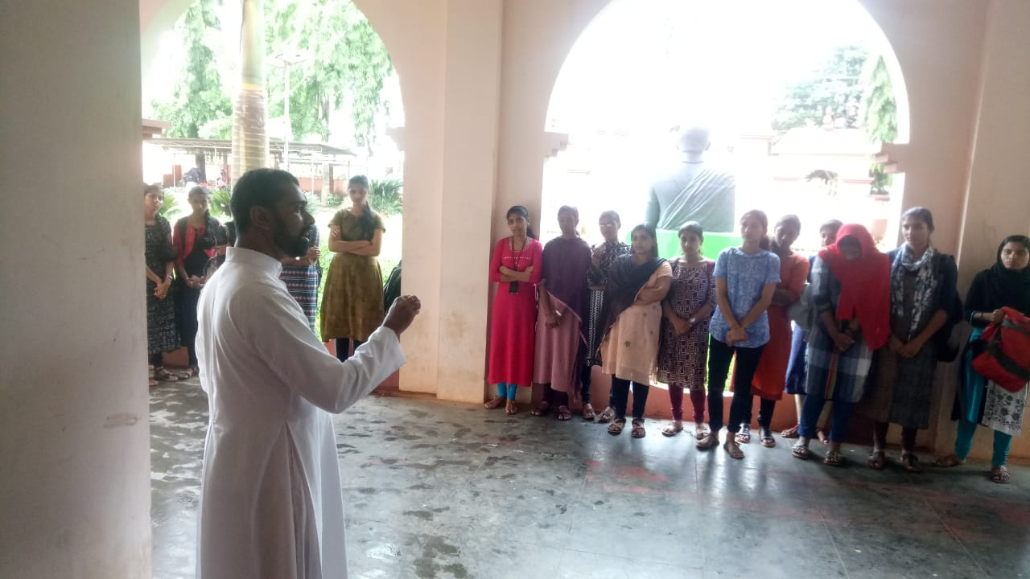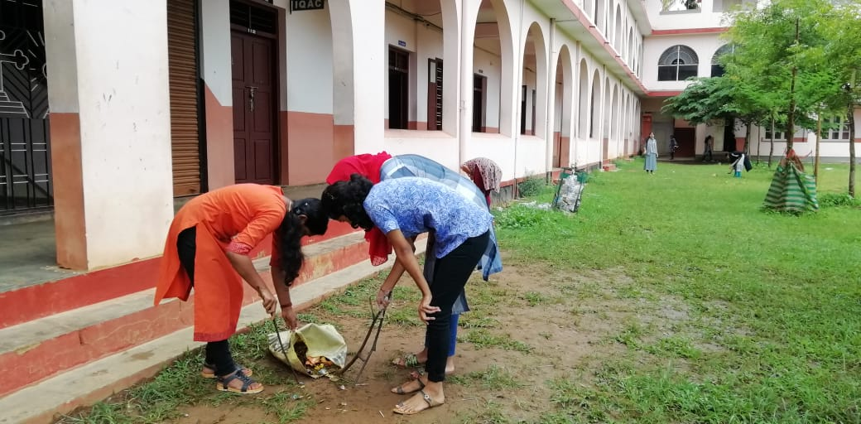
AUGUST
The details and photographs of the flood related activities in which the volunteers had taken part is given in the table.
1 | Joined in Quick Response Team, Wayanad for the flood relief activities co-ordination | 07-08-2019
2 | Perikalloor & Pulpally camp visit and participated in food distribution | 08-08-2019
3 | Dress materials and essential items collected for relief camps | 09-08-2019
4 | Nadavayal camp visit | 09-08-2019
5 | Nadavayal camp –helping in food preparation | 10-08-2019
6 | Materials distributed for Perikalloor&Pulpally camp | 10-08-2019
7 | Volunteered in relief activities in Pulpally camp | 11-18-2019
8 | Cleaning houses at Chekadi | 12-08-2019
9 | Visited and helped in Kappunchal&Cherukattoor camps | 12-08-2019
10 | Cleaning houses at Meenamkolly | 13-08-2019
11 | Cleaning houses at Paakom | 14-08-2019
12 | Sorting flood relief kits in Pulpally | 14-08-2019
13 | Cleaning houses atChekadi | 15-08-2019
14 | Camp visit at Nadavayal&Panamaram | 16-08-2019
15 | 1)Collection of things at S K M J Kalpetta from NSS Units of Palakkad  2)Sorting of items at St. Mary’s College, Bathery | 17-08-2019
16 | Flood relief kit distribution in Pulpally | 19-08-2019
17 | Flood relief kit distribution in Boodanam | 20-08-2019
18 | Flood relief kit distribution in Pulpally | 21-08-2019
19 | Flood relief kit distribution in Pulpally | 22-08-2019

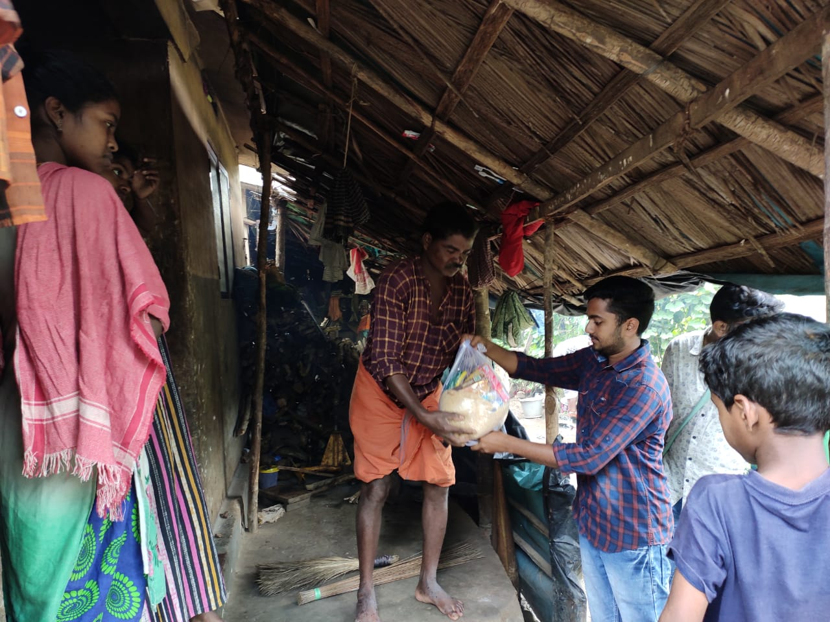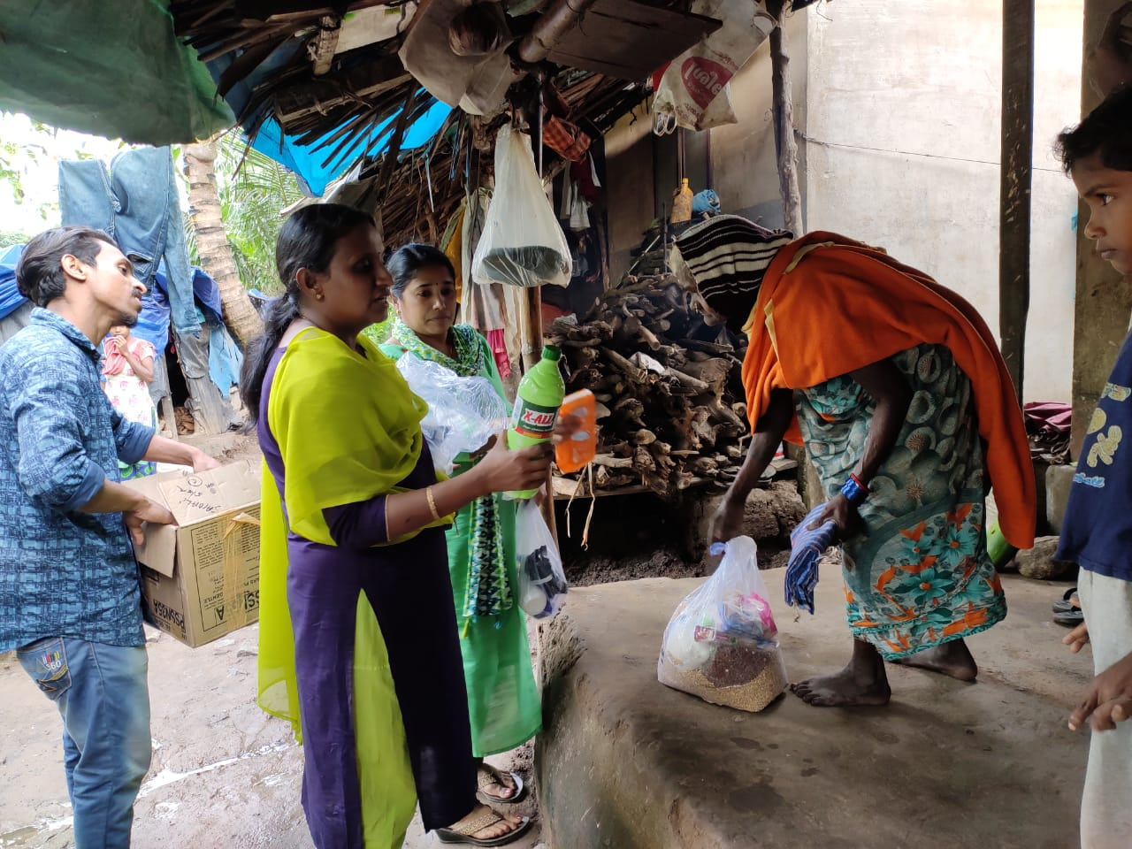
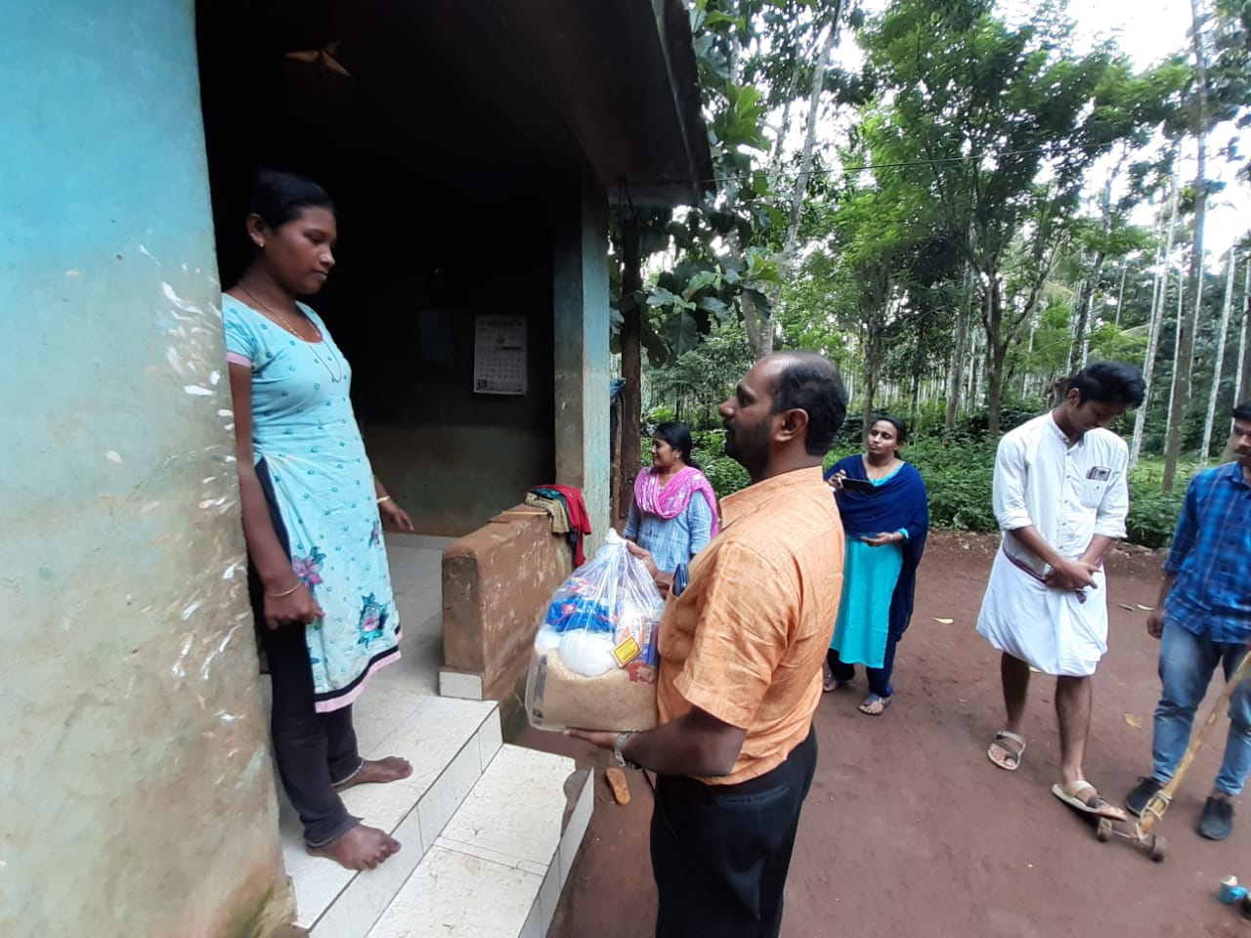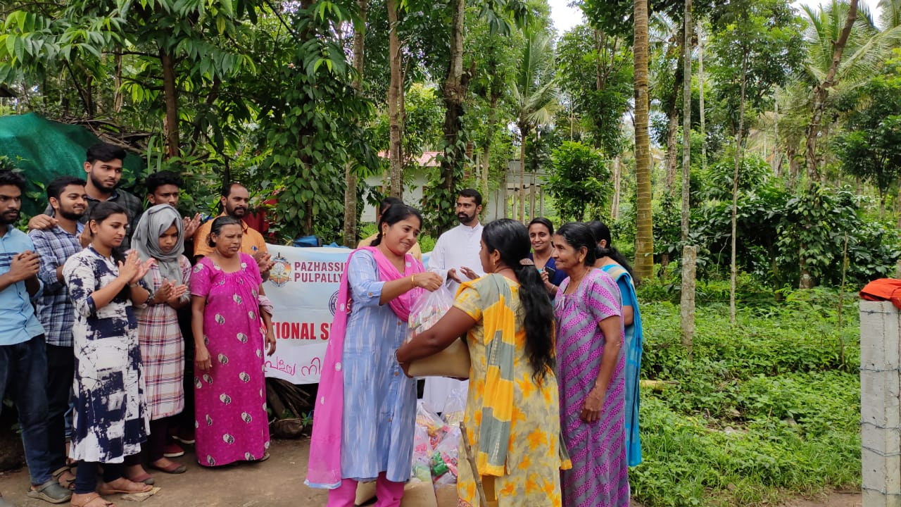

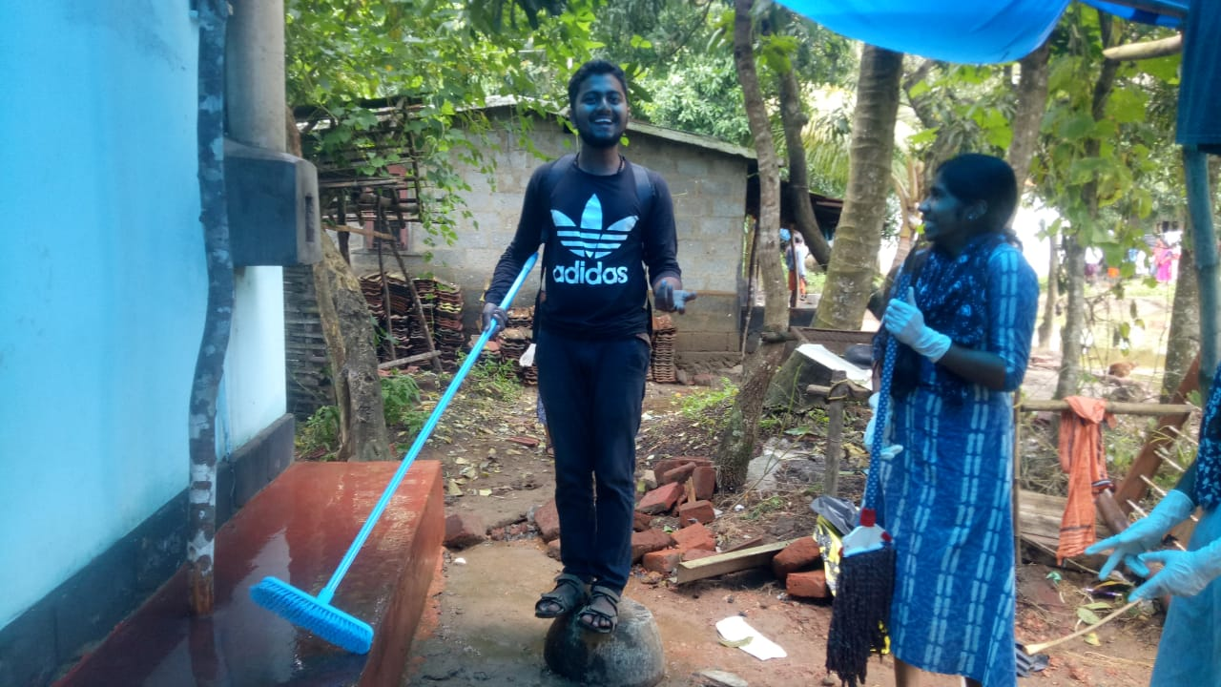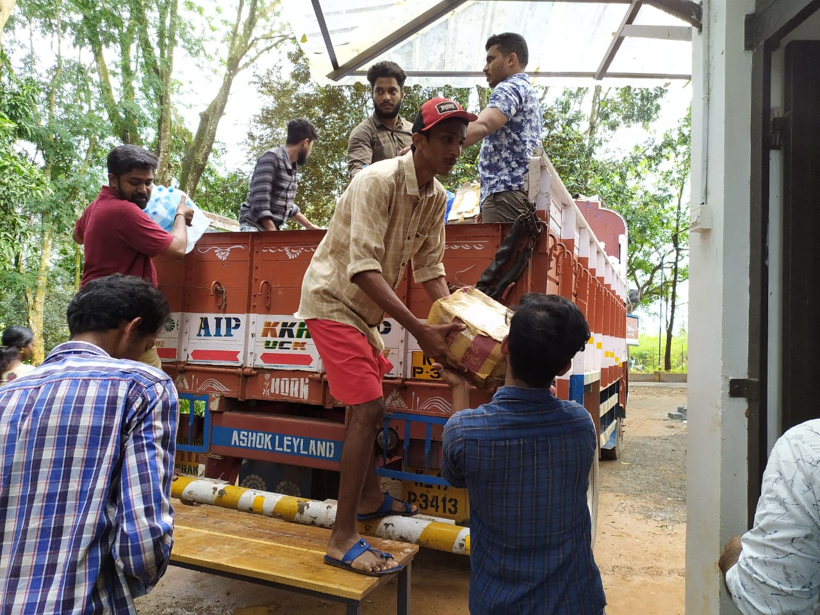

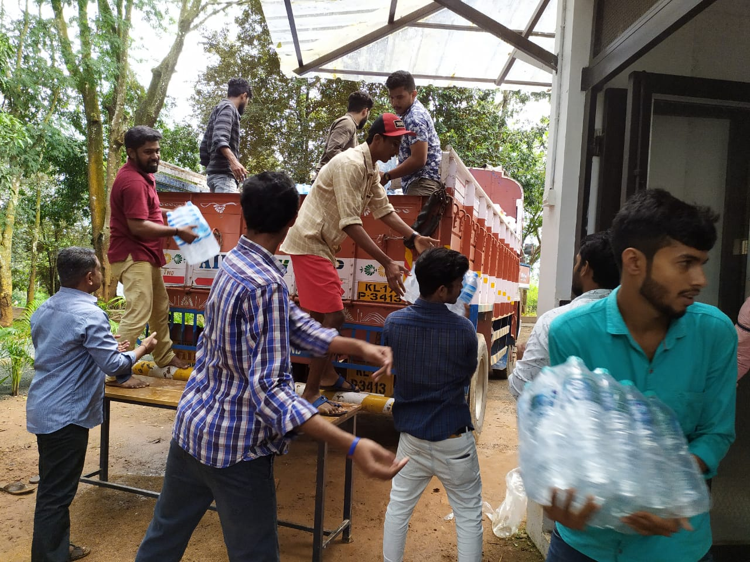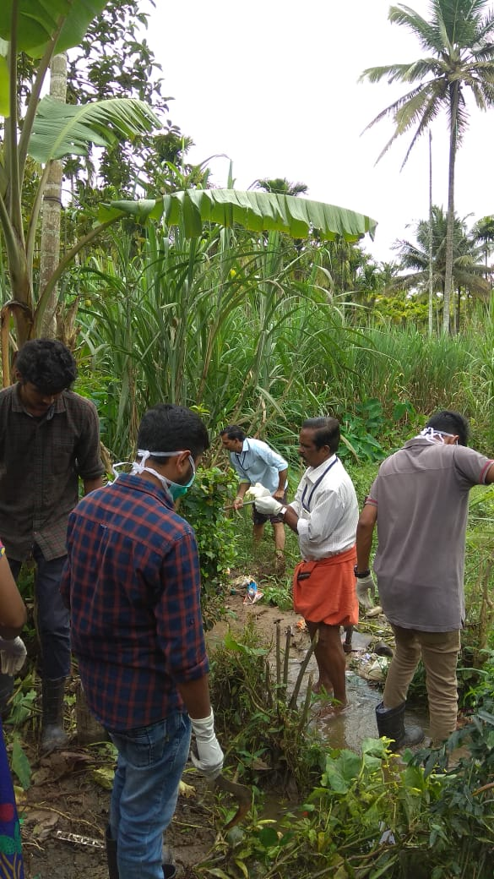
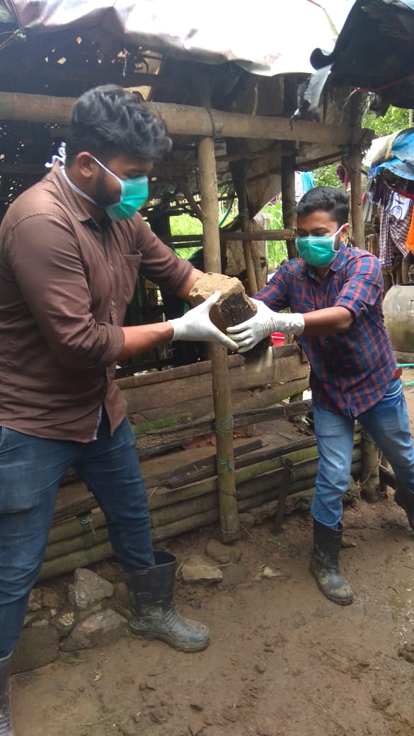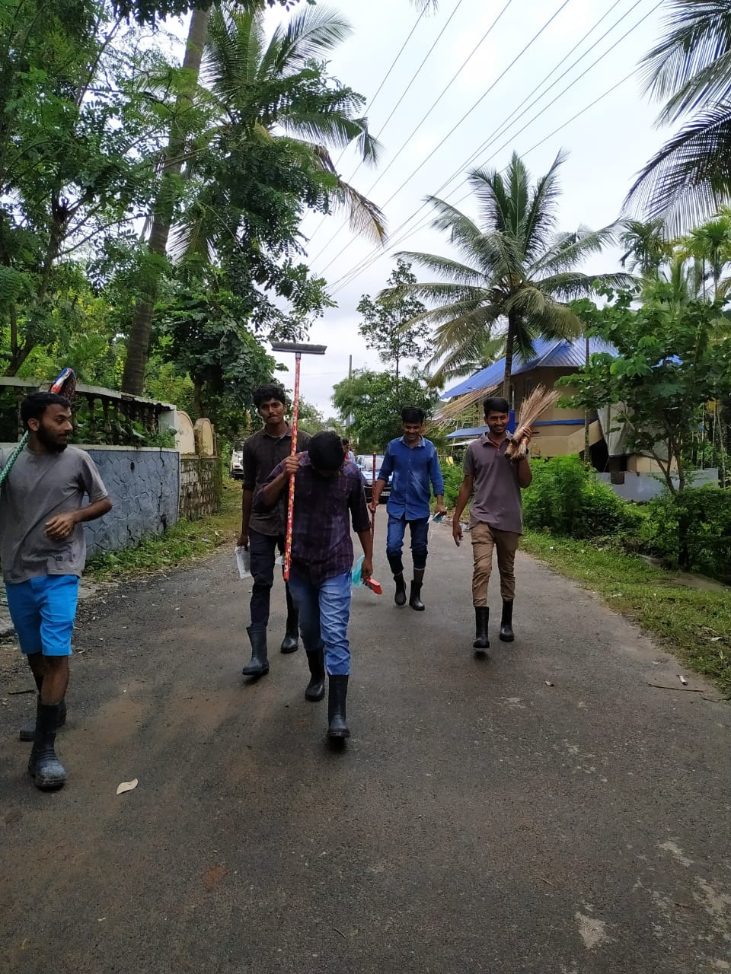

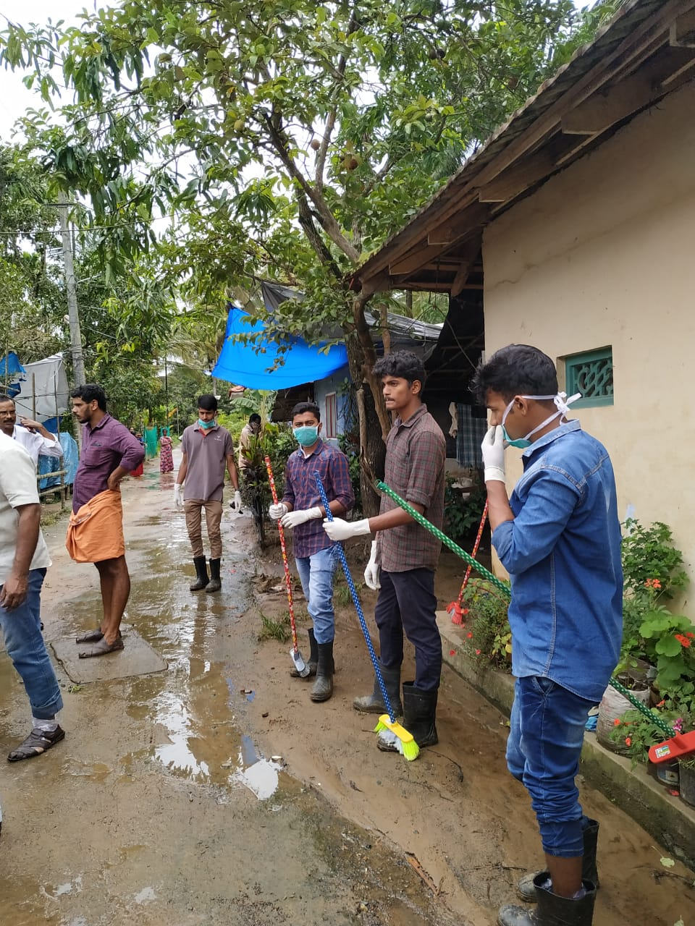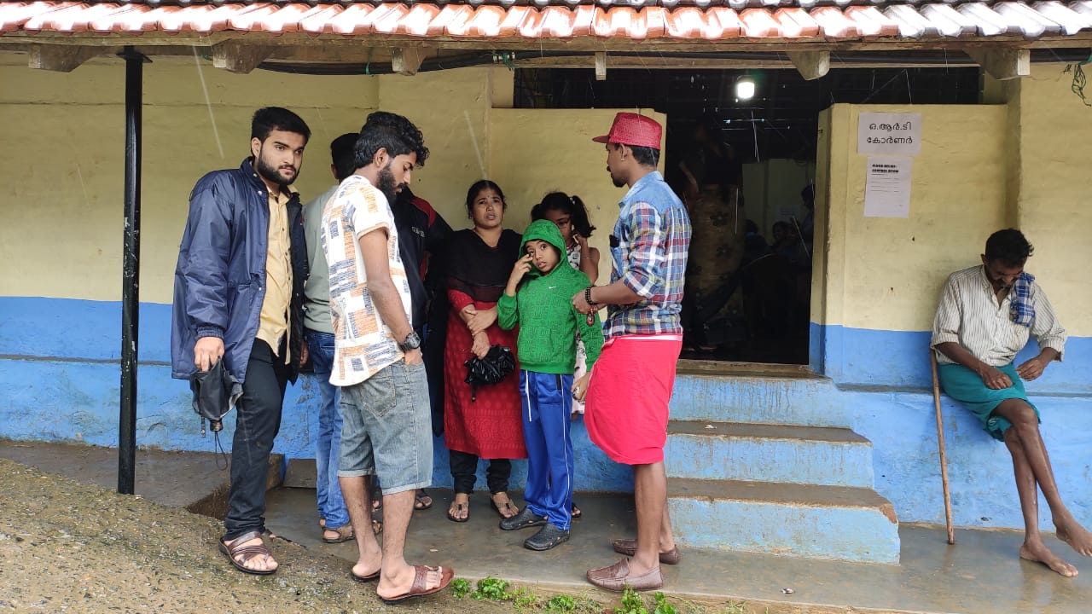

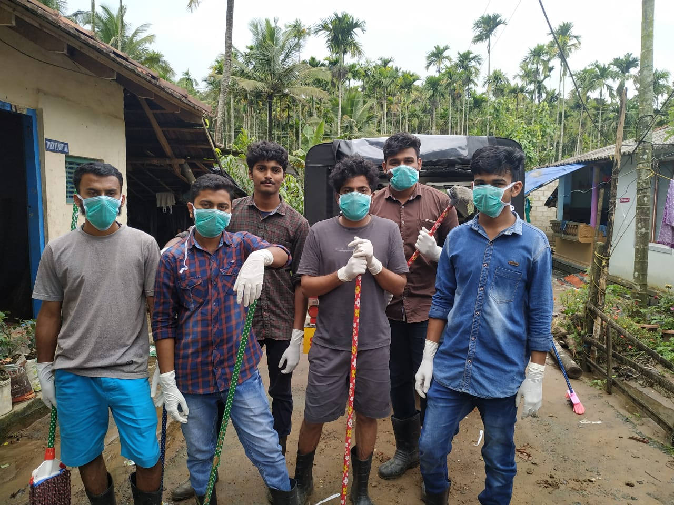
ANNUAL REPORT ON NSS FOR THE YEAR 2019-20
(April 1st 2019 to March 31st 2020)
SEPTEMBER – DECEMBER

Orientation Programme for first years
NSS units of Pazhassiraja College (Unit No: 71 & 153) celebrated NSS Day and Golden Jubilee of NSS in the College auditorium on 24-09-2019 at 1.30 PM. An orientation programme on ‘The Importance of NSS’ was conducted at Chithrasala by former NSS Programme Officer Dr. Joshy Mathew for the newly joined volunteers. It started with the NSS song. Principal Dr. Anilkumar K, CEO Fr. Varghese Kollamavudy, Programme Officers Ms. Smitha Chacko and Ms. Neetha Francis delivered falicitated on NSS Day. The programme was followed by planting saplings by Principal Dr. Anilkumar K and programme officers of two units. NSS volunteers actively took part in ‘Town Cleaning’ programme in connection with NSS Day 2019. About 120 volunteers participated in the programme. It was a grand success.
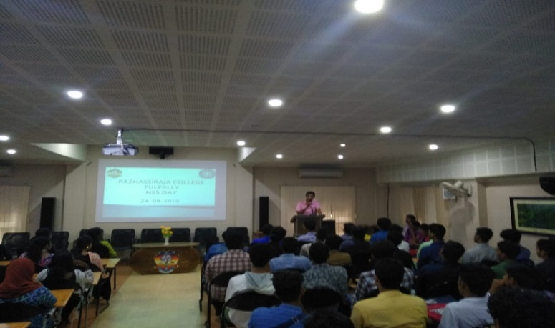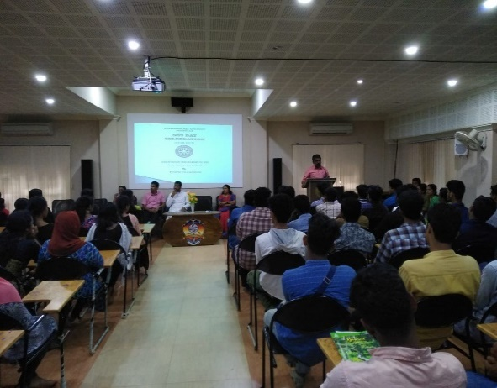
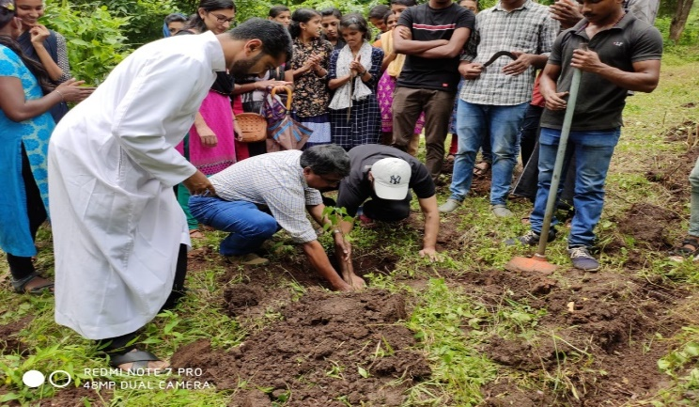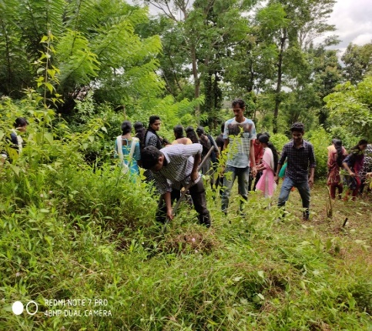

Campus Cleaning
NSS Volunteers actively involved in the Campus cleaning on 26-09-19. Every Wednesday and Friday the NSS volunteers in every class led a class cleaning activity and that is a regularized programme in the college initiated by the NSS units.
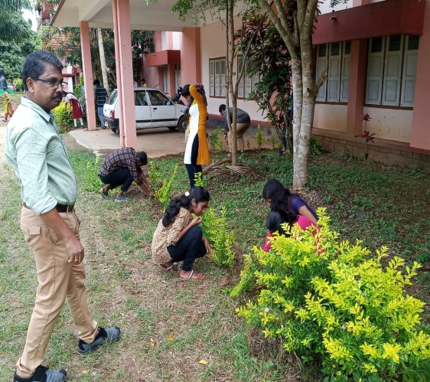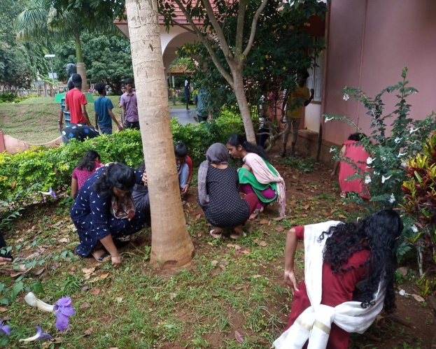
Observation of Vayojanadinam
Vayojanadinam was observed in association with Vayomithra, Kalpetta on 01-10-19.This day was an unforgettable day for the 20 NSS volunteers as this day opened a new insight in the volunteers. Our volunteers entertained the old aged people with many cultural programmes.
Gandhi Jayanthi observation
NSS Units observed Gandhi Jayanthi on 02-10-19 systematically. They have given awareness by our wise principal Fr. Varghese Kollamavkudiyil in this regard and the nearly 76 volunteers actively involved in the Campus and town cleaning in connection with Gandhi Jayanthi
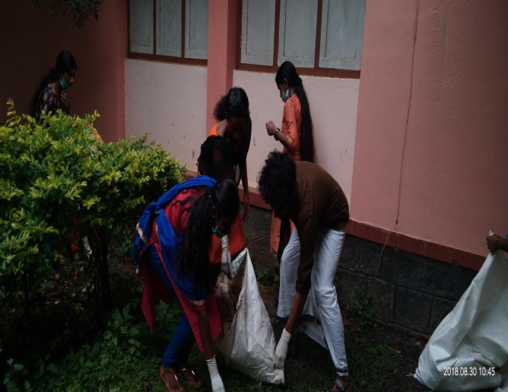i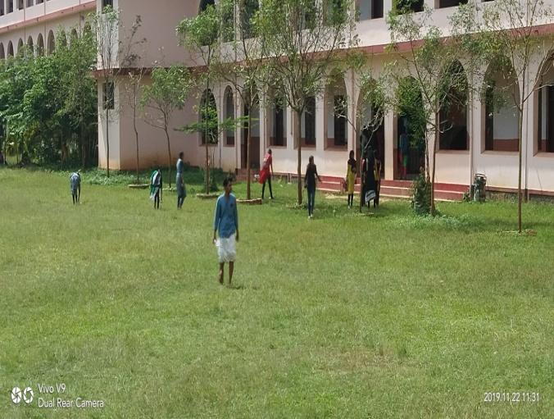

Orientation Programme
Orientation Programme for first years was conducted on 19-10-19. The class was led by Mr. Ameer Ali, Motivational Trainer. 89 Volunteers participated and they were grouped and given many group activities as a part of personality development and motivation.
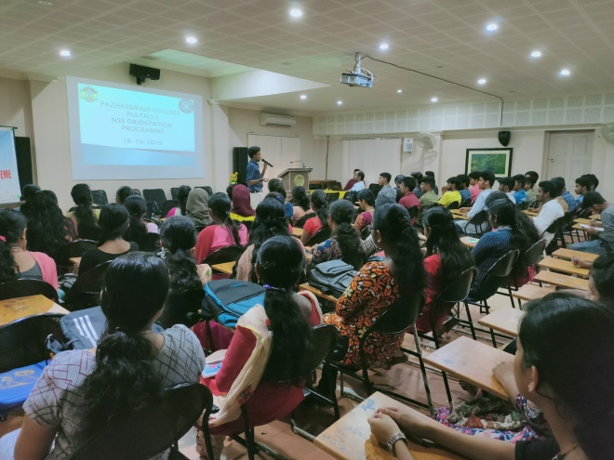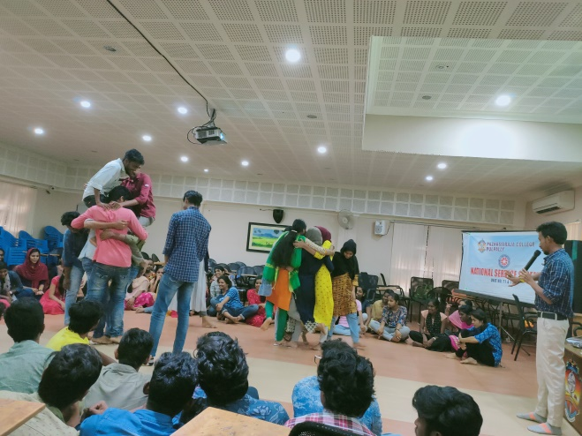

Documentary Release and Awareness Programme
Documentary release and Awareness Programme in association with Gudalloor Pain and Palliative Care Unit on 28-10-19. Dr. Sr. Savitha gave awareness on palliative care and the importance and the volunteers actively interacted with the team.
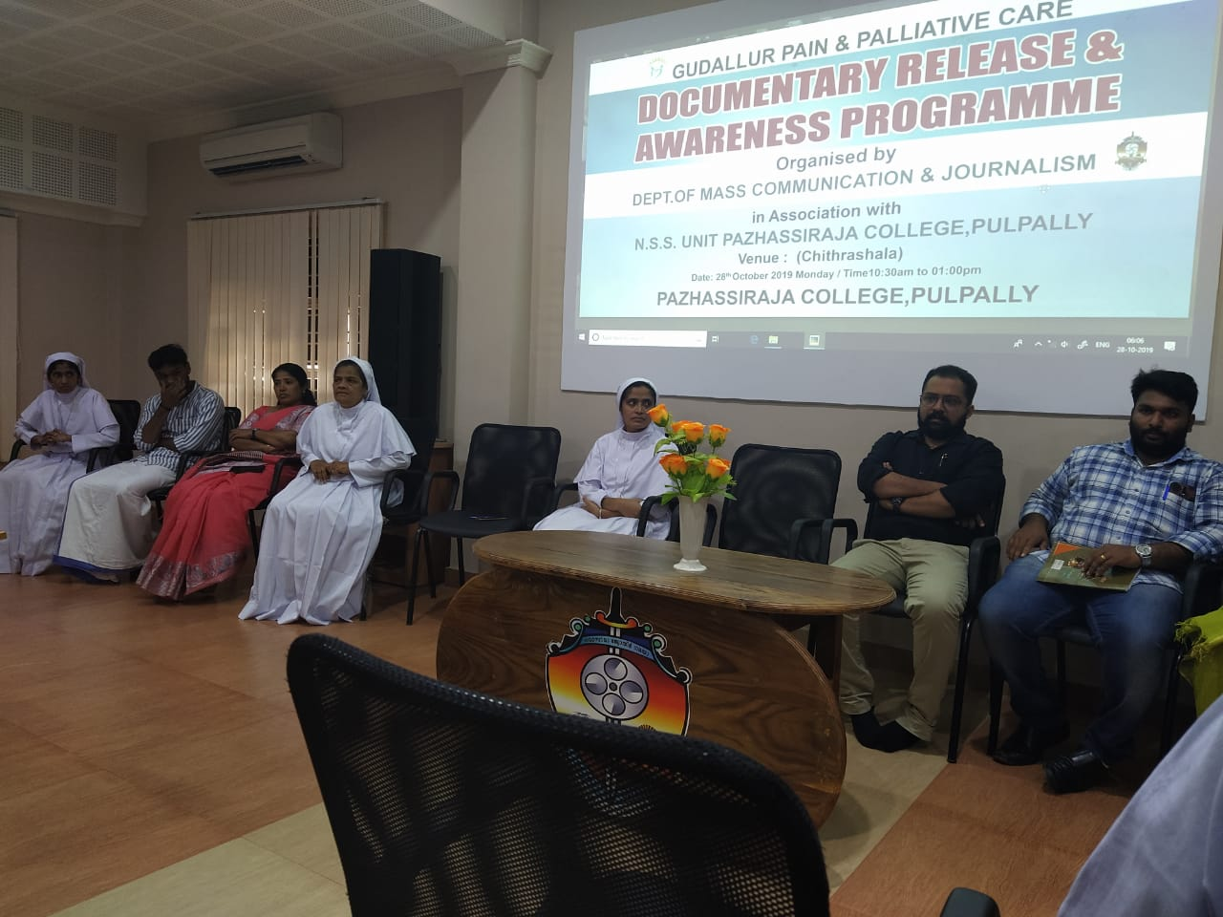
National Unity Day observation 0n 31-10-2019
National Unity Day was observed well in the campus starting with a message given by our Principal Dr. Anilkumar. Oath taking ceremony was organized in the chitrasala on this behalf. All the Volunteers and many teachers participated in the run from the college campus to the town; it was an outstanding programme
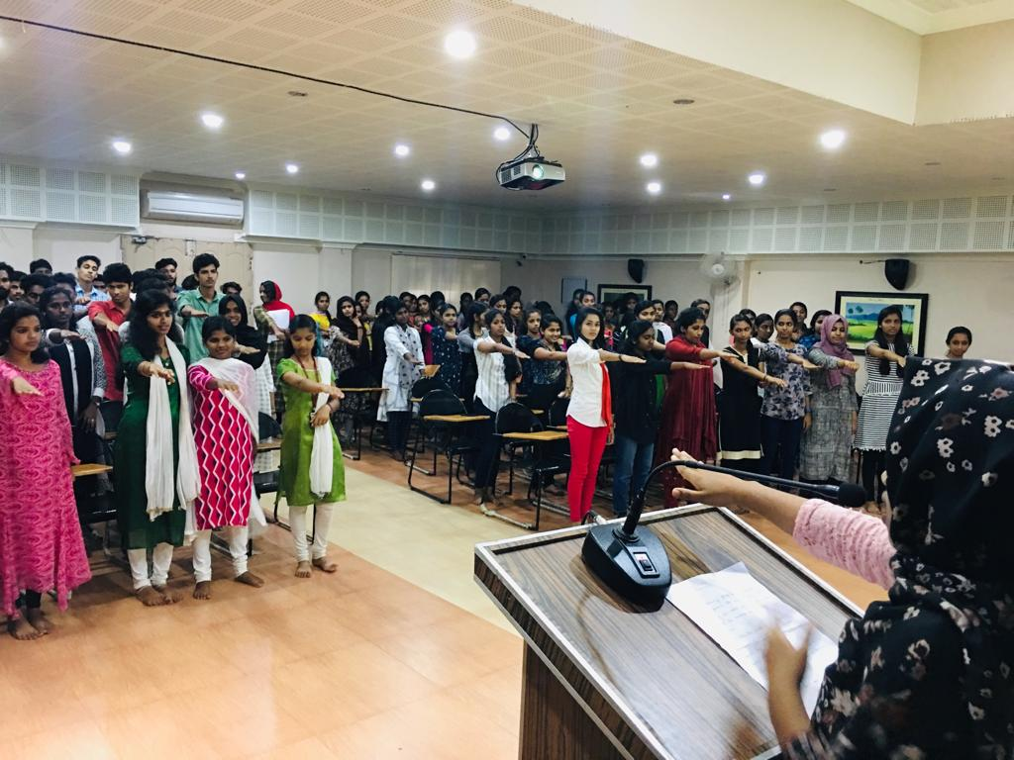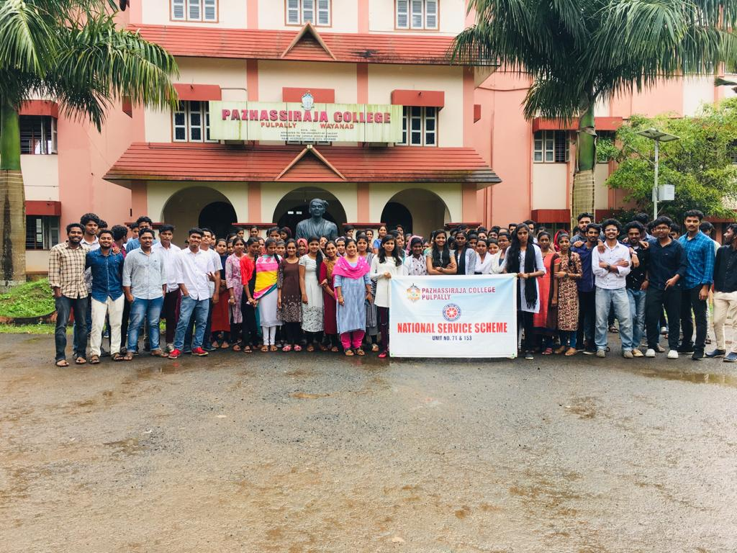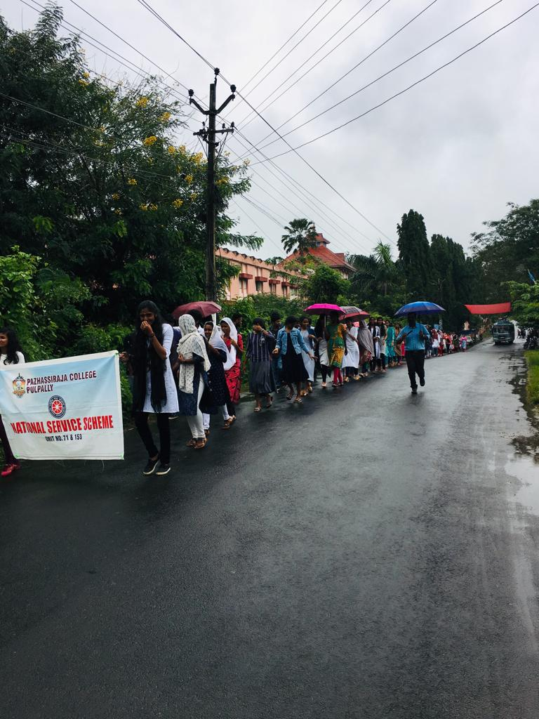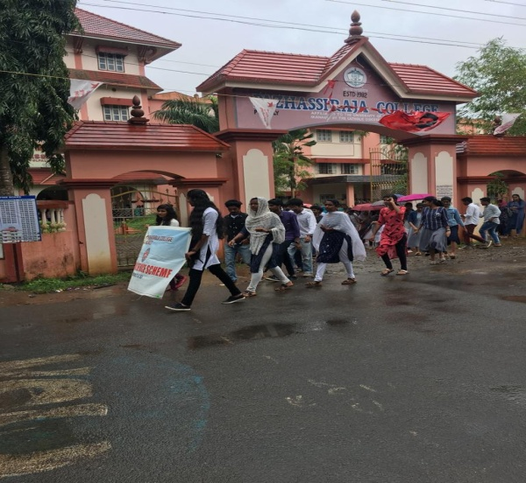
Helping in Pain and Palliative Clinic
NSS volunteers are grouped and each group were involved in the activities of pain and palliative units in a rotation basis.
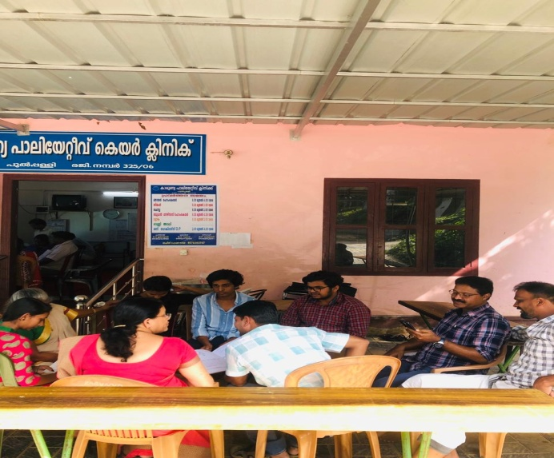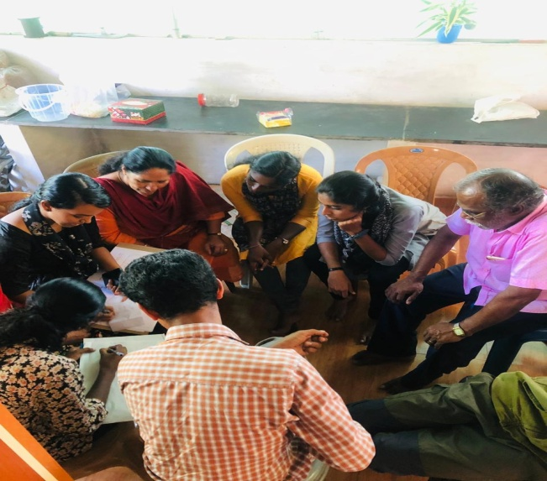
Initial Site visit of NSS House Construction Project
NSS Units planned to construct a house for a beneficiary identified by the NSS family of Pazhassiraja College, The team members of the project visited the plot on 02-11-2019

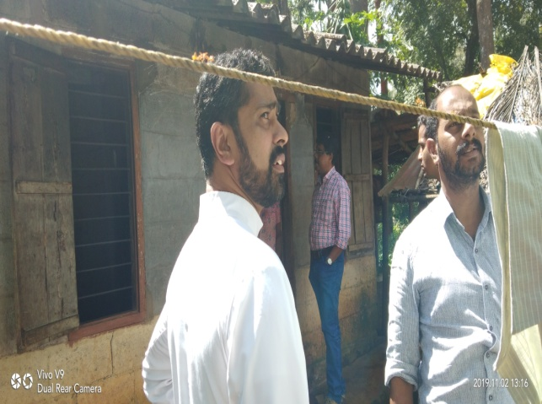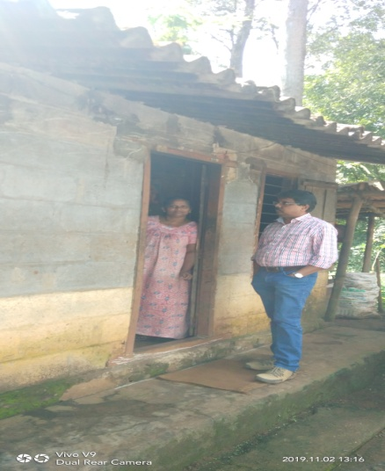
Training for volunteers on Pain and palliative care
There was training for volunteers on Pain and palliative care on 24-11-2019. 40 v0lunteers participated in the training program me arranged by the palliative care centre, Pulpally
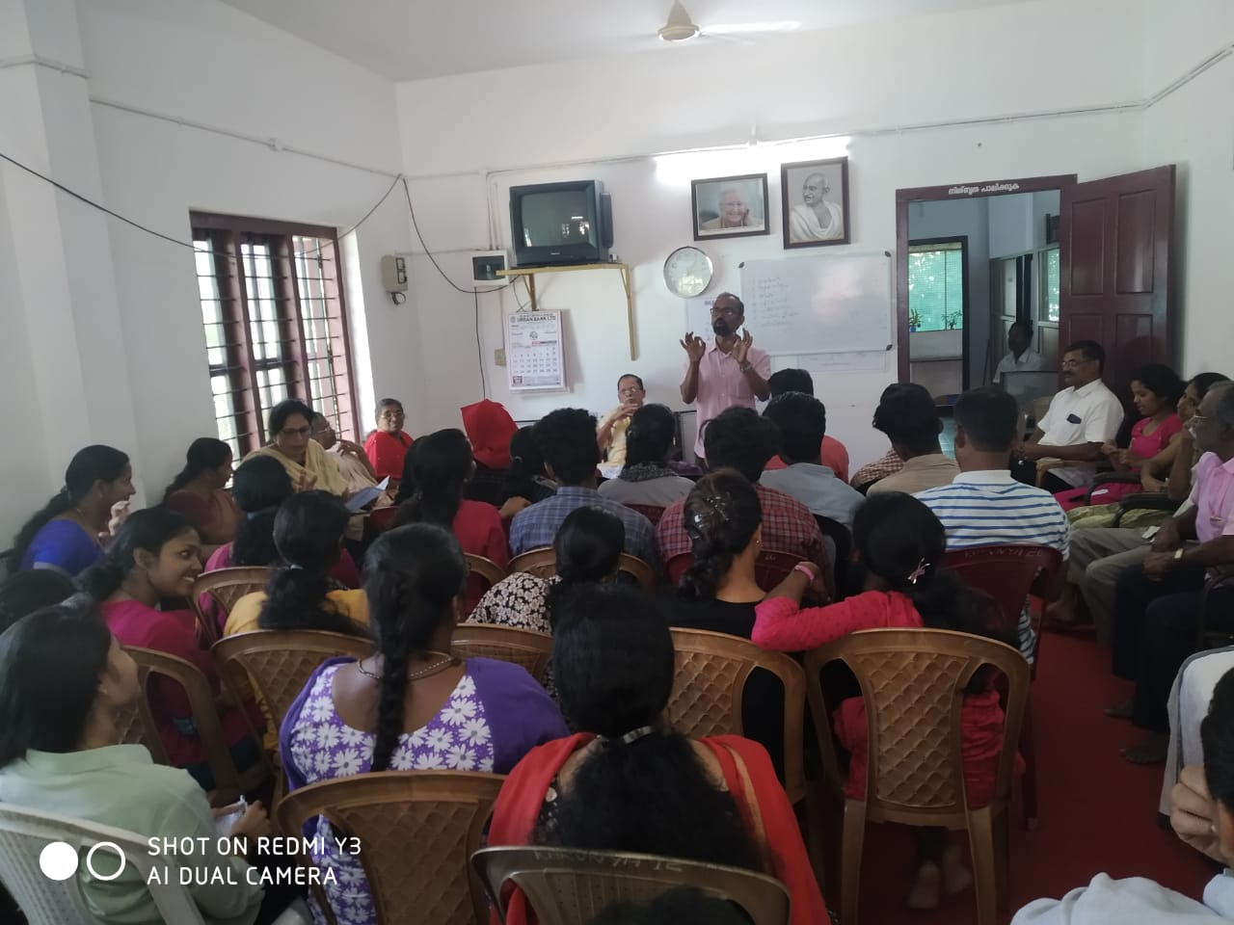

Site visit of NSS House Construction Project

On 26-11-2019 NSS volunteers and PO’s visited the project site for taking the measurements for plan preparation
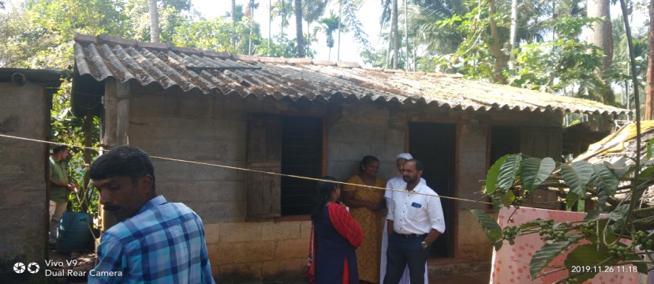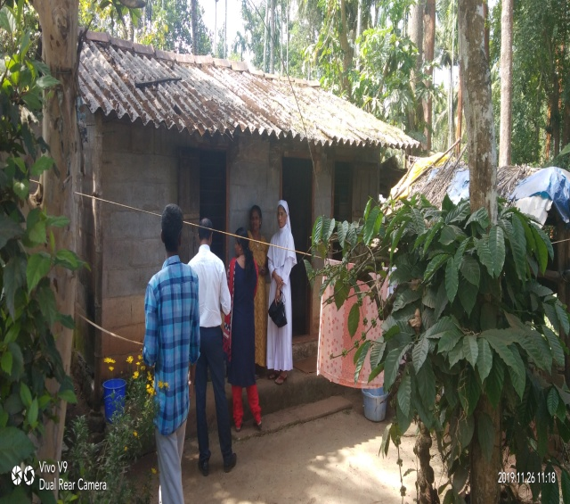

Voter’s ID verification
Voter’s ID verification in association with Mullenkolly Panchayath on 30-11-2019.Village Officer gave a class on this regard and the volunteers actively participated in the process to complete the task. Weekends were used for the same. It was a GroupWise activity and the panchayath acknowledged the NSS volunteers.
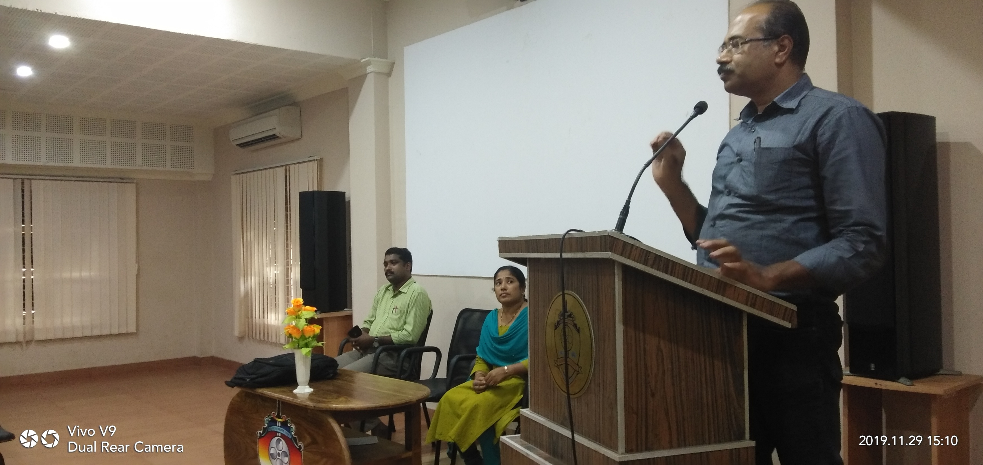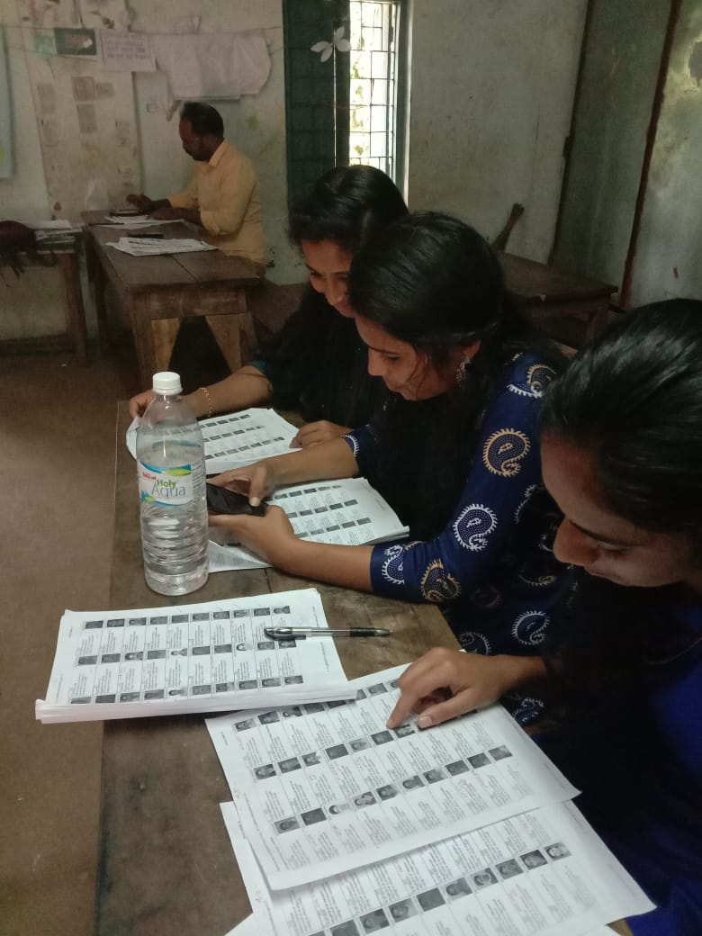
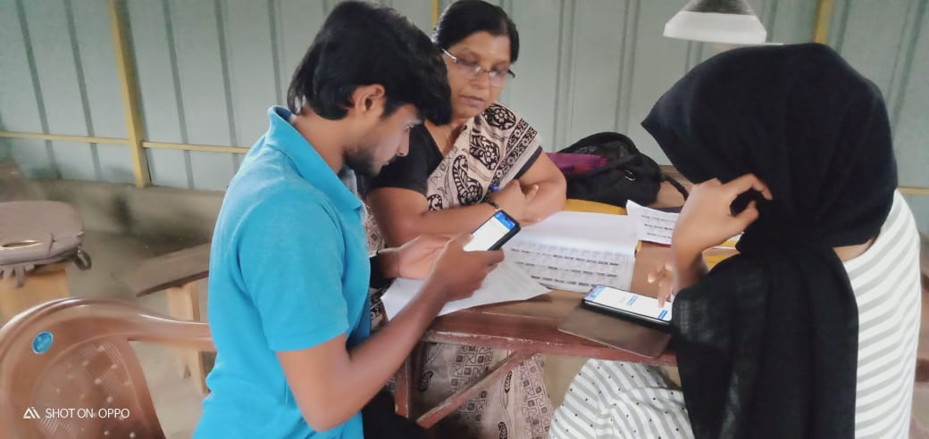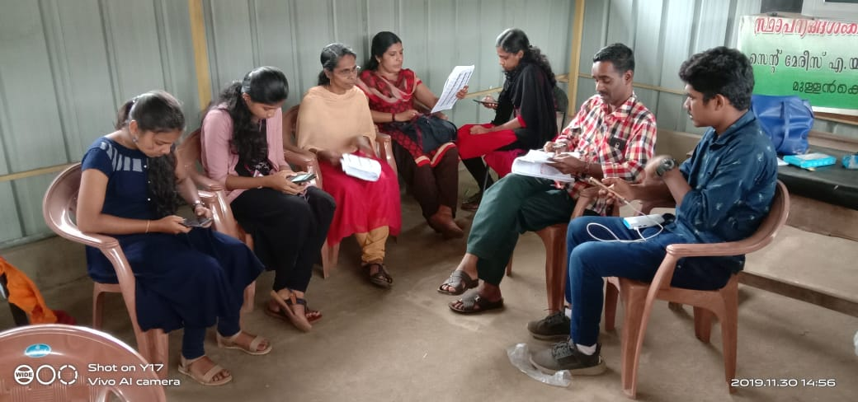

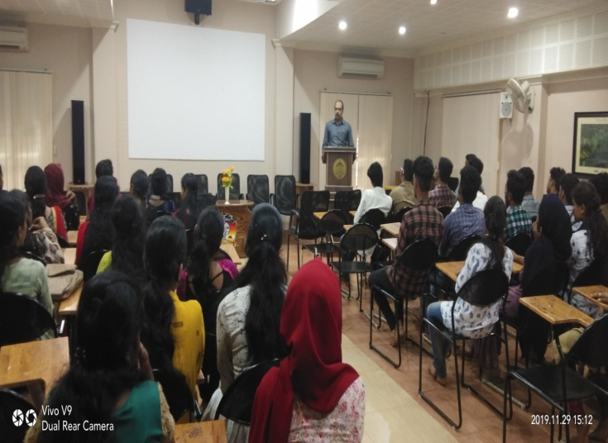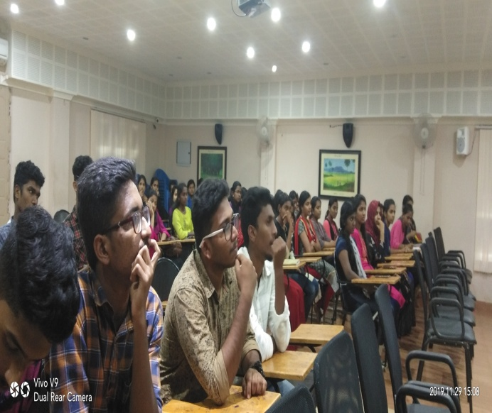

International day for Disabled on 03-12-2019
54 volunteers visited Kripalaya Special School, Pulpally and entertained them with cultural programmes. They spent time interacting with the special school students and they were motivated by the creative talents of the special students. It was a wonderful experience for the volunteers.
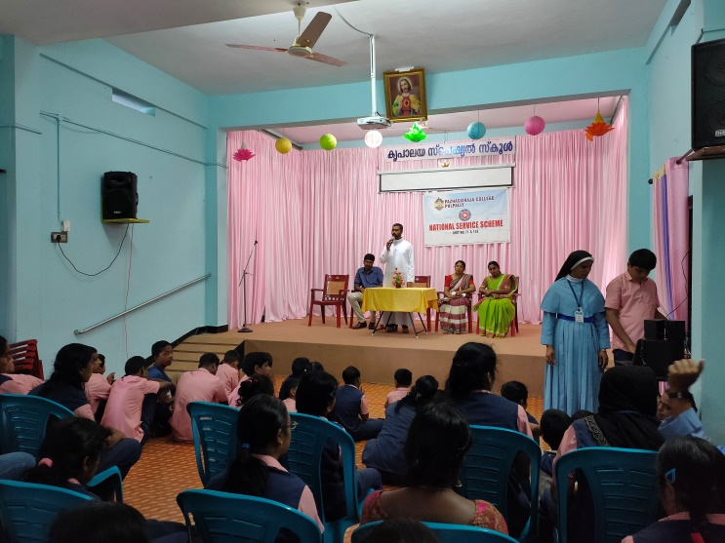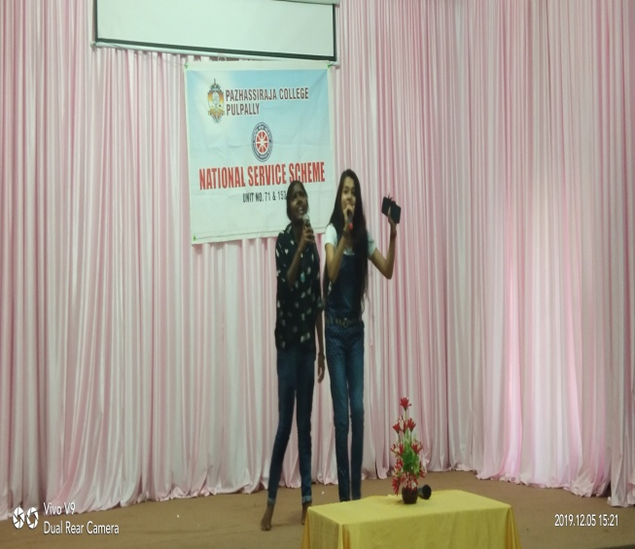

Volunteer day Celebration on 05-12-2019
Volunteer day was celebrated on 05-12-2019 and an orientation was given by Mr. Jyothish Joseph and students were grouped and performed various activities
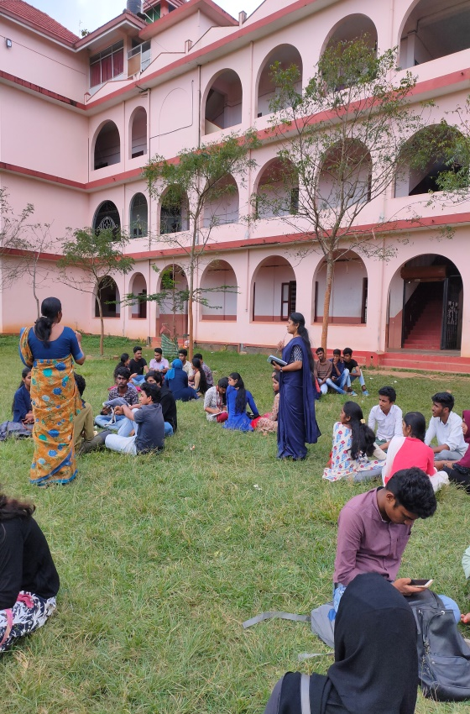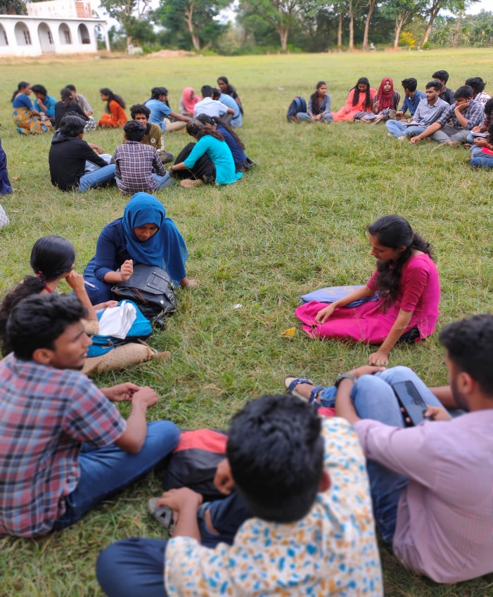

Food Fest on 09-12-2019
Savola Y2K19 was the fund raising programme for the house construction project. It was a grant food fest ever in the campus. All the volunteers enthusiastically involved in the fest and they made the food items for the feat.
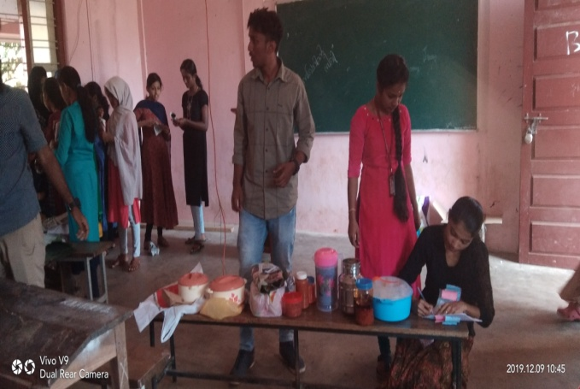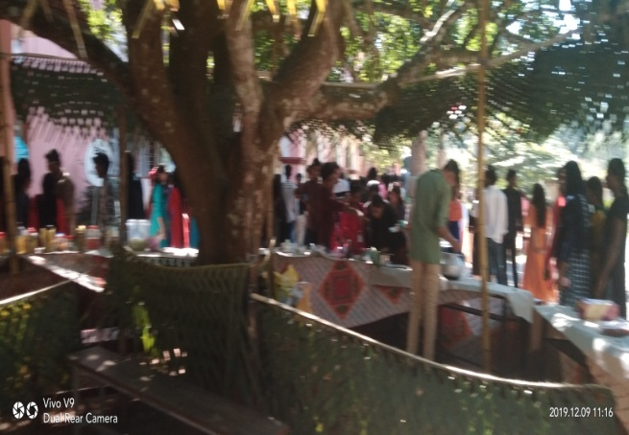
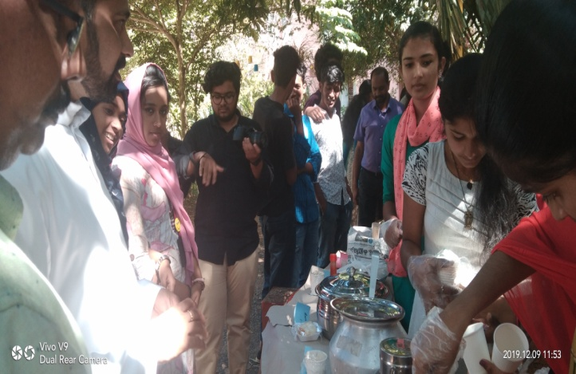
Helping in Pain and Palliative Clinic on 14-12-2019
NSS Volunteers as part of their regular activity, involved in the pain and palliative works. The Clinic members depend our volunteers for many of their regular work and always happy with support of NSS volunteers.
Camp preparation and distribution of caps and badges on 17-12-2019
NSS caps and badges were distributed by Dr. Anilkumar K to the volunteers.

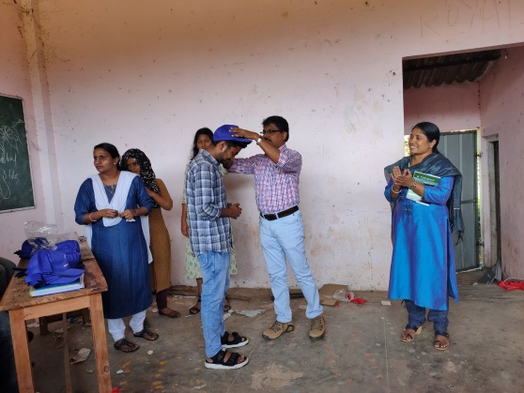

JANUARY-MARCH
- A campus cleaning programme was conducted on 10-01-2020 in connection with Film Festival by Department of Mass Communication. 74 volunteers took part in the cleaning programme.
- Conducted rally in connection with Pain and palliative day on 15-01-2020 in association with Pain and Palliative care unit, Pulpally. 52 volunteers participated in the rally. Several volunteers are frequently servicing with members of pain and palliative in the house visits during weekends.
- Inauguration of ‘Used pen drop box’ is conducted in association with Haritha Kerala Mission on 20-01-2020. Principal Dr. Anilkumar K inaugurated the gathering by dropping used pens into the box. 64 volunteers participated in the function. It gave an opportunity to the students to drop their used pens in the box instead of throwing away in the college premises and classrooms.
- Conducted an awareness programme on the ‘Safety measures taken to resist Corona’ in association with Health Department, Pulpally, The class was taken by Health Inspector Mr. Radhakrishnan on 4-3-2020. 58 volunteers took part in the awareness programme.
- Delivered an awareness message to the other students in the college about ‘Corona disease and precautions’ by NSS volunteers on 5-3-2020. The volunteers were split into groups and they made others also aware of the pandemic situation.
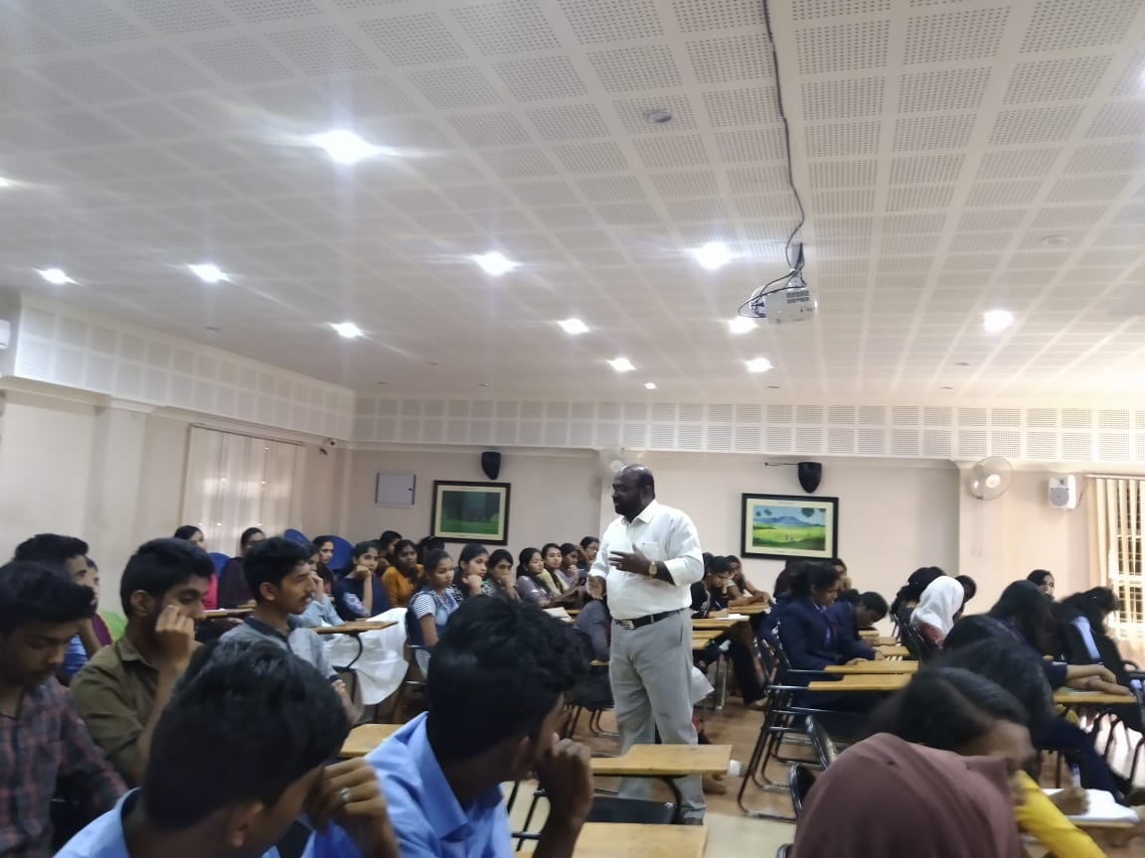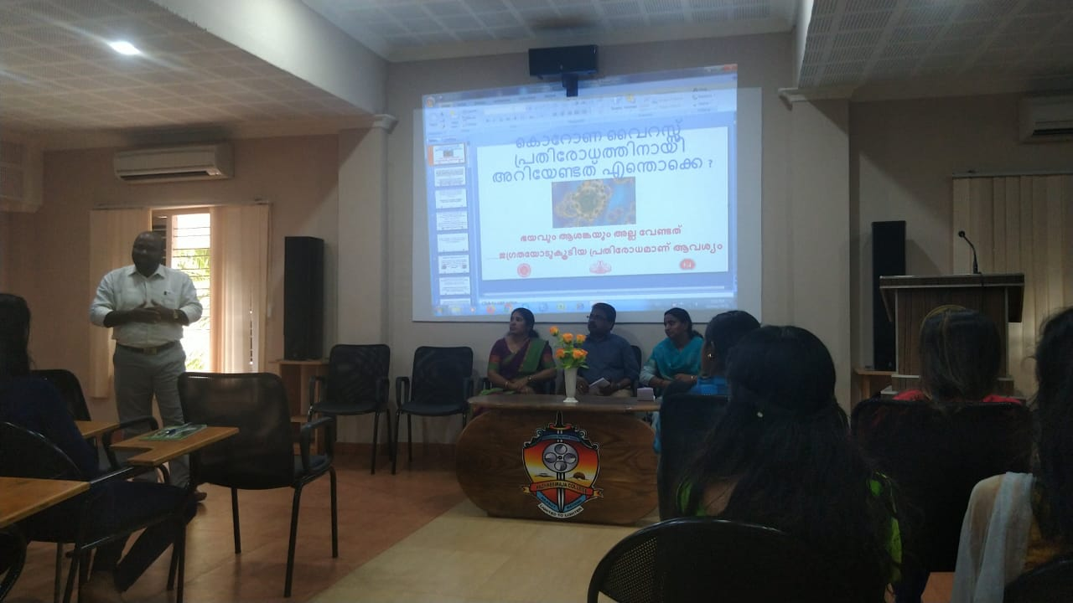
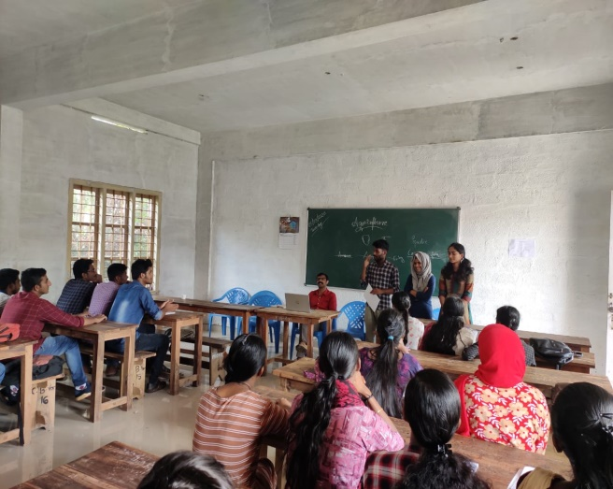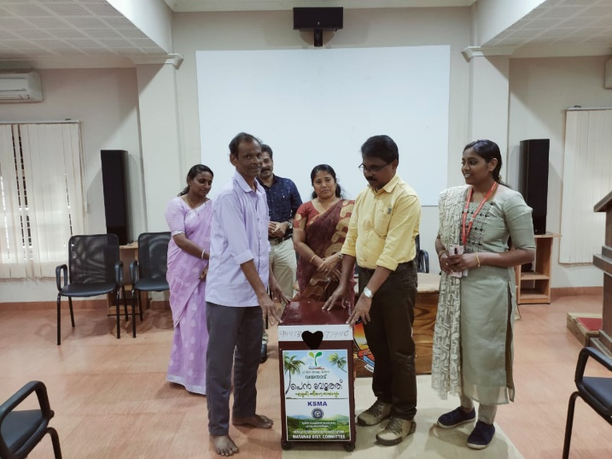
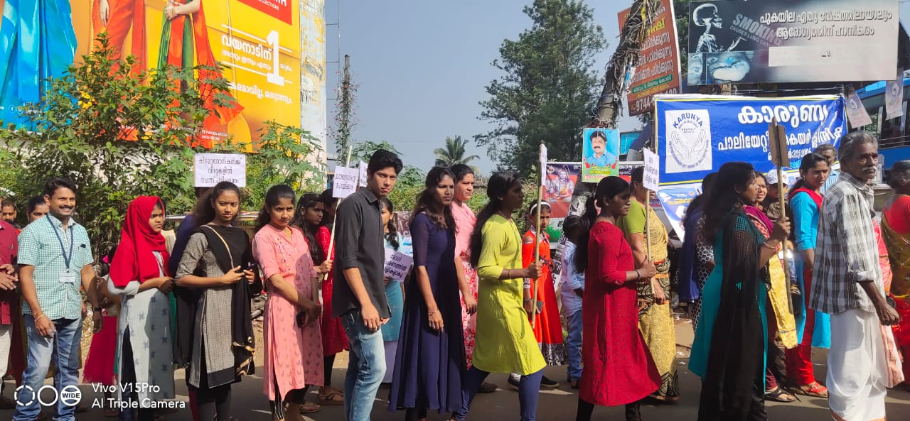
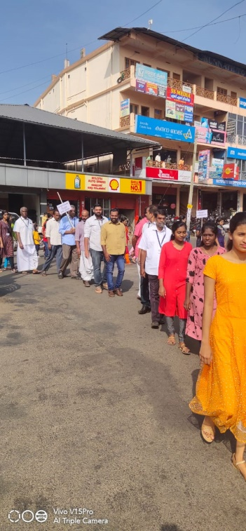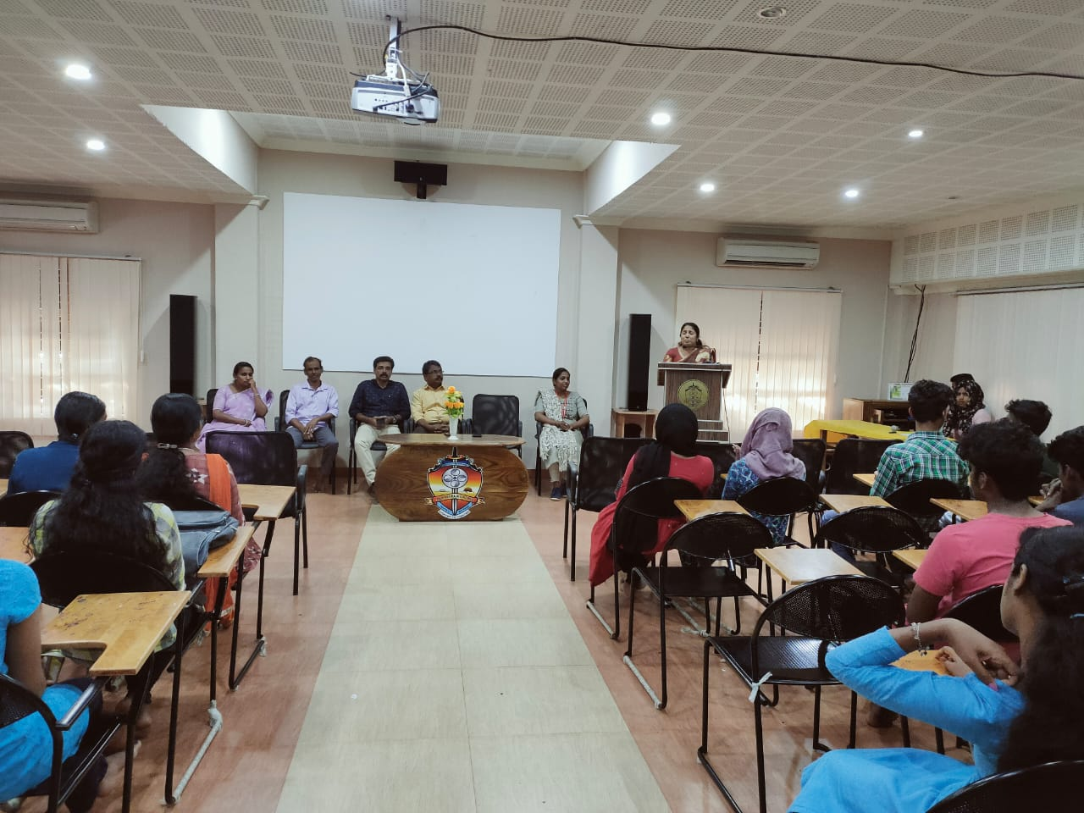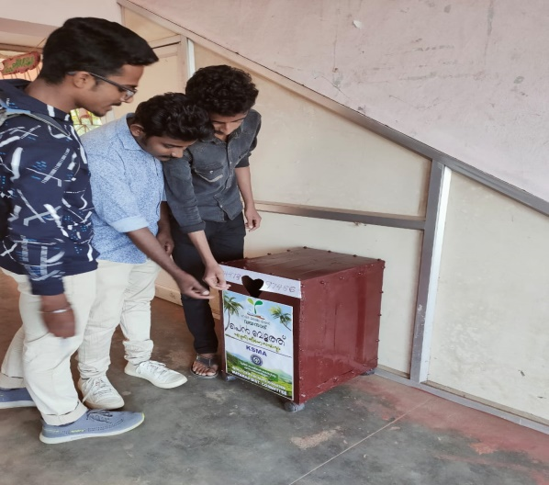
APRIL-MAY
Activities during lockdown 2020 for the months of April and May
- 54 volunteers registered in Sannadasena volunteer registration portal
- Two of our NSS volunteers Alisha and Athira jointly with Dept.of Biochemistry, Pazhassiraja College Pulpally prepared 600 bottles (100ml) of sanitizers and handed over to Pulpally Panchayath
- One of our volunteer Arjun was actively involved in supply of emergency medicine, community kitchen activities
- 57 volunteers downloaded 'Arogyasethu' app
- 30 volunteers completed COVID19 training programme
- Took part in the project with NSS units of Wayanad district of planting 10000 saplings on World Environment Day. Each volunteer planted 10 saplings to take up the project.
Tasks assigned during lockdown
5 different tasks were assigned to our volunteers in order to enhance social commitment during these lockdown days. Majority of the volunteers performed well and actively participated in the programme. The tasks assigned to them are:
- Task 1 : Self prepared dishes

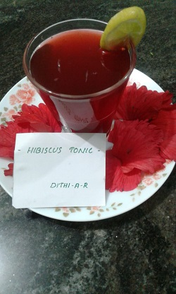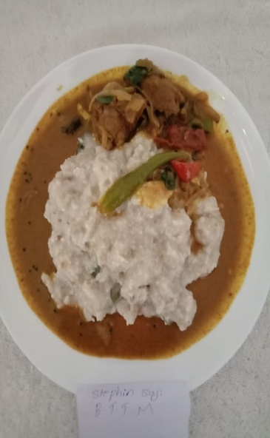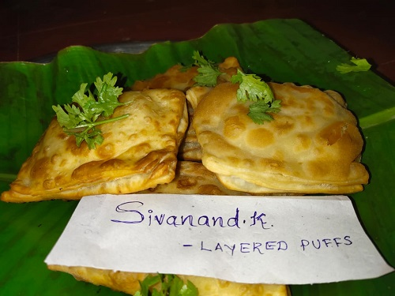

- Task 2 : Planting saplings

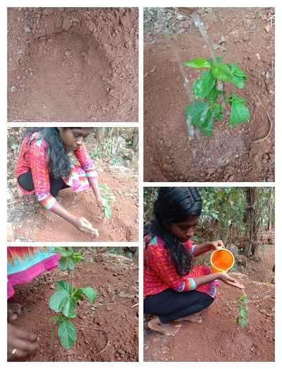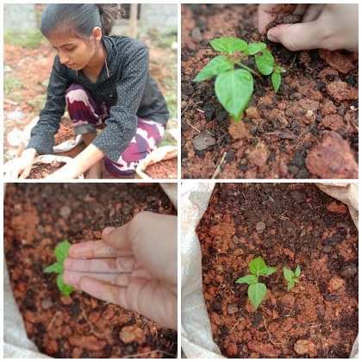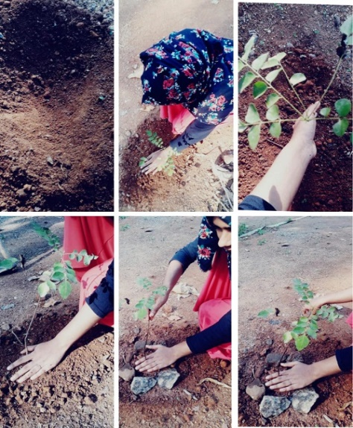

- Task 3 : Creative article writing
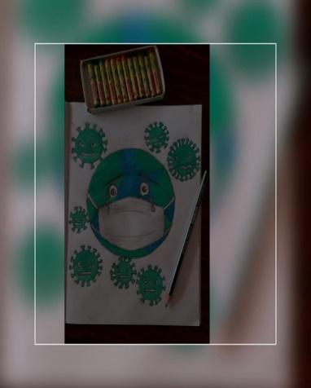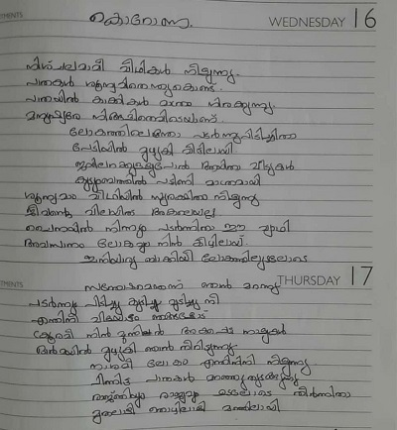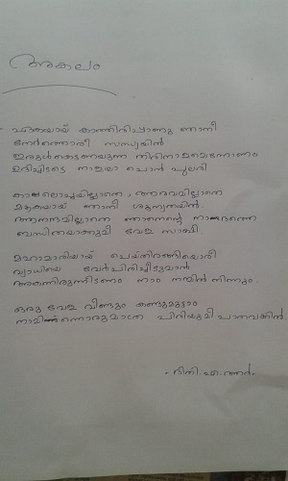

- Task 4 : Cleaning house premises
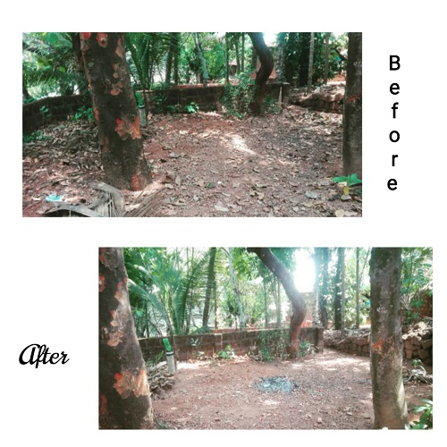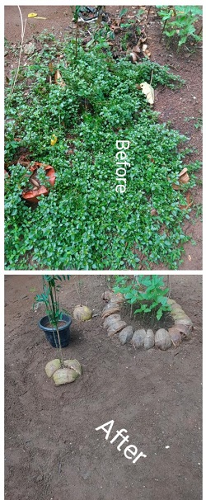

- Task 5 : Craft making

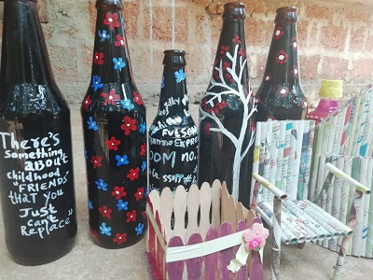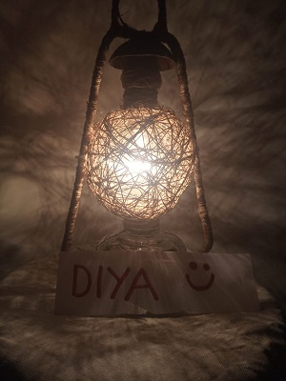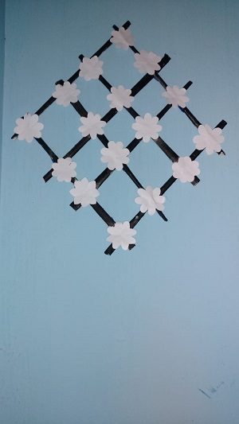
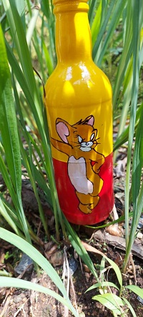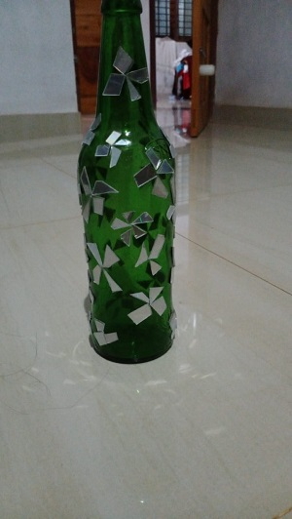

NSS Programme Officer
Pazhassiraja College Pulpally

Ms. Neetha Francis
Unit 71

